# INVENTORY PROJECT SCHEDULE

The following are the project schedule with its expected deliverables. This schedule will be adjusted to the project nature and needs. The rolled out production will be marked with milestone and will be repeated in each release.

## Table 3 - Project Schedule for Inventory System using Agile Software Development

|  |  |  |  |  |  |
| --- | --- | --- | --- | --- | --- |
| |  | | --- | | **Milestone** | | |  | | --- | | **Duration** | | |  | | --- | | **Deliverables** | |
| 1. Project Initiation | 1 Week | • Project Proposal |
| 2. System Design | 2 Week | • Requirement Specification   * User Requirements Document   + Prioritised Requirements List   + Non-functional Requirements   + Future Business Process * Technical Requirements   • System Specification   * Functional Specification   + High-level Required System Overview   + High-level Functional Definition * Architecture Design ➢ System Design   + High-level Logical Data Model (e.g.   Entity Relationship Diagram, Class Diagram)   * + User Experience (using prototyping techniques)   • Technical System Option |
| 3. Program  Development, Coding | 6 Week | * Site Specification * Accepted site |
| 4. Unit Tests and  Integration  Tests | 2 Week | * Test Plan and Test Result |

|  |  |  |  |
| --- | --- | --- | --- |
|  | **Milestone** | **End of Date** | **Deliverables** |
| 6. User Acceptance | 1 Week | * Acceptance Test Plan for the overall system, Specifications and Results * "Passing tests" software components |
| 7. Training | 1 Week | * Training Plan * Training Manual * Training Courses * Trained Users |
| 8. Prepare System Documentation | 6th Month | * Application Operation Manual * Application User Manual     *<Below are for mission critical systems* >   * Business Impact Analysis *<if not yet in place or the reviewed one if already in place>;* * Business Continuity Plan which includes a Disaster Recovery Plan |

|  |  |
| --- | --- |
| **User Story 1** |  |
| Story Title: | ***Computer Items*** |
| Story Content: | ***As a system administrator I should be able to enter computer items details and generate a QR code easily*** |
| Acceptance Criteria: | 1. ***Should be able to capture all the required details regarding every computer or accessories*** 2. ***Able to generate QR code.*** 3. ***Able to track and list out the status of every computer.*** 4. ***Able to update the system if required*** 5. ***Can generate report base on selected criteria*** 6. ***Able to manually enter QR if QR Reader is unavailable*** 7. ***Able to separate computer item grouping to lease or not lease*** 8. ***Able to save details of computer return to vendor or return for repair*** 9. ***Able to manage system user*** |
| Submitted By: | ***System Administrator*** |
| Submitted On: | ***01.10.2018*** |
| Last Modified: | ***09.10.2018*** |

|  |  |
| --- | --- |
| **User Story 2** |  |
| Story Title: | ***Personnel Detail*** |
| Story Content: | ***As a system administrator I should be able to enter personnel detail (employee data)*** |
| Acceptance Criteria: | 1. ***Should be able to capture all the required details regarding personnel detail*** 2. ***Should be able to store which office , unit , and subunit each personnel is*** 3. ***Should be able to update personnel status if required*** 4. ***Able to store history of personnel previous working place*** |
| Submitted By: | ***System Administrator*** |
| Submitted On: | ***01.10.2018*** |
| Last Modified: | ***09.10.2018*** |

|  |  |
| --- | --- |
| **User Story 3** |  |
| Story Title: | ***Supplier Detail*** |
| Story Content: | ***As a system administrator I should be able to enter supplier detail*** |
| Acceptance Criteria: | 1. ***Should be able to capture all the required details regarding supplier detail*** 2. ***Should be able to store which computer item supplied*** 3. ***Should be able to update supplier status if required*** 4. ***Able to list out supplier report if required*** |
| Submitted By: | ***System Administrator*** |
| Submitted On: | ***01.10.2018*** |
| Last Modified: | ***09.10.2018*** |

|  |  |
| --- | --- |
| **User Story 2** |  |
| Story Title: | ***Manage Inventory System*** |
| Story Content: | ***As a system administrator I should be able to manage computer item and accessories*** |
| Acceptance Criteria: | 1. ***Should be able to capture all the required details regarding computer issued to personnel*** 2. ***Should be able to track additional computer or accessories issued to personnel*** 3. ***Should be able to update status of computer and accessories*** 4. ***Able to store the history of who a computer is issued to.*** 5. ***Able to search who is the supplier of the computer*** 6. ***Should be able to track any computer issued location or office and the status*** 7. ***Should be able to categories computer type (lease or not lease)*** |
| Submitted By: | ***System Administrator*** |
| Submitted On: | ***01.10.2018*** |
| Last Modified: | ***09.10.2018*** |

Group 2  
Project Scope

6th October 2018

# Overview

## Project Background and Description

|  |  |
| --- | --- |
|  | Describe how this project came about, who is involved, and the purpose.  Note: To delete any tip (such as this), select it and start typing. If you’re not yet ready to add your own text, select a tip and press spacebar to remove it.  Asset/Inventory Tracking System  Defense Information Technology Unit deals with anything related to technology and computer needs in Ministry of Defense. Obviously there will be a huge amount of employee be as an army men or the civilian employee. In order to cater for all that needs will involve a huge amount of computer hardware such as a complete personal computer, printer monitor and others.  In order to keep on par with the rapid development of technological growth, issued personal computer system too are in rapidly approaching their phase out stage. This is due to compatibility issues in hardware and software and ultimately due to wear and tear of daily use. As part of the government asset, each issued computer require proper paper work regarding the status of issued computer not forgetting disposal of each asset. Managing and tracking all the above are the support section in DITU.  Realizing duplication issues found in Microsoft Excel this section opted to adapt Microsoft Access to solve the issues. As years past by the requirement to have a much more robust and scalable solution are in demand. It should be easy to integrate and adapting the use of QR system  In the past few years disposal of hardware that is verified and considered Beyond Economical Repair by the technician are not properly organized and manage effectively. This resulted in difficulty and a process bottleneck. This is the identified problem which needs to be solve. After conducting several meeting with the client, we had come up with the first proposal which will involve the use of QR technology, mobile apps that will be integrated with the current system.  Propose solution: Admin - To create an app that scans a QR code to retrieve information of the asset where the admin can edit or add the asset information. During auditing, the user can scan the QR code to edit the asset information such as issued to which user, location, status of the asset (need to be replace or not).  A web application can be use to provide the same function accessible using a computer browser. Functions such as adding users (admin or end-user), generating reports and statistics can also be implemented.  End-User - Able to access the asset information and update certain information such as the status or if there is an issue with the asset that requires maintenance (slow performance, virus, no network connection, etc) |

## Project Scope

|  |  |
| --- | --- |
|  | Project scope defines the boundaries of a project. Think of the scope as an imaginary box that will enclose all the project elements/activities. It not only defines what you are doing (what goes into the box), but it sets limits for what will not be done as part of the project (what doesn’t fit in the box). Scope answers questions including what will be done, what won’t be done, and what the result will look like.  Asset/Inventory Tracking System  Current system: The system is used to stored details of various devices (computers, projectors, keyboards, storage devices, etc), office equipments (chairs, tables, etc) and components (network cables, power adapters, dongles, etc). Currently, the asset details are stored in an excel file, indicated by a serial number.  Some of the details include: Types of Assets 1.    PC a.    Monitor b.    Keyboard c.    Mouse d.    Dvd rom e.    Power adapter  2.    Printer a.    Power adapter b.    Usb cable  3.    Scanner a.    Power adapter b.    Usb cable  4.    Laptop a.    Wireless mouse b.    Power adapter c.    Vga adapter d.    Dvd rom  5.    Spare parts a.    HDD b.    RAM c.    CMOS Battery  Information to be captured (Incoming) 1.    Brand 2.    Model 3.    Serial Number 4.    Registration ID (DITU issue) 5.    Supplier Information 6.    DO/PO Number 7.    Price 8.    Warranty  Information to be captured (outgoing) 1.    User information a.    Name b.    IC c.    Unit d.    Sub-Unit e.    Status (Issued, Still in store, returned, on loan, BER [Beyond Economy Repair])  Reports 1.    What items are under this unit? 2.    What items are under a specific user 3.    Report on BER items  This system is used to check availability, issues if require replacements, auditing, etc. and this file is only accessible one user at a time.  Propose solution: Admin - To create an app that scans a QR code to retrieve information of the asset where the admin can edit or add the asset information. During auditing, the user can scan the QR code to edit the asset information such as issued to which user, location, status of the asset (need to be replace or not).  A web application can be use to provide the same function accessible using a computer browser. Functions such as adding users (admin or end-user), generating reports and statistics can also be implemented.  End-User - Able to access the asset information and update certain information such as the status or if there is an issue with the asset that requires maintenance (slow performance, virus, no network connection, etc) |

## High-Level Requirements

|  |  |
| --- | --- |
|  | Describe the high level requirements for the project. For example: |

The new system must include the following:

* Ability to allow both internal and external users to access the application without downloading any software
* Ability to interface with the existing data warehouse application
* Ability to incorporate automated routing and notifications based on business rules

## Deliverables

|  |  |
| --- | --- |
|  | List agencies, stakeholders or divisions which will be impacted by this project and describe how they will be affected by the project. |

## Affected Parties

|  |  |
| --- | --- |
|  | List business processes or systems which will be impacted by this project and describe how they will be affected. |

## Affected Business Processes or Systems

|  |  |
| --- | --- |
|  | Describe any specific components that are excluded from this project. |

## Specific Exclusions from Scope

|  |  |
| --- | --- |
|  | Describe how you plan to implement the project. For example, will all parts of the project be rolled out at once or will it be incremental? What will be included in each release? |

## Implementation Plan

|  |  |
| --- | --- |
|  | Include recommendations that lead to your proposed solution. Summarize what you’re proposing to do and how you’re going to meet the goals. You’ll be able to expand on the details within the ‘Our Proposal’ section. |

## High-Level Timeline/Schedule

|  |  |
| --- | --- |
|  | Describe what the high level timeline/schedule will be to plan, design, develop and deploy the project. Generally, by when do you expect this project to be finished? |

# Approval and Authority to Proceed

We approve the project as described above, and authorize the team to proceed.

|  |  |  |
| --- | --- | --- |
| Name | Title | Date |
|  |  |  |
|  |  |  |
|  |  |  |

|  |  |  |  |  |  |  |  |  |
| --- | --- | --- | --- | --- | --- | --- | --- | --- |
|  |  |  |  |  |  |  |  |  |
| Approved By |  |  | Date |  | Approved By |  |  | Date |

|  |  |
| --- | --- |
|  | **MINISTRY OF EDUCATION AND TRAINING** |

**FPT UNIVERSITY**

|  |  |
| --- | --- |
| Capstone Project Document | |
| **Mindef Inventory System** | |
| **Group 02 – Colaboration** | |
| **Group members** | Tôn thất bảo(Vietnam) – SE62569 (Leader)  Masdey (Brunei)  Nguyễn Trung Tín (Vietnam)  Anas (Brunei)  Aidee Suherman (Brunei)  Aziah (Brunei) |
| **Supervisor** | Ngô Đăng Hà An |
| **Ext. Supervisor** | N/A |
| **Project Code** | MIS |

**Table of Content**

INVENTORY PROJECT SCHEDULE 1

Table 3 - Project Schedule for Inventory System using Agile Software Development 1

Overview 7

Project Background and Description 7

Project Scope 8

High-Level Requirements 9

Deliverables 9

Affected Parties 9

Affected Business Processes or Systems 9

Specific Exclusions from Scope 10

Implementation Plan 10

High-Level Timeline/Schedule 10

Approval and Authority to Proceed 10

List of Figure 18

List of Table 22

A. Introduction 27

1. Project Information 27

2. Introduction 27

3. Situation 27

4. Problem Definition 28

5. Proposed Solution 28

6. Feature Functions 28

5.1. Advantages 28

5.2. Disadvantages 29

1. Functional Requirements 29

User Story 29

2. Roles and Responsibilities 30

B. Software Project Management Plan 31

1. Problem Definition 31

**1.1.** **Name of this Capstone Project** 31

**1.2.** **Problem Abstract** 31

**1.3.** **Project Overview** 31

**1.4.** **Development Environment** 32

**2.** **Project Organization** 33

**2.1.** **Software Process Model** 33

**2.2.** **Roles and Responsibilities** 34

2.3. Tools and Techniques 35

3. Project Management Plan 36

**3.1.** **Product Backlog** 36

**3.2.** **Deliverables** 37

4. Coding Convention 38

C. Software Requirement Specification 40

**1. User Requirement Specification** 40

**1.1 Guest Requirement** 40

**1.2 Admin Requirement** 40

**1.3 Inventory Department Requirement** 40

Main user and system owner which can perform all the system ability such as adding, editing , searching, view, print according to given role set by admin 40

**1.4 Manager Requirement** 40

**1.6 System Requirement** 40

**2. System Requirement Specification** 40

**2.1 External Interface Requirement** 40

**2.2 System Overview Use Case** 42

2.3 List of Use Cases 43

**3.** **Software System Attributes** 122

3.1. Usability 122

3.1.1. Graphic User Interface 122

3.1.2. Usability 122

3.2. Reliability 122

3.3. Availability 122

**3.5.** **Maintainability** 123

3.6. Portability 123

3.7. Performance 123

4. Conceptual Diagram 123

D. Software Design Description 124

**1. Design Overview** 124

**2. System Architectural Design** 124

**3. Component Diagram** 125

**4. Detail Description** 128

**4.1 Class Diagram** 128

**4.2 Class Diagram Explanation** 130

4.3 Interaction Diagram 135

5.1. Home Page 139

5.2. Login Page 140

5.3. Personal Interface Design 141

5.4. Manager Interface Design 144

5.4.1. Manager’s menu 144

5.4.2. Staff management 145

5.4.2.1. View staff list 145

5.4.2.2. Create staff 147

5.4.3. Customer management 148

5.4.3.1. View customer list 148

5.4.3.2. Create customer 150

5.4.4. Product management 151

5.4.4.1. View product list 151

5.4.4.2. Create product 153

5.4.5. Template Management 154

5.4.5.1. View Template List 154

5.4.5.2. View template detail 155

5.4.5.3. Create template 157

5.5. Accountant Interface Design 159

5.5.1. Accountant’s menu 159

5.5.2. Invoice management 160

5.5.2.1. View invoice list 160

5.5.2.2. Create invoice 162

5.5.2.2.1. Customer information 162

5.5.2.2.2. Product information 163

5.5.2.2.3. Create invoice’s product popup 165

5.5.3. Proforma invoice management 166

5.5.3.1. View proforma invoice list 166

5.5.3.2. Create proforma invoice 168

5.5.3.2.1. Proforma invoice information 168

5.5.3.2.2. Create proforma invoice’s product popup 171

5.5.4. Liabilities management 172

5.5.4.1. View liabilities list 172

5.5.4.2. Liabilities detail 174

5.5.4.3. Payment popup 175

5.6. Customer Interface Design 176

5.6.1. Customer’s menu 176

5.6.2. Invoice list 177

5.6.3. Proforma invoice list 179

5.6.4. Liabilities 180

5.6.5. Liabilities detail 181

5.7. Admin Interface Design 183

5.7.1. Admin’s menu 183

5.7.2. Company management 184

5.7.2.1. View company list 184

5.7.2.2. Create company 185

5.7.3. Account management 187

5.7.3.1. View admin list 187

5.7.3.2. Create Admin 189

**5.8. Windows Application** 191

E. System Implementation & Test 196

1. Introduction 196

1.1. Overview 196

1.2. Test Approach 196

2. Database Relationship Diagram 197

2.1. Physical Diagram 197

2.2. Data Dictionary 200

3. Test Plan 200

3.1. Features To Be Tested 200

3.2. Features Not To Be Tested 201

4. System Testing Test Case 201

4.1. Test Case 201

**F1. Software User’s Manual** 210

**1. Installation Guide** 210

1.1. Hardware Requirement 210

1.2. Software Requirement 210

**2. User Manual** 210

2.1. Web Application 210

2.2. Windows Application 222

**F2. ソフトウェアユーザーマニュアル** 226

**1. インストレーションガイド** 226

1.1. ハードウェア要件 226

1.2. ソフトウェア要件 226

**2. ユーザーマニュアル** 226

**2.1.** **ウェブアプリケーション** 226

**2.2.** **Windowsアプリケーション** 240

**G. Appendix** 241

# List of Figure

Figure 1. Scrum framework 34

Figure 2. System overview use case 42

Figure 3. Guest overview use cases 43

Figure 4. <Guest> Login 43

Figure 5. <Guest> Lookup invoice 45

Figure 6. <Guest> Lookup proforma invoice 47

Figure 7. Authorized user overview use cases 51

Figure 8. <Authorized User> Logout 51

Figure 9. <Authorized User> Change password 52

Figure 10. <Authorized User> Update profile 53

Figure 11. Admin overview use cases 55

Figure 12. <Admin> View company list 55

Figure 13. <Admin> Create company 56

Figure 14. <Admin> Update company 58

Figure 15. <Admin> Activate.Deactivate company 59

Figure 16. <Admin> Delete company 60

Figure 17. <Admin> View account list 61

Figure 18. <Admin> Create account 62

Figure 19. <Admin> Update account 65

Figure 20. <Admin> Activate.Deactivate account 66

Figure 21. <Admin> Change account password 67

Figure 22. <Admin> Delete account 68

Figure 23. Manager overview use cases 70

Figure 24. <Manager> View staff list 70

Figure 25. <Manager> Create staff 71

Figure 26. <Manager> Update staff 73

Figure 27. <Manager> Delete staff 74

Figure 28. <Manager> View customer list 76

Figure 29. <Manager> Add customer 77

Figure 30. <Manager> Add customer’s product 78

Figure 31. <Manager> Remove customer’s product 79

Figure 32. <Manager> View template release list 81

Figure 33. <Manager> Create template release 82

Figure 34. <Manager> Delete block 83

Figure 35. <Manager> Add more block 84

Figure 36. <Manager> View product list 85

Figure 37. <Manager> Create product 86

Figure 38. <Manager> Update product 88

Figure 39. <Manager> Delete product 89

Figure 40. Liability accountant overview use cases 91

Figure 41. < Accountant, Accounting Manager, Customer> View invoice list 91

Figure 42. <Liability Accountant, Payable Accountant> Create invoice 93

Figure 43. <Liability Accountant, Payable Accountant> Update invoice 96

Figure 44. <Liability, Payable Accountant, Accounting Manager, Customer> View invoice 98

Figure 45. <Liability Accountant, Payable Accountant> Delete invoice 99

Figure 46. <Liability Accountant, Payable Accountant> Send email 101

Figure 47. < Accountant, Accounting Manager, Customer> View proforma invoice list 103

Figure 48. <Liability Accountant> Create proforma invoice 104

Figure 49. <Liability Accountant> Update proforma invoice 106

Figure 50. < Accountant, Accounting Manager, Customer> View proforma invoice 109

Figure 51. <Liability Accountant> Delete proforma invoice 110

Figure 52. <Liability Accountant, Payable Accountant> Convert into invoice 111

Figure 53. <Liability Accountant, Payable Accountant> Send email 113

Figure 54. <Liability, Payable Accountant, Accounting Manager, Customer> View liabilities 114

Figure 55. <Payable Accountant> Add payment 115

Figure 56. Payable accountant overview use cases 117

Figure 57. <Payable Accountant> Confirm payment 117

Figure 58. Accounting manager overview use cases 118

Figure 59. <Accounting Manager> Approve proforma invoice 119

Figure 60. <Accounting Manager> Approve invoice 120

Figure 61. System overview use cases 121

Figure 62. <System> Auto-number outdated invoices 121

Figure 63. Conceptual diagram 123

Figure 64. System architectural design 124

Figure 65. Component diagram 125

Figure 66. Class diagram 128

Figure 67. <Sequence Diagram><Payable, Liability Accountant> Create invoice 136

Figure 68. <Sequence Diagram><Payable Accountant > Confirm payment 136

Figure 69. <Sequence Diagram><Accounting Manager> Approve invoice 137

Figure 70. <Sequence Diagram><Liability Accountant> Create proforma invoice 137

Figure 71. <Sequence Diagram><Accounting Manager> Approve proforma invoice 138

Figure 72. <Sequence Diagram><Payable Accountant, Liability Accountant> Convert proforma invoice into invoice 138

Figure 73. <Sequence Diagram><Payable Accountant > Add payment 139

Figure 74. Home page 139

Figure 75. Login page 140

Figure 76. Personal menu 141

Figure 77. Personal information page 142

Figure 78. Change password page 143

Figure 79. Manager’s menu 144

Figure 80. View staff list 145

Figure 81. Create staff 147

Figure 82. View customer list 148

Figure 83. Create customer 150

Figure 84. View product list 151

Figure 85. Create product 153

Figure 86. View template list 154

Figure 87. View template detail 155

Figure 88. Create template 157

Figure 89. Accountant’s menu 159

Figure 90. View invoice list 160

Figure 91. Customer information 162

Figure 92. Product information 163

Figure 93. Create invoice’s product popup 165

Figure 94. View proforma invoice list 166

Figure 95. Proforma invoice information 169

Figure 96. Create proforma invoice’s product popup 171

Figure 97. View liabilities list 172

Figure 98. Liabilities detail 174

Figure 99. Payment popup 175

Figure 100. Customer’s menu 176

Figure 101. Invoice list 177

Figure 102. Proforma invoice list 179

Figure 103. Liabilities 180

Figure 104. Liabilities detail 181

Figure 105. Liabilities detail 182

Figure 106. Admin’s menu 183

Figure 107. View company list 184

Figure 108. Create company 186

Figure 109. View admin list 187

Figure 110. Create admin account 189

Figure 111. Login form 191

Figure 112. Sign form 192

Figure 113. Entity relationship diagram 193

Figure 114. Physical database 197

Figure 115. <User Manual> Login 211

Figure 116. <User Manual> Create invoice (1) 211

Figure 117. <User Manual> Create invoice (2) 212

Figure 118. <User Manual> Create invoice (3) 212

Figure 119. <User Manual> Create invoice (4) 212

Figure 120. <User Manual> Confirm payment (1) 213

Figure 121. <User Manual> Confirm payment (2) 214

Figure 122. <User Manual> Create proforma invoice (1) 214

Figure 123. <User Manual> Create proforma invoice (2) 215

Figure 124. <User Manual> Create proforma invoice (3) 216

Figure 125. <User Manual> Approve proforma invoice (1) 217

Figure 126. <User Manual> Approve proforma invoice (2) 218

Figure 127. <User Manual> Convert proforma invoice (1) 219

Figure 128. <User Manual> Convert proforma invoice (2) 219

Figure 129. <User Manual> Convert proforma invoice (3) 220

Figure 130. <User Manual> Add payment (1) 221

Figure 131. <User Manual> Add payment (2) 222

Figure 132. <User Manual> Add payment (3) 222

Figure 133. <User Manual> Window application - Login 223

Figure 134. <User Manual> Window application - Sign (1) 224

Figure 135. <User Manual> Window application - Sign (2) 224

Figure 136. ログイン 227

Figure 137. 請求書を作成します (1) 228

Figure 138. 請求書を作成します (2) 228

Figure 139. 請求書を作成します (3) 229

Figure 140. 請求書を作成します (4) 229

Figure 141. 支払いを確認します (1) 230

Figure 142. 支払いを確認します (2) 231

Figure 143. プロフォーマインボイスを作成します (1) 231

Figure 144. プロフォーマインボイスを作成します (2) 232

Figure 145. プロフォーマインボイスを作成します (3) 233

Figure 146. プロフォーマインボイスを承認します (1) 234

Figure 147. プロフォーマインボイスを承認します (2) 235

Figure 148. プロフォーマインボイスを請求書に変換します (1) 236

Figure 149. プロフォーマインボイスを請求書に変換します (2) 237

Figure 150. プロフォーマインボイスを請求書に変換します (3) 237

Figure 151. 支払いを追加します (1) 238

Figure 152. 支払いを追加します(2) 238

Figure 153. 支払いを更新します(3) 239

Figure 154. ログイン 240

Figure 155. 請求書に署名します (1) 241

Figure 156. 請求書に署名します(2) 241

# List of Table

Table 1. Roles and responsibilities 19

Table 2. Hardware requirements for server 21

Table 3. Hardware requirements for PC 22

Table 4. Software requirements 22

Table 5. Roles and responsibilities details 23

Table 6. Tools and techniques 24

Table 7. Product backlog 25

Table 8. Deliverables 26

Table 9. <Guest> Login 32

Table 10. <Guest> Lookup invoice 33

Table 11. Lookup proforma invoice 35

Table 12. <Authorized User> Logout 36

Table 13. <Authorized User> Change password 37

Table 14. <Authorized User> Update profile 38

Table 15. <Admin> View company list 40

Table 16. <Admin> Create company 41

Table 17. <Admin> Update company 42

Table 18. <Admin> Activate.Deactivate company 43

Table 19. <Admin> Delete company 45

Table 20. <Admin> View account list 46

Table 21. <Admin> Create account 47

Table 22. <Admin> Update account 49

Table 23. <Admin> Activate.Deactivate account 50

Table 24. <Admin> Change account password 51

Table 25. <Admin> Delete account 52

Table 26. <Manager> View staff list 54

Table 27. <Manager> Create staff 56

Table 28. <Manager> Update staff 57

Table 29. <Manager> Delete staff 58

Table 30. <Manager> View customer list 59

Table 31. <Manager> Add customer 61

Table 32. <Manager> Add customer’s product 62

Table 33. <Manager> Remove customer’s product 63

Table 34. <Manager> View template release list 64

Table 35. <Manager> Create template release 66

Table 36. <Manager> Delete block 67

Table 37. <Manager> Add more block 68

Table 38. <Manager> View product list 69

Table 39. <Manager> Create product 71

Table 40. <Manager> Update product 72

Table 41. <Manager> Delete product 73

Table 42. <Liability, Payable Accountant, Accounting Manager, Customer> View invoice list 75

Table 43. <Liability Accountant, Payable Accountant> Create invoice 78

Table 44. <Liability Accountant, Payable Accountant> Update invoice 80

Table 45. <Liability, Payable Accountant, Accounting Manager, Customer> View invoice 82

Table 46. <Liability Accountant, Payable Accountant> Delete invoice 83

Table 47. <Liability Accountant, Payable Accountant> Send email 84

Table 48. < Accountant, Accounting Manager, Customer> View proforma invoice list 86

Table 49. <Liability Accountant> Create proforma invoice 88

Table 50. <Liability Accountant> Update proforma invoice 91

Table 51. < Accountant, Accounting Manager, Customer> View proforma invoice 92

Table 52. <Liability Accountant> Delete proforma invoice 93

Table 53. <Liability Accountant, Payable Accountant> Convert into invoice 94

Table 54. <Liability Accountant, Payable Accountant> Send email 96

Table 55. <Liability, Payable Accountant, Accounting Manager, Customer> View liabilities 97

Table 56. <Payable Accountant> Add payment 98

Table 57. <Payable Accountant> Confirm payment 100

Table 58. <Accounting Manager> Approve proforma invoice 102

Table 59. <Accounting Manager> Approve invoice 103

Table 60. <System> Auto-number outdated invoice 104

Table 61. Component diagram dictionary 107

Table 62. Class Diagram Dictionary 111

Table 63. <Class Diagram Attributes> User 111

Table 64. <Class Diagram Methods> User 112

Table 65. <Class Diagram Attributes> Role 112

Table 66. <Class Diagram Methods> Role 112

Table 67. < Class Diagram Attributes> UserRole 112

Table 68. <Class Diagram Attributes> Company 112

Table 69. <Class Diagram Methods> Company 112

Table 70. <Class Diagram Attributes> Staff 113

Table 71. <Class Diagram Methods> Staff 113

Table 72. <Class Diagram Attributes> Customer 113

Table 73. <Class Diagram Methods> Customer 113

Table 74. <Class Diagram Attributes> Company Customer 113

Table 75. <Class Diagram Methods> Company Customer 113

Table 76. <Class Diagram Attributes> Product 114

Table 77. <Class Diagram Methods> Product 114

Table 78. <Class Diagram Attributes> CustomerProduct 114

Table 79. <Class Diagram Methods> CustomerProduct 114

Table 80. <Class Diagram Attributes> Transaction 114

Table 81. <Class Diagram Methods> Transaction 115

Table 82. <Class Diagram Attributes> Template 115

Table 83. <Class Diagram Methods> Template 115

Table 84. <Class Diagram Attributes> Invoice 116

Table 85. <Class Diagram Methods> Invoice 116

Table 86. <Class Diagram Attributes> InvoiceItem 116

Table 87. <Class Diagram Methods> Invoice Item 116

Table 88. <Class Diagram Attributes> ProformaInvoice 117

Table 89. <Class Diagram Methods> ProformaInvoice 117

Table 90. <Class Diagram Attributes> ProformaInvoiceItem 117

Table 91. <Class Diagram Methods> ProformaInvoiceItem 117

Table 92. <Fields> Home page 121

Table 93. <Buttons/Hyperlinks> Home page 122

Table 94. <Fields> Login page 122

Table 95. <Buttons/Hyperlinks> Login page 122

Table 96. <Fields>Personal menu 123

Table 97. <Buttons/Hyperlinks> Personal menu 123

Table 98. <Fields> Personal information page 124

Table 99. <Buttons/Hyperlinks> Personal information page 124

Table 100. <Fields> Change password page 124

Table 101. <Buttons/Hyperlinks> Change password page 124

Table 102. <Fields> Manager’s menu 125

Table 103. <Buttons/Hyperlinks> Manager’s menu 125

Table 104. <Fields> View staff list 126

Table 105. <Buttons/Hyperlinks> View staff list 127

Table 106. <Fields> Create staff 128

Table 107. <Buttons/Hyperlinks> Create staff 128

Table 108. <Fields>View customer list 129

Table 109. <Buttons/Hyperlinks>View customer list 129

Table 110. <Fields> Create customer 130

Table 111. <Buttons/Hyperlinks> Create customer 130

Table 112. View product list 131

Table 113. <Buttons/Hyperlinks> View product list 132

Table 114. <Fields> Create product 132

Table 115. <Buttons/Hyperlinks> Create product 132

Table 116. <Fields> View template list 133

Table 117. <Buttons/Hyperlinks> View template list 133

Table 118. <Fields> View template detail 135

Table 119. <Buttons/Hyperlinks> View template detail 135

Table 120. <Fields> Create template 136

Table 121. <Buttons/Hyperlinks> Create template 136

Table 122. <Fields> Accountant’s menu 137

Table 123. <Buttons/Hyperlinks> Accountant’s menu 137

Table 124. <Fields> View invoice list 138

Table 125. <Buttons/Hyperlinks> View invoice list 138

Table 126. <Fields> Customer information 139

Table 127. <Buttons/Hyperlinks> Customer information 140

Table 128. <Fields> Product information 140

Table 129. <Buttons/Hyperlinks> Product information 141

Table 130. <Fields> Create invoice’s product popup 141

Table 131. <Buttons/Hyperlinks> Create invoice’s product popup 141

Table 132. <Fields> View proforma invoice list 142

Table 133. <Buttons/Hyperlinks> View proforma invoice list 143

Table 134. <Fields> Proforma invoice information 144

Table 135. <Buttons/Hyperlinks> Proforma invoice information 144

Table 136. <Fields> Create proforma invoice’s product popup 146

Table 137. <Buttons/Hyperlinks> Create proforma invoice’s product popup 146

Table 138. <Fields> View liabilities list 147

Table 139. <Buttons/Hyperlinks> View liabilities list 147

Table 140. <Fields> Liabilities detail 148

Table 141. <Buttons/Hyperlinks> Liabilities detail 148

Table 142. <Fields> Payment popup 149

Table 143. <Buttons/Hyperlinks> Payment popup 149

Table 144. <Fields> Customer’s menu 150

Table 145. <Buttons/Hyperlinks> Customer’s menu 150

Table 146. <Fields> Invoice list 151

Table 147. <Buttons/Hyperlinks> Invoice list 151

Table 148. <Fields> Proforma invoice list 152

Table 149. <Buttons/Hyperlinks> Proforma invoice list 152

Table 150. <Fields> Liabilities 153

Table 151. <Buttons/Hyperlinks> Liabilities 153

Table 152. <Fields> Liabilities detail 154

Table 153. <Fields> Liabilities detail 154

Table 154. <Buttons/Hyperlinks> Liabilities detail 155

Table 155. <Fields> Admin’s menu 155

Table 156. <Buttons/Hyperlinks> Admin’s menu 156

Table 157. <Fields> View company list 156

Table 158. <Buttons/Hyperlinks> View Company List 157

Table 159. <Fields> Create company 158

Table 160. <Buttons/Hyperlinks> Create company 158

Table 161. <Fields> View admin list 159

Table 162. <Buttons/Hyperlinks> View admin list 159

Table 163. <Fields> Create admin account 160

Table 164. <Buttons/Hyperlinks> Create admin account 160

Table 165. <Fields> Login form 161

Table 166. <Buttons/Hyperlinks> Login form 161

Table 167. <Fields> Sign form 162

Table 168. <Buttons/Hyperlinks> Sign form 162

Table 169. Entity dictionary 165

Table 170. Database dictionary 169

Table 171. <Test case> Create proforma invoice 171

Table 172. <Test case> Create invoice 173

Table 173. <Test case> Add payment 174

Table 174. <Test case> Confirm payment 174

Table 175. <Test case> Approve proforma invoice 175

Table 176. <Test case> Convert proforma invoice into invoice 175

Table 177. <Test case> Approve invoice 176

Table 178. <Test case> Create template release 176

Table 179. Hardware requirement 177

Table 180. Software requirement 177

Table 181. <User Manual> Login 178

Table 182. <User Manual> Create invoice 180

Table 183. <User Manual> Confirm payment 181

Table 184. <User Manual> Create proforma invoice 182

Table 185. <User Manual> Approve proforma invoice 183

Table 186. <User Manual> Convert proforma invoice 185

Table 187. <User Manual> Add payment 186

Table 188. <User Manual> Window application - Login 186

Table 189. <User Manual> Window application - Sign 187

Table 190. ハードウェア要件 188

Table 191. ソフトウェア要件 188

Table 192.ログイン 189

Table 193. 請求書を作成します 191

Table 194. 支払いを確認します 192

Table 195. プロフォーマインボイスを作成します 194

Table 196. プロフォーマインボイスを承認します 195

Table 197. プロフォーマインボイスを請求書に変換します 196

Table 198. 支払いを更新します 197

Table 199. ログイン 198

Table 200. 請求書に署名します 199

# A. Introduction

## Project Information

* Project name: **Mindef Inventory System**
* Project Code: **MIS**
* Product Type: **Mobile Apps**
* Start Date: **August 14th, 2018**
* End Date: **August 30th, 2018**

## Introduction

Defense Information Technology Unit deals with anything related to technology and computer needs in Ministry of Defense. Obviously there will be a huge amount of employee be as an army men or the civilian employee. In order to cater for all that needs will involve a huge amount of computer hardware such as a complete personal computer, printer monitor and others.

In order to keep on par with the rapid development of technological growth, issued personal computer system too are in rapidly approaching their phase out stage. This is due to compatibility issues in hardware and software and ultimately due to wear and tear of daily use. As part of the government asset, each issued computer require proper paper work regarding the status of issued computer not forgetting disposal of each asset. Managing and tracking all the above are the support section in DITU.

Realizing duplication issues found in Microsoft Excel this section opted to adapt Microsoft Access to solve the issues. As years past by the requirement to have a much more robust and scalable solution are in demand. It should be easy to integrate and adapting the use of QR system

In the past few years disposal of hardware that is verified and considered Beyond Economical Repair by the technician are not properly organized and manage effectively. This resulted in difficulty and a bottleneck in the process.

## Situation

Current system is used to stored details of various devices (computers, projectors, keyboards, storage devices, etc), office equipments (chairs, tables, etc) and components (network cables, power adapters, dongles, etc). Currently, the asset details are stored in Microsoft Access file, indicated by a serial number.

This system is used to check availability, issues if require replacements, auditing, etc. and this file is only accessible one user at a time.

In order to have a more scalable and reliable system the management decided to adopt Mobile Application and the use of QR tagging system

## Problem Definition

1. **Unsustainable:** Using the current Microsoft Access is obviously unscalabe to sustain the increase storage and process deman
2. **Integration Issu:** Microsoft Access are difficult to integrate with other system used in the company
3. **Tracking:** Tracking inventory item are not organized resulting to improper storage system.

## Proposed Solution

Admin - To create an app that scans a QR code to retrieve information of the asset where the admin can edit or add the asset information. During auditing, the user can scan the QR code to edit the asset information such as issued to which user, location, status of the asset (need to be replace or not).  
  
A web application can be use to provide the same function accessible using a computer browser. Functions such as adding users (admin or end-user), generating reports and statistics can also be implemented.  
  
End-User - Able to access the asset information and update certain information such as the status or if there is an issue with the asset that requires maintenance (slow performance, virus, no network connection, etc)

## Feature Functions

* Item will be tracked using QR Tag or sticker
* The system will use mobile phone to scan the QR code or using webcam
* Managers can view inventory item eiter through web browser or mobile apps
* Easy to manage user
* The system will enable to list out search result base on selected criteria

### Advantages

* Efficient management: easy to lookup and manage inventory information, future ready, scalalbility and storage.
* Cost saving: reduce the costs of printing, and paper usage.
* Time saving: minimize administrative procedures.
* Security: ensure accuracy and safety, avoid counterfeit invoices.

### Disadvantages

* System have only basic function.

## Functional Requirements

## User Story

Functional requirements are listed as below:

* **Admin:**
  + Manage user
  + Manage user account
* **Inventory Department:**
  + Manage Inventory item
  + Manage Issued Personnel
  + Manage Supplier Detail
  + Manage Inventory Status
* **Manager:**
  + View Inventory List
  + View Issued Personnel
  + View Lease Inventory
  + View Supplier
* **System:**
  + Track Location of Inventory Issued

## Roles and Responsibilities

|  |  |  |  |  |
| --- | --- | --- | --- | --- |
| **No** | **Full name** | **Role** | **Position** | **Contact** |
| 1 | Tôn thất bảo(Vietnam) | Project manager/  Devleoper | Leader  Vietnam |  |
| 2 | Masdey(Brunei) | Project manager/  Devleoper | Leader Brunei |  |
| 3 | Anas (Brunei) | Developer | Member |  |
| 4 | Nguyễn Trung Tín (Vietnam) | Developer | Member |  |
| 5 | Aidee Suherman (Brunei) | Assistant Developer/Documentation | Member |  |
| 6 | Aziah (Brunei) | Developer/Documentation | Member |  |
|  |  |  |  |  |

Table 1. Roles and responsibilities

# B. Software Project Management Plan

## Problem Definition

* 1. **Name of this Capstone Project**
* Official name: **Mindef Inventory System**
* Abbreviation: MIS
  1. **Problem Abstract**

Increasing amount of computer items in DITU Mindef need an upgrade by adapting latest technology and hardware use. Due to the lack of Storage space to store phase out and damage computer half of the item need to be relocated to a temporary storage. This is where the current system maximum capability are identified. Requirement for a robust and scalable system are in need to effectively tackle this problem. This is where Mindef Inventory System come up to the picture

* 1. **Project Overview**
     1. **Current Situation**

Due to the storage relocation computer are difficult to track for final audit..

Huge amount of manpower are required annually, and usually takes minimum of a week to find and locate the serial number of each hardware for final validation before disposal or auction.

* + 1. **The Proposed System**

Admin - To create an app that scans a QR code to retrieve information of the asset where the admin can edit or add the asset information. During auditing, the user can scan the QR code to edit the asset information such as issued to which user, location, status of the asset (need to be replace or not).  
  
A web application can be use to provide the same function accessible using a computer browser. Functions such as adding users (admin or end-user), generating reports and statistics can also be implemented.  
  
End-User - Able to access the asset information and update certain information such as the status or if there is an issue with the asset that requires maintenance (slow performance, virus, no network connection, etc)

* + 1. **Boundaries of the System**

This section provide the perquisites that this system will need mindef closed network to run

**The system can:**

* + - Allow generating a printable QR code for tagging .
    - Allow scanning the QR code to locate any computer item
    - Allow inventory unit to produce detail report .
    - Allow to track who the item is issued to
    - User for this system need to be registered by this section for access

**The system cannot:**

* + - Can be access without connecting first to mindef closed network.
    1. **Future Plan**

Further development can be added for future plan to provide more usefulness and value to mindef as a whole.

* Support multiple languages.
* Able to cater and provide access to other department such as Finance and Acquisition department
* Ability to integrate with other system
  1. **Development Environment**

#### **Hardware Requirements**

|  |  |  |
| --- | --- | --- |
| **Server** | **Minimum Requirements** | **Recommended** |
| **Internet Connection** | Cable, Wi-Fi (4 Mbps) | Cable, Wi-Fi (8 Mbps) |
| **Operating System** | Window Server 2008 | Window Server 2008 |
| **Computer Processor** | Intel® Xeon ® 1.4GHz | Intel® Xeon ® Quad Core (12M Cache, 2.50 GHz) |
| **Computer Memory** | 1GB RAM | 2GB or more |

Table 2. Hardware requirements for server

|  |  |  |
| --- | --- | --- |
| **PC** | **Minimum Requirements** | **Recommended** |
| **Internet Connection** | Cable, Wi-Fi (4 Mbps) | Cable, Wi-Fi (8 Mbps) |
| **Operating System** | Window 7 | Window 7 or more. |
| **Computer Processor** | Intel® Core i3 1.4GHz | Intel® Core i5 2.50GHz |
| **Computer Memory** | 1GB RAM | 2GB RAM or more |
| **Web Browser** | Firefox (v52 or higher), Chromes (v28 or higher) | Chrome latest stable version |

Table 3. Hardware requirements for PC

#### **Software Requirements**

|  |  |  |
| --- | --- | --- |
| **Software** | **Name/ Version** | **Description** |
| **Operating System** | Windows 8 or above | Operating system and platform for development |
| **IDE** | Visual Studio 2017 | Used for implementing website |
| **Design Model Tool** | StarUML v2.5.1 | Used for creating model and diagram |
| **DBMS** | SQL Server 2014 | Used for creating & managing database |
| **Document storage** | Google Drive | Used for storing documents |
| **Store and manage source code** | Bitbucket | Used for storing source code |
| **Communication** | Facebook, email | Used for exchanging information, online meeting, communication |
| **Web browser** | Chrome 28 or higher | Testing browser |

Table 4. Software requirements

1. **Project Organization**
2. **Software Process Model**

Software development process for this project will be using agile framework which we agreed are the best development approach. System development will have several sprint iterated until both party agree which will resulted in its release number or version. Selection of this model are due to the following reasons:

* User Friendly: number of meeting during sprint will ensure accurate and more user oriented development.
* Easy to use: suitable model for small and medium project.
* Fast response to changes: product owner may change requirements or extend / reduce scope and we can adapt better.
* Encourage teamwork: roles and tasks are divided and assigned efficiently.
* Functional tests are frequent in the entire process.

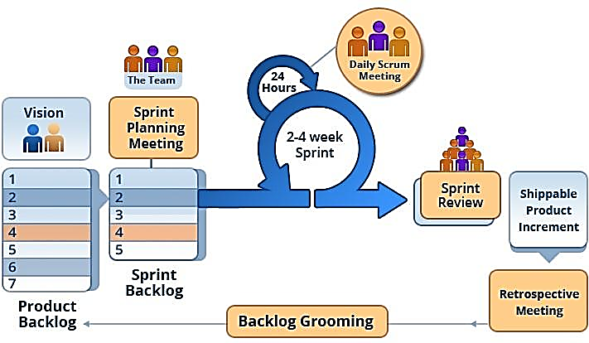

Figure 1. Scrum framework

1. **Roles and Responsibilities**

|  |  |  |  |
| --- | --- | --- | --- |
| **No.** | **Full name** | **Role in Group** | **Responsibilities** |
| 1. | Tôn thất bảo | Team Leader,  Vietnam,  Developer,  Project Manager | * Manage process * Plan Scrum implementations * Code * Task Delegation * Clarify requirements * Create Ui Function |
| 2. | Masdey | Team Leader  Brunei  Developer  Project Manager | * Specify user requirements * Control the development process * Support in technique and business logic. * Arrange Meeting with Client * Code |
| 3. | Nguyễn Trung Tín | Team member,  Developer  Documenter | * Design database * Code * Clarify requirements |
| 4. | Anas | Team member,  Developer  Documenter | * Design GUI * Code * Create test plan |
| 5. | Aidee Suherman | Team member,  Documenter  Tester | * Design database * Write document and report * Test |
| 6. | Aziah | Team member  Developer  Documenter |  |

Table 5. Roles and responsibilities details

To be confirm

### Tools and Techniques

|  |  |
| --- | --- |
| **Tool/Technique** | **Name/Version** |
| Front-end | HTML5, CSS3, Bootstrap, Javascript/jQuery |
| Back-end | C#, .NET Framework |
| Managing Database | Microsoft® SQL Server® 2014 Management Studio |
| Source Control | Sourcetree (server github.com) / Tortoise GIT |
| Modeling Tool | StarUML v2.8.1 |
| Web Browser | Google Chrome |

Table 6. Tools and techniques

## Project Management Plan

1. **Product Backlog**

|  |  |  |  |  |
| --- | --- | --- | --- | --- |
| **Story**  **ID** | **Features** | **Task**  **ID** | **Task description** | **Sprint** |
| 1 | Create Product Backlog | 1.1 | Create product backlog | 1 |
| 2 | Create Introduction document | 2.1 | Create introduction document | 1 |
| 2.2 | Review introduction document | 1 |
| 3 | Learning MVC, Entity Framework | 3.1 | Learning MVC, Entity Framework | 1 |
| 4 | Create UI mockups | 4.1 | Search for suitable UI | 2 |
| 4.2 | Login and register UI | 2 |
| 4.3 | Admin UI | 2 |
| 4.4 | Staff UI | 2 |
| 4.5 | Customer UI | 2 |
| 4.6 | Manager UI | 2 |
| 5 | Create Software Project Management Plan | 5.1 | Problem definition | 2 |
| 5.2 | Project organization | 2 |
| 5.3 | Project management plan | 2 |
| 5.4 | Coding convention | 2 |
| 6 | Create Software Requirement Specifications | 6.1 | User requirement specification | 3 |
| 6.2 | External interface requirement | 3 |
| 6.3 | Use case diagram | 2 |
| 6.4 | Software system attributes | 3 |
| 6.5 | Database diagram | 3 |
| 7 | Create Software Design Description | 7.1 | Design overview | 4, 5 |
| 7.2 | System architectural design | 4, 5 |
| 7.3 | Component diagram | 4, 5 |
| 7.4 | Detailed description of components | 4, 5 |
| 7.5 | Sequence diagram | 4, 5 |
| 7.6 | User interface design | 2 |
| 7.7 | Database design | 4 |
| 7.8 | Coding | 5 đến 11 |
| 8 | Create Software Test Documentation | 8.1 | Test Plan | 12 |
| 8.2 | Test Cases | 12 |
| 8.3 | Checklists | 12 |
| 9 | Software User’s Manual | 9.1 | Installation Guide | 13 |
| 9.2 | User’s Guide | 13 |

Table 7. Product backlog

1. **Deliverables**

|  |  |  |  |  |
| --- | --- | --- | --- | --- |
| **No** | **Deliverable** | **Delivery date** | **Delivery location** | **Note** |
| 1 | Introduction Document, Task list | 22/05/2018 | Supervisor’s office | Report No.1 |
| 2 | Software Project Management Plan | 29/5/2018 | Supervisor’s office | Report No.2 |
| 3 | Software Requirements Specification | 11/06/2018 | Supervisor’s office | Report No.3 |
| 4 | Software Design Description | 05/07/2018 | Supervisor’s office | Report No.4 |
| 5 | Software Test Documentation Guide Implementation (Coding) | 30/07/2018 | Supervisor’s office | Report No.5 |
| 6 | Software User’s Manual | 14/08/2018 | Supervisor’s office | Report No.6 |

Table 8. Deliverables

* For each sprint, deliverables are potentially shippable products, which can be a part of documents or runnable software application which is implementation of some program features.

* Each sprint is completed in 1 week.

## Coding Convention

* **Naming conventions:**
  + Use pascal case for class names and method names.
  + Use camel case for method arguments and local variables.
  + Do not use underscore in identifiers. Except: prefix private static variables with an underscore.
  + Use noun or noun phrases to name a class.
  + Prefix interfaces with letter ‘I’.
* **Layout conventions:**
  + Tabs must be set exactly 4 spaces.
  + Avoid lines longer than 80 characters.
  + Vertically align curly brackets.
  + Write only one statement per line.
  + Write only one declaration per line.
  + Add one blank line between method definitions and property definitions.
* **Declaration:**
  + Use implicit type ‘var’ for local variable declarations. Except: primitive types (int, string, double, etc.) use predefined names.
  + Organize namespaces with a clearly defined structure.
* **Commenting conventions:**
  + Place comment on a separate line.
  + Begin comment text with an uppercase letter and end with a period.
  + Add one space between comment delimiter (//) and comment text.

# C. Software Requirement Specification

**1. User Requirement Specification**

**1.1 Guest Requirement**

Any person who doesn’t have account can do search only in the system. This will be general information which is not confidential. How ever other function such as adding, editing or deleting will be disable or being greyed out below are the fuction that a guest could perform:

* Search Inventory
* Scan to Search Inventory

**1.2 Admin Requirement**

Admin is any inventory employee team which can perform the following functions:

* Manage user
* Manage user account

**1.3** **Inventory Department Requirement**

Main user and system owner which can perform all the system ability such as adding, editing , searching, view, print according to given role set by admin

* Manage inventory item
* Manage issued personnel
* Manage supplier detail
* Manage inventory status

**1.4 Manager Requirement**

Mostly able to perform view and search only function

* View inventory list
* View issued personnel
* View type least or linventory
* View Supplier

**1.6 System Requirement**

* Track Location of Inventory Issued

**2. System Requirement Specification**

**2.1 External Interface Requirement**

**2.1.1 User Interface**

* Mobile application to scan QR to locate item and issued to
  + 1. **Hardware Interface**:
* The system should be able to use QR or barcode scanner as additional plugin interface to scan

**2.1.3 Software Interface**

* The Web application: work with browsers Firefox (v52 or higher), Chromes (v28 or higher), Internet Explorer (v10 or above) or with any web browser that supports HTML5 & CSS3

**2.1.4 Communication Protocol**

* It uses HTTP protocol for communication between web browser and web server.
* It uses HTTP protocol for communication between window application and web server.

**2.2 System Overview Use Case**



Figure 2. System overview use case

2.3 List of Use Cases

* + - 1. Inventroy User Overview Use Cases



Figure 3. Inventory User overview use cases

* + - 1. <Inventory User> Login

**Use Case Diagram**



Figure 4. <Inventory User> Login

**Use Case Specification**

|  |  |  |  |
| --- | --- | --- | --- |
| **USE CASE – UC_MIS_01** | | | |
| **Use Case No.** | **01** | **Use Case Version** | 1.0 |
| **Use Case Name** | Login | | |
| **Author** | Anas | | |
| **Date** | 24/5/2018 | **Priority** | Normal |
| **Actor:** Inventory User  **Summary:** This use case allows Inventory User to login.  **Goal:** Inventory User can access their account.  **Triggers:**  Inventory User fills in their account information in login page and click on “Login” button.  **Preconditions:** Inventory User has an active account.  **Post Conditions:**  **Success:** Access to the system with specified roles.  **Fail:** Show error message.  **Main Success Scenario:**   |  |  |  | | --- | --- | --- | | Step | Actor Action | System Response | | 1 | Click on “Login” link in home page. | Navigate to login page with two input fields: “Username” and “Password”. | | 2 | Fill in login information and click on “Login” button. | [Exception]  Inventory User is logged in with specific roles.  Redirect to default page corresponding to user’s roles. |   **Alternative:** N/A  **Exceptions:**   |  |  |  | | --- | --- | --- | | No | Cause | System Response | | 1 | Missing required fields. | Show instruction message bellow missing fields. | | 2 | User does not exist. | Show not found message. | | 3 | User does not have authorization to access a specific page. | Show error message. | | 4 | Database occurs exception. | Show error message and ask user to try again later. |   **Relationships:**  N/A  **Business Rules:**  Validation:   * Require username and password. * Username does not contain special characters. * Password requires at least 6 characters.   User is redirected to specific default page corresponding to user’s roles after logging in. | | | |

Table 9. <Inventory User> Login

* + - 1. <Inventory User> Search Overview

**Use Case Diagram**



Figure 5. <Inventroy User> Search Overview

**Use Case Specification**

|  |  |  |  |
| --- | --- | --- | --- |
| **USE CASE – UC_MIS_02** | | | |
| **Use Case No.** | **02** | **Use Case Version** | 1.0 |
| **Use Case Name** | Search Overview | | |
| **Author** | Anas | | |
| **Date** | 24/5/2018 | **Priority** | Normal |
| **Actor:**  Inventory User  **Summary:**  This use case allows Inventory User to search item by three criteria.  **Goal:**  Inventory User can view result of item details according to criteria.  **Triggers:**  Input Search criteria and click on “Search” button.  **Preconditions:** N/A  **Post Conditions:**  **Success:** Displaya popup containing search item result of the inputted search criteria.  **Fail:** Show error message.  **Main Success Scenario:**   |  |  |  | | --- | --- | --- | | Step | Actor Action | System Response | | 1 | Access to home page and choose “Search” tab. | Display “Search Criteria” input field. | | 2 | Input search criteria and click on “Search” button. | Display Search Result in popup.  [Exception] |   **Alternative:** N/A  **Exceptions:**   |  |  |  | | --- | --- | --- | | No | Cause | System Response | | 1 | No Search Criteria is inputted. | Show warning message. | | 2 | Item doesn’t exist. | Show not found message. | | 3 | Database occurs exception. | Show error message and ask user to try again later. |   **Relationships:**  Generalized from Search use case.  **Business Rules:** Valid Search Criteria Result will be shown. | | | |

Table 10. <Inventory User> Search Overview

* + - 1. <Inventory User> Search by Personnel

**Use Case Diagram**



Figure 6. <Inventory User> Search by Personnel

**Use Case Specification**

|  |  |  |  |
| --- | --- | --- | --- |
| **USE CASE – UC_MIS_03** | | | |
| **Use Case No.** | **03** | **Use Case Version** | 1.0 |
| **Use Case Name** | Search by Personnel | | |
| **Author** |  | | |
| **Date** | 24/5/2018 | **Priority** | Normal |
| **Actor:**  Inventory User  **Summary:**  This use case allows Inventory User to search item group by personnel criteria.  **Goal:**  Inventory User can view search result that should contain Issued Personel containing Fullname, Designation, Identity Card No, Unit, Contact No, Email, Issued items: brand and model.  **Triggers:**  Input criteria in the search by personnel textboxt and click on “Search” button.  **Preconditions:** N/A  **Post Conditions:**  **Success:** Displayresult popup containing list according to the sequence in Goal group by Personnel  **Fail:** Show error message.  **Main Success Scenario:**   |  |  |  | | --- | --- | --- | | Step | Actor Action | System Response | | 1 | Access to home page and choose “Search by Personnel” tab. | Display “Please key in Personel Name or IC No” input field. | | 2 | Input name or IC number and click on “Search” button. | Display result of expected personel and details.  [Exception] |   **Alternative:** N/A  **Exceptions:**   |  |  |  | | --- | --- | --- | | No | Cause | System Response | | 1 | Search textbox is blank. | Show warning message. | | 2 | Search result doesn’t exist. | Show not found message. | | 3 | Database occurs exception. | Show error message and ask user to try again later. |   **Relationships:**  Generalized from Search use case.  **Business Rules:** Valid Search Criteria Result will be shown. | | | |

Table 11. Search by Personnel

* + - 1. <Inventory User> Search by Type

**Use Case Diagram**



Figure 6. <Inventory User> Search by Type

**Use Case Specification**

|  |  |  |  |
| --- | --- | --- | --- |
| **USE CASE – UC_MIS_04** | | | |
| **Use Case No.** | **04** | **Use Case Version** | 1.0 |
| **Use Case Name** | Search by Type | | |
| **Author** |  | | |
| **Date** | 24/5/2018 | **Priority** | Normal |
| **Actor:**  Inventory User  **Summary:**  This use case allows Inventory User to search item group by Type criteria.  **Goal:**  Inventory User can view search result that should contain Issued Personel containing Fullname, Designation, Identity Card No, Unit, Contact No, Email, Issued items: brand and model.  **Triggers:**  Select Type dropdown criteria in the search by Type input selection and click on “Search” button.  **Preconditions:** N/A  **Post Conditions:**  **Success:** Displayresult popup containing list according to the sequence in Goal group by Personnel  **Fail:** Show error message.  **Main Success Scenario:**   |  |  |  | | --- | --- | --- | | Step | Actor Action | System Response | | 1 | Access to home page and choose “Search by Personnel” tab. | Display “Please key in Personel Name or IC No” input field. | | 2 | Input name or IC number and click on “Search” button. | Display result of expected personel and details.  [Exception] |   **Alternative:** N/A  **Exceptions:**   |  |  |  | | --- | --- | --- | | No | Cause | System Response | | 1 | Search textbox is blank. | Show warning message. | | 2 | Search result doesn’t exist. | Show not found message. | | 3 | Database occurs exception. | Show error message and ask user to try again later. |   **Relationships:**  Generalized from Search use case.  **Business Rules:** Valid Search Criteria Result will be shown. | | | |

Table 11. Search by Type

* + - 1. <Inventroy User> Search by Location

**Use Case Diagram**



Figure 6. <Inventory User> Search by Location

**Use Case Specification**

|  |  |  |  |
| --- | --- | --- | --- |
| **USE CASE – UC_MIS_03** | | | |
| **Use Case No.** | **03** | **Use Case Version** | 1.0 |
| **Use Case Name** | Search by Personnel | | |
| **Author** |  | | |
| **Date** | 24/5/2018 | **Priority** | Normal |
| **Actor:**  Inventory User  **Summary:**  This use case allows Inventory User to search item group by personnel criteria.  **Goal:**  Inventory User can view search result that should contain Issued Personel containing Fullname, Designation, Identity Card No, Unit, Contact No, Email , issued items: brand and model.  **Triggers:**  Input criteria in the search by personnel textboxt and click on “Search” button.  **Preconditions:** N/A  **Post Conditions:**  **Success:** Displayresult popup containing list according to the sequence in Goal group by Personnel  **Fail:** Show error message.  **Main Success Scenario:**   |  |  |  | | --- | --- | --- | | Step | Actor Action | System Response | | 1 | Access to home page and choose “Search by Personnel” tab. | Display “Please key in Personel Name or IC No” input field. | | 2 | Input name or IC number and click on “Search” button. | Display result of expected personel and details.  [Exception] |   **Alternative:** N/A  **Exceptions:**   |  |  |  | | --- | --- | --- | | No | Cause | System Response | | 1 | Search textbox is blank. | Show warning message. | | 2 | Search result doesn’t exist. | Show not found message. | | 3 | Database occurs exception. | Show error message and ask user to try again later. |   **Relationships:**  Generalized from Search use case.  **Business Rules:** Valid Search Criteria Result will be shown. | | | |

Table 11. Search by Personnel

* + - 1. Authorized User Overview Use Cases

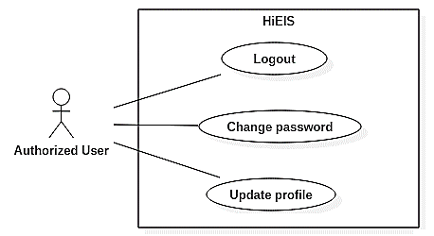

Figure 7. Authorized user overview use cases

* + - 1. <Authorized User> Logout

**Use Case Diagram**

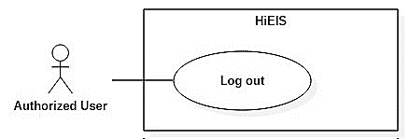

Figure 8. <Authorized User> Logout

**Use Case Specification**

|  |  |  |  |
| --- | --- | --- | --- |
| **USE CASE – UC_EIS_04** | | | |
| **Use Case No.** | **04** | **Use Case Version** | 1.0 |
| **Use Case Name** | Logout | | |
| **Author** | GiangHNM | | |
| **Date** | 24/5/2018 | **Priority** | Normal |
| **Actor:**  Authorized user  **Summary:**  This use case allows authorized user to log out from the system.  **Goal:**  Authorized user can exit their current account.  **Triggers:**  Click on “Đăng xuất” link.  **Preconditions:** User is logged in.  **Post Conditions:**  **Success:** User exits the cms and is returned to lookup page.  **Fail:** Show error message.  **Main Success Scenario:**   |  |  |  | | --- | --- | --- | | Step | Actor Action | System Response | | 1 | Click on “Đăng xuất” link on the top right of the screen. | Destroy user’s session and return to “Tra cứu thông tin” page.  [Exception] |   **Alternative:** N/A  **Exceptions:**   |  |  |  | | --- | --- | --- | | No | Cause | System Response | | 1 | Database occurs exception. | Show error message and ask user to try again later. |   **Relationships:**  N/A  **Business Rules:** N/A | | | |

Table 12. <Authorized User> Logout

* + - 1. <Authorized User> Change password

**Use Case Diagram**

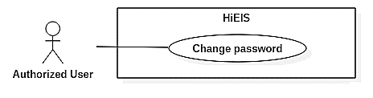

Figure 9. <Authorized User> Change password

**Use Case Specification**

|  |  |  |  |
| --- | --- | --- | --- |
| **USE CASE – UC_EIS_05** | | | |
| **Use Case No.** | **05** | **Use Case Version** | 1.0 |
| **Use Case Name** | Change password | | |
| **Author** | GiangHNM | | |
| **Date** | 24/5/2018 | **Priority** | Normal |
| **Actor:**  Authorized user  **Summary:**  This use case allows authorized user to change password.  **Goal:**  Password of currently logged in user is updated.  **Triggers:**  Click on “Thay đổi mật khẩu” link in dropdown list below user avatar.  **Preconditions:** User is logged in.  **Post Conditions:**  **Success:** Password of currently logged in user is updated.  **Fail:** Show error message.  **Main Success Scenario:**   |  |  |  | | --- | --- | --- | | Step | Actor Action | System Response | | 1 | Click on “Thay đổi mật khẩu” link in dropdown list below user avatar. | Navigate to change password page. | | 2 | Fill in required input fields and click on “Lưu” button. | [Exception]  Update user’s password. Show success message. |   **Alternative:** N/A  **Exceptions:**   |  |  |  | | --- | --- | --- | | No | Cause | System Response | | 1 | Required fields are missing or invalid. | Show instruction message bellow those input fields. | | 2 | Database occurs exception. | Show error message and ask user to try again later. |   **Relationships:**  N/A  **Business Rules:**  Validation:   * Password must contain at least 6 characters. * Confirm password field must be the same as new password field. | | | |

Table 13. <Authorized User> Change password

* + - 1. <Authorized User> Update profile

**Use Case Diagram**

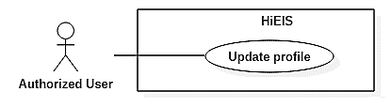

Figure 10. <Authorized User> Update profile

**Use Case Specification**

|  |  |  |  |
| --- | --- | --- | --- |
| **USE CASE – UC_EIS_06** | | | |
| **Use Case No.** | **06** | **Use Case Version** | 1.0 |
| **Use Case Name** | Update profile | | |
| **Author** | GiangHNM | | |
| **Date** | 24/5/2018 | **Priority** | Normal |
| **Actor:**  Authorized user  **Summary:**  This use case allows authorized user to update profile.  **Goal:**  User information is updated.  **Triggers:**  Click on “Tài khoản” link in dropdown list below user avatar.  **Preconditions:** User is logged in.  **Post Conditions:**  **Success:** User’s information is updated.  **Fail:** Show error message.  **Main Success Scenario:**   |  |  |  | | --- | --- | --- | | Step | Actor Action | System Response | | 1 | Click on “Tài khoản” link in dropdown list below user avatar. | Navigate to update profile page. | | 2 | Change information and click on “Lưu” button. | [Exception]  Update user’s information. Show success message. |   **Alternative:** N/A  **Exceptions:**   |  |  |  | | --- | --- | --- | | No | Cause | System Response | | 1 | Required fields are missing or fields are invalid. | Show instruction message bellow those input fields. | | 2 | Database occurs exception. | Show error message and ask user to try again later. |   **Relationships:**  N/A  **Business Rules:**  Input fields may be different depending on user’s roles. | | | |

Table 14. <Authorized User> Update profile

* + - 1. Admin Overview Use Cases

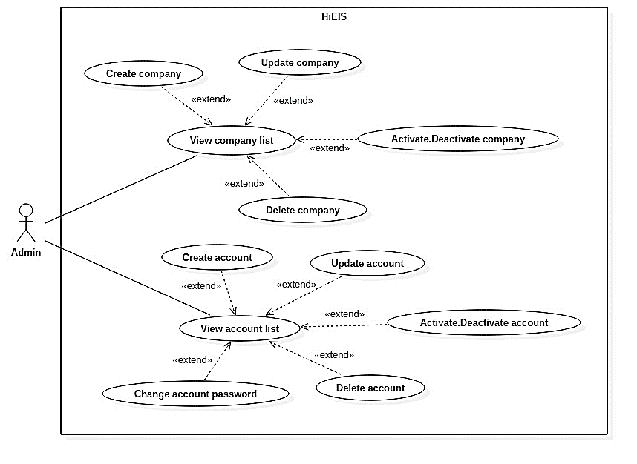

Figure 11. Admin overview use cases

* + - 1. <Admin> View company list

**Use Case Diagram**

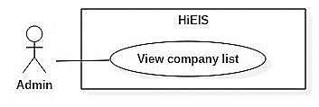

Figure 12. <Admin> View company list

**Use Case Specification**

|  |  |  |  |
| --- | --- | --- | --- |
| **USE CASE – UC_EIS_07** | | | |
| **Use Case No.** | **07** | **Use Case Version** | 1.0 |
| **Use Case Name** | View company list | | |
| **Author** | GiangHNM | | |
| **Date** | 24/5/2018 | **Priority** | Normal |
| **Actor:** Admin  **Summary:**  This use case allows user to view company list.  **Goal:**  User can see a list of companies.  **Triggers:**  Click on "Doanh nghiệp" menu.  **Preconditions:**  User is logged in as admin.  **Post Conditions:**  **Success:** Navigate to company list page.  **Fail:** Show error message.  **Main Success Scenario:**   |  |  |  | | --- | --- | --- | | Step | Actor Action | System Response | | 1 | Click on “Doanh nghiệp” menu on the left sidebar. | Navigate to company list page.  [Exception] |   **Alternative:** N/A  **Exceptions:**   |  |  |  | | --- | --- | --- | | No | Cause | System Response | | 1 | Database occurs exception. | Show error message and ask user to try again later. |   **Relationships:** N/A  **Business Rules:** N/A | | | |

Table 15. <Admin> View company list

* + - 1. <Admin> Create company

**Use Case Diagram**

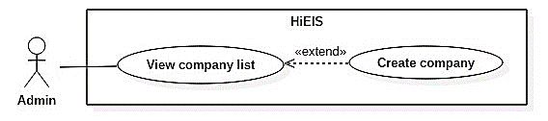

Figure 13. <Admin> Create company

**Use Case Specification**

|  |  |  |  |
| --- | --- | --- | --- |
| **USE CASE – UC_EIS_08** | | | |
| **Use Case No.** | **08** | **Use Case Version** | 1.0 |
| **Use Case Name** | Create company | | |
| **Author** | GiangHNM | | |
| **Date** | 24/5/2018 | **Priority** | Normal |
| **Actor:** Admin  **Summary:**  This use case allows admin to create new company.  **Goal:**  New company is added to database.  **Triggers:**  Click on "Tạo doanh nghiệp" button in company list page.  **Preconditions:**  User is logged in as admin.  **Post Conditions:**  **Success:** Company is added to database and a new row appears on company list page.  **Fail:** Show error message.  **Main Success Scenario:**   |  |  |  | | --- | --- | --- | | Step | Actor Action | System Response | | 1 | Click on “Tạo doanh nghiệp” button in company list page. | Navigate to create company page. | | 2 | Input company’s tax number and click on “Lấy mã số thuế” button. | Auto-fill name and address of that company into “Tên doanh nghiệp” and “Địa chỉ” field. | | 3 | Fill in other required input fields and click on “Lưu” button. | [Exception]  Create new company with inputted information.  Redirect to list page with a toast message “Đã tạo mới công ty”. |   **Alternative:** N/A  **Exceptions:**   |  |  |  | | --- | --- | --- | | No | Cause | System Response | | 1 | Required fields are missing or fields are invalid. | Show instruction message below those input fields. | | 2 | Database occurs exception. | Show error message and ask user to try again later. |   **Relationships:**  Extended from View Company List use case.  **Business Rules:**  Validation:   * Require tax number, company name, address, phone number, email. * Tax number must be valid. | | | |

Table 16. <Admin> Create company

* + - 1. <Admin> Update company

**Use Case Diagram**

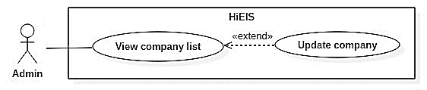

Figure 14. <Admin> Update company

**Use Case Specification**

|  |  |  |  |
| --- | --- | --- | --- |
| **USE CASE – UC_EIS_09** | | | |
| **Use Case No.** | **09** | **Use Case Version** | 1.0 |
| **Use Case Name** | Update company | | |
| **Author** | GiangHNM | | |
| **Date** | 24/5/2018 | **Priority** | Normal |
| **Actor:** Admin  **Summary:** This use case allows admin to edit company.  **Goal:**  Company information is updated.  **Triggers:**  Click on “Sửa” button (pencil icon) in the last column of a company row.  **Preconditions:**  User is logged in as admin.  The chosen company already exists in the system.  **Post Conditions:**  **Success:** New company information is updated.  **Fail:** Show error message.  **Main Success Scenario:**   |  |  |  | | --- | --- | --- | | Step | Actor Action | System Response | | 1 | Access to company list page and click on “Sửa” button (pencil icon) in the last column of a company row. | Navigate to update page with company information automatically filled in. | | 2 | Change information and click on “Lưu” button. | [Exception]  Update company.  Redirect to company list page with a toast message “Đã cập nhật công ty”. |   **Alternative:** N/A  **Exceptions:**   |  |  |  | | --- | --- | --- | | No | Cause | System Response | | 1 | Required fields are missing or fields are invalid. | Show instruction message below those input fields. | | 2 | Database occurs exception. | Show error message and ask user to try again later. |   **Relationships:**  Extended from View Company List use case.  **Business Rules:**  Validation:   * Require tax number, company name, address, phone number, email. * Tax number must be valid. | | | |

Table 17. <Admin> Update company

* + - 1. <Admin> Activate.Deactivate comany

**Use Case Diagram**

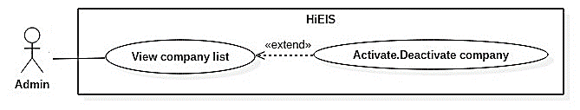

Figure 15. <Admin> Activate.Deactivate company

**Use Case Specification**

|  |  |  |  |
| --- | --- | --- | --- |
| **USE CASE –UC_EIS_10** | | | |
| **Use Case No.** | **10** | **Use Case Version** | 1.0 |
| **Use Case Name** | Activate.Deactivate company | | |
| **Author** | GiangHNM | | |
| **Date** | 24/5/2018 | **Priority** | Normal |
| **Actor:** Admin  **Summary:** This use case allows admin to activate/deactivate company.  **Goal:** Company and all accounts of that company are activated/deactivated.  **Triggers:** Click on “Khôi phục” / “Khóa” button.  **Preconditions:**  User is logged in as admin.  The chosen company already exists in the system.  **Post Conditions:**  **Success:** Company status changes to toggle-on icon or toggle-off icon.  **Fail:** Show error message.  **Main Success Scenario:**   |  |  |  | | --- | --- | --- | | Step | Actor Action | System Response | | 1 | Access company list page and click on “Khóa” / “Khôi phục” button (toggle icon) in the last column of a company row. | [Exception] Activate/deactivate the chosen company. Its status icon is changed to toggle-off/toggle-on. |   **Alternative:** N/A  **Exceptions:**   |  |  |  | | --- | --- | --- | | No | Cause | System Response | | 1 | Database occurs exception. | Show error message and ask user to try again later. |   **Relationships:**  Extended from View Company List use case.  **Business Rules:**  All accounts of the chosen company are also activated/deactivated. | | | |

Table 18. <Admin> Activate.Deactivate company

* + - 1. <Admin> Delete company

**Use Case Diagram**

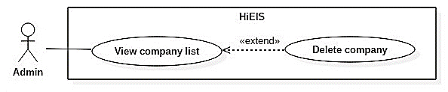

Figure 16. <Admin> Delete company

**Use Case Specification**

|  |  |  |  |
| --- | --- | --- | --- |
| **USE CASE – UC_EIS_11** | | | |
| **Use Case No.** | 11 | **Use Case Version** | 1.0 |
| **Use Case Name** | Delete company | | |
| **Author** | GiangHNM | | |
| **Date** | 24/5/2018 | **Priority** | Normal |
| **Actor:**  Admin  **Summary:**  This use case allows admin to delete a company.  **Goal:**  The chosen company is removed.  **Triggers:**  Click on "Xóa" button (trash icon) in the last column of a company row.  **Preconditions:**  User is logged in as admin.  The chosen company already exists in the system.  **Post Conditions:**  **Success:**  The chosen company is deleted and company list is reloaded.  **Fail:**  Show error message.  **Main Success Scenario:**   |  |  |  | | --- | --- | --- | | Step | Actor Action | System Response | | 1 | Click on “Xóa” button (trash icon) in the last colum of a company row. | Show a popup for comfirmation. | | 2 | Choose “Có” to confirm. | [Exception]  Delete the chosen company. Company list is reloaded. |   **Alternative:** N/A  **Exceptions:**   |  |  |  | | --- | --- | --- | | No | Cause | System Response | | 1 | The chosen company has foreign key constraint(s) in database. | Show error message. | | 2 | Database occurs exception. | Show error message and ask user to try again later. |   **Relationships:**  Extended from View Company List use case.  **Business Rules:** N/A | | | |

Table 19. <Admin> Delete company

* + - 1. <Admin> View account list

**Use Case Diagram**

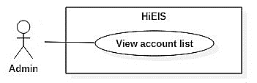

Figure 17. <Admin> View account list

**Use Case Specification**

|  |  |  |  |
| --- | --- | --- | --- |
| **USE CASE – UC_EIS_12** | | | |
| **Use Case No.** | 12 | **Use Case Version** | 1.0 |
| **Use Case Name** | View account list | | |
| **Author** | AnhDT | | |
| **Date** | 24/5/2018 | **Priority** | Normal |
| **Actor:**  Admin  **Summary:**  This use case allows user to view account list.  **Goal:**  User can view list of accounts.  **Triggers:**  Click on a submenu from “Tài khoản” menu.  **Preconditions:**  User is logged in as admin.  **Post Conditions:**  **Success:**  Navigate to account list page.  **Fail:**  Show error message.  **Main Success Scenario:**   |  |  |  | | --- | --- | --- | | Step | Actor Action | System Response | | 1 | Click on a submenu from “Tài khoản” menu on the left sidebar. | Navigate to account list page.  [Exception] |   **Alternative:** N/A  **Exceptions:**   |  |  |  | | --- | --- | --- | | No | Cause | System Response | | 1 | Database occurs exception. | Show error message and ask user to try again later. |   **Relationships:**  N/A  **Business Rules:**  There are 3 types of listing accounts: admin accounts, company’s staff accounts, customer accounts. Each has some different display settings.   * Admin account list page: display username, email, phone number. * Company’s staff account list page: display name, username, company name, address, email, role(s). * Customer list page: display name, username, enterprise/address, email, tax no, phone number/fax, bank/bank account number. | | | |

Table 20. <Admin> View account list

* + - 1. <Admin> Create account

**Use Case Diagram**

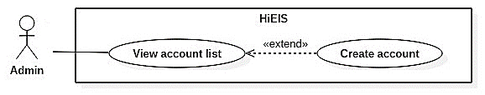

Figure 18. <Admin> Create account

**Use Case Specification**

|  |  |  |  |
| --- | --- | --- | --- |
| **USE CASE – UC_EIS_13** | | | |
| **Use Case No.** | 13 | **Use Case Version** | 1.0 |
| **Use Case Name** | Create account | | |
| **Author** | AnhDT | | |
| **Date** | 24/5/2018 | **Priority** | Normal |
| **Actor:**  Admin  **Summary:**  This use case allows admin to create new account.  **Goal:**  Admin can create new account for user. Account information is stored in database.  **Triggers:**  Click on "Tạo tài khoản" button in account list page.  **Preconditions:**  User is logged in as admin.  **Post Conditions:**  **Success:** Account is added to database and a new row appears on account list.  **Fail:** Show error message.  **Main Success Scenario:**   |  |  |  | | --- | --- | --- | | Step | Actor Action | System Response | | 1 | Click on “Tạo tài khoản” button in account list page. | Navigate to create account page. | | 2 | Fill in required information and click on “Lưu” button. | [Exception]  Create new account with inputted information.  Redirect to list page with a toast message “Đã tạo mới tài khoản”. |   **Alternative:** N/A  **Exceptions:**   |  |  |  | | --- | --- | --- | | No | Cause | System Response | | 1 | Required fields are missing or fields are invalid. | Show instruction message below those input fields. | | 2 | Account already exists. | Show warning message below account name input field. | | 3 | Database occurs exception. | Show error message and ask user to try again later. |   **Relationships:**  Extended from View Account List use case.  **Business Rules:**  General validation:   * Require email, username, password, confirm password fields. * Username does not contain special characters. * Username and password must be between 6 and 100 characters. * Password and Confirm password must be the same.   There are 3 types of creating an account: create admin account, company account, customer account. Each has some different input fields and validation.   * Create admin account. * Create company account: require company, name, email. At least one role must be selected. * Create customer account: require name, address. | | | |

Table 21. <Admin> Create account

* + - 1. <Admin> Update account

**Use Case Diagram**

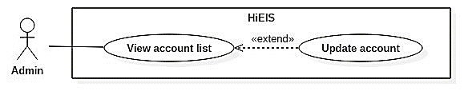

Figure 19. <Admin> Update account

**Use Case Specification**

|  |  |  |  |
| --- | --- | --- | --- |
| **USE CASE – UC_EIS_14** | | | |
| **Use Case No.** | **14** | **Use Case Version** | 1.0 |
| **Use Case Name** | Update account | | |
| **Author** | AnhDT | | |
| **Date** | 24/5/2018 | **Priority** | Normal |
| **Actor:**  Admin  **Summary:**  This use case allows admin to edit account.  **Goal:**  Account information is updated.  **Triggers:**  Click on "Sửa" button (pencil icon) in the last column of an account row.  **Preconditions:**  User is logged in as admin.  The chosen account already exists in the system.  **Post Conditions:**  **Success:** New information of user account is updated.  **Fail:** Show error message.  **Main Success Scenario:**   |  |  |  | | --- | --- | --- | | Step | Actor Action | System Response | | 1 | Access account list page and click on “Sửa” button (pencil icon) in the last column of an account row. | Redirect to update page with account information automatically filled in. | | 2 | Change information and click on “Lưu” button. | Update account.  Redirect to account list page with a toast message “Đã cập nhật tài khoản”. |   **Alternative:** N/A  **Exceptions:**   |  |  |  | | --- | --- | --- | | No | Cause | System Response | | 1 | Required fields are missing or fields are invalid. | Show instruction message below those input fields. | | 2 | Database occurs exception. | Show error message and ask user to try again later. |   **Relationships:**  Extended from View Account List use case.  **Business Rules:**  There are 3 types of updating an account: update admin account, company account, customer account. Each has some different input fields and validation.   * Update admin account: require email. * Update company account: require company, name, email. At least one role must be selected. * Update customer account: require name, address. | | | |

Table 22. <Admin> Update account

* + - 1. <Admin> Activate.Deactivate account

**Use Case Diagram**

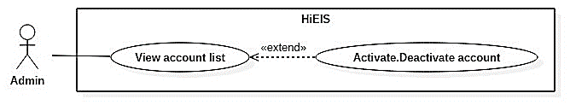

Figure 20. <Admin> Activate.Deactivate account

**Use Case Specification**

|  |  |  |  |
| --- | --- | --- | --- |
| **USE CASE – UC_EIS_15** | | | |
| **Use Case No.** | **15** | **Use Case Version** | 1.0 |
| **Use Case Name** | Activate.Deactivate Account | | |
| **Author** | AnhDT | | |
| **Date** | 24/5/2018 | **Priority** | Normal |
| **Actor:**  Admin  **Summary:**  This use case allows admin to activate/deactivate an account.  **Goal:**  Account is activated/deactivated.  **Triggers:**  Click on “Khôi phục” / “Khóa” button.  **Preconditions:**  User is logged in as admin.  The chosen account already exists in the system.  **Post Conditions:**  **Success:** Account status changes to toggle-on icon or toggle-off icon.  **Fail:** Show error message.  **Main Success Scenario:**   |  |  |  | | --- | --- | --- | | Step | Actor Action | System Response | | 1 | Access account list page and click on “Khóa” / “Khôi phục” button (toggle icon) in the last column of an account row. | Activate/deactivate the chosen account. Its status icon is changed to toggle-off/toggle-on.  [Exception] |   **Alternative:** N/A  **Exceptions:**   |  |  |  | | --- | --- | --- | | No | Cause | System Response | | 1 | Database occurs exception. | Show error message and ask user to try again later. |   **Relationships:**  Extended from View Account List use case.  **Business Rules:**  If an employee account is deactivated, his/her company will decide by themselves how to hand over the remaining work to another employee (account). | | | |

Table 23. <Admin> Activate.Deactivate account

* + - 1. <Admin> Change account password

**Use Case Diagram**

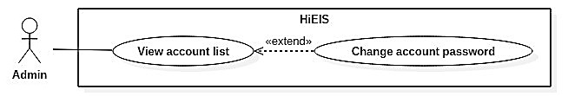

Figure 21. <Admin> Change account password

**Use Case Specification**

|  |  |  |  |
| --- | --- | --- | --- |
| **USE CASE – UC_EIS_16** | | | |
| **Use Case No.** | **16** | **Use Case Version** | 1.0 |
| **Use Case Name** | Change account password | | |
| **Author** | AnhDT | | |
| **Date** | 24/05/2018 | **Priority** | Normal |
| **Actor:**  Admin  **Summary:**  This use case allows admin to change password of an account.  **Goal:**  New password of the chosen account is updated.  **Triggers:**  Click on "Thay đổi mật khẩu" button (lock icon) in the last column of an account row.  **Preconditions:**  User is logged in as admin.  The chosen account exists in the system.  **Post Conditions:**  **Success:** Account password is updated.  **Fail:** Show error message.  **Main Success Scenario:**   |  |  |  | | --- | --- | --- | | Step | Actor Action | System Response | | 1 | Click on “Thay đổi mật khẩu” button (lock icon) in the last colum of an account row. | Navigate to change password page. | | 2 | Fill in new password and confirm password.  Click on “Lưu” button. | [Exception]  Update new password.  Redirect to account list page with a toast message “Đã thay đổi mật khẩu”. |   **Alternative:** N/A  **Exceptions:**   |  |  |  | | --- | --- | --- | | No | Cause | System Response | | 1 | Required fields are missing or fields are invalid. | Show instruction message below those input fields. | | 2 | Database occurs exception. | Show error message and ask user to try again later. |   **Relationships:** Extended from View Account List use case.  **Business Rules:**  Validation:   * Require new password and confirm password fields. * New password and confirm password fields must be the same. | | | |

Table 24. <Admin> Change account password

* + - 1. <Admin> Delete account

**Use Case Diagram**

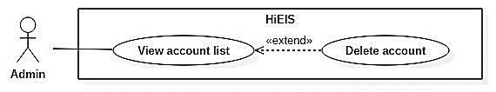

Figure 22. <Admin> Delete account

**Use Case Specification**

|  |  |  |  |
| --- | --- | --- | --- |
| **USE CASE – UC_EIS_17** | | | |
| **Use Case No.** | **17** | **Use Case Version** | 1.0 |
| **Use Case Name** | Delete account | | |
| **Author** | AnhDT | | |
| **Date** | 24/05/2018 | **Priority** | Normal |
| **Actor:** Admin  **Summary:** This use case allows admin to delete an account.  **Goal:**  The chosen account is removed.  **Triggers:**  Click on "Xóa" button (trash icon) in the last column of an account row.  **Preconditions:**  User is logged in as admin.  The chosen account already exists in the system.  **Post Conditions:**  **Success:** Account is deleted and account list is reloaded.  **Fail:** Show error message.  **Main Success Scenario:**   |  |  |  | | --- | --- | --- | | Step | Actor Action | System Response | | 1 | Click on “Xóa” button (trash icon) in the last colum of an account row. | Show a popup for confirmation. | | 2 | Choose “Có” to confirm. | [Exception]  Delete the chosen account. Account list is reloaded. |   **Alternative:** N/A  **Exceptions:**   |  |  |  | | --- | --- | --- | | No | Cause | System Response | | 1 | The chosen account has foreign key constraint(s) in database. | Show error message. | | 2 | Database occurs exception. | Show error message and ask user to try again later. |   **Relationships:** Extended from View Account List use case.  **Business Rules:**  Cannot delete currently logged in admin.  If an employee account is deleted, his/her company will decide by themselves how to hand over the remaining work to another employee (account). | | | |

Table 25. <Admin> Delete account

* + - 1. Manager Overview Use Cases

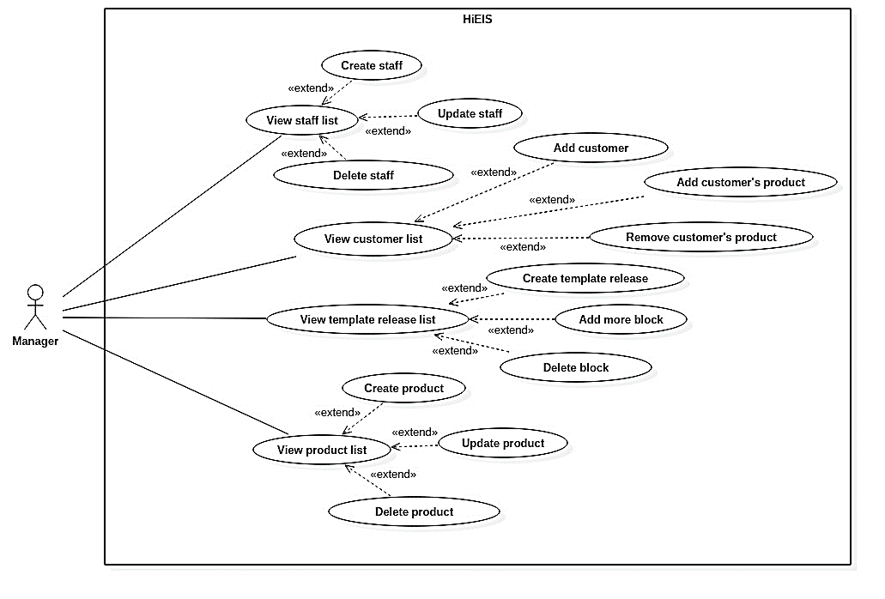

Figure 23. Manager overview use cases

* + - 1. <Manager> View staff list

**Use Case Diagram**

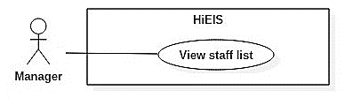

Figure 24. <Manager> View staff list

**Use Case Specification**

|  |  |  |  |
| --- | --- | --- | --- |
| **USE CASE – UC_EIS_18** | | | |
| **Use Case No.** | 18 | **Use Case Version** | 1.0 |
| **Use Case Name** | View staff list | | |
| **Author** | GiangHNM | | |
| **Date** | 03/06/2018 | **Priority** | Normal |
| **Actor:** Manager  **Summary:**  This use case allows user to view staff list.  **Goal:**  User can see a list of company’s staffs.  **Triggers:**  Click on “Nhân viên” menu.  **Preconditions:**  User is logged in as company’s manager.  **Post Conditions:**  **Success:** Staff is created and a new row is added to staff list.  **Fail:** Show error message.  **Main Success Scenario:**   |  |  |  | | --- | --- | --- | | Step | Actor Action | System Response | | 1 | Click on “Nhân viên” menu on the left sidebar. | Navigate to staff list page.  [Exception] |   **Alternative:** N/A  **Exceptions:**   |  |  |  | | --- | --- | --- | | No | Cause | System Response | | 1 | Required fields are missing or fields are invalid. | Show instruction message below those input fields. | | 2 | Staff account name already exists. | Show warning message below account name input field. | | 3 | Database occurs exception. | Show error message and ask user to try again later. |   **Relationships:** N/A  **Business Rules:** N/A | | | |

Table 26. <Manager> View staff list

* + - 1. <Manager> Create staff

**Use Case Diagram**

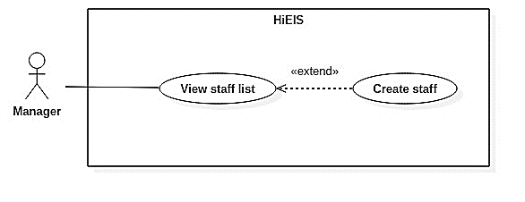

Figure 25. <Manager> Create staff

**Use Case Specification**

|  |  |  |  |
| --- | --- | --- | --- |
| **USE CASE – UC_EIS_19** | | | |
| **Use Case No.** | 19 | **Use Case Version** | 1.0 |
| **Use Case Name** | Create staff | | |
| **Author** | GiangHNM | | |
| **Date** | 03/06/2018 | **Priority** | Normal |
| **Actor:**  Manager  **Summary:**  This use case allows manager to create new staff.  **Goal:**  New staff account is added to database. Company’s accountants can use this account to manipulate some functions of the system corresponding to specific roles.  **Triggers:**  Click on “Tạo nhân viên” button in staff list page.  **Preconditions:**  User is logged in as company’s manager.  **Post Conditions:**  **Success:** Staff is created and a new row is added to staff list.  **Fail:** Show error message.  **Main Success Scenario:**   |  |  |  | | --- | --- | --- | | Step | Actor Action | System Response | | 1 | Click on “Tạo nhân viên” button in staff list page. | Navigate to create staff page. | | 2 | Fill in required information and click on “Lưu” button. | [Exception]  Create new staff account with inputted information.  Redirect to list page with a toast message “Đã tạo mới nhân viên”. |   **Alternative:** N/A  **Exceptions:**   |  |  |  | | --- | --- | --- | | No | Cause | System Response | | 1 | Required fields are missing or fields are invalid. | Show instruction message below those input fields. | | 2 | Staff account name already exists. | Show warning message below account name input field. | | 3 | Database occurs exception. | Show error message and ask user to try again later. |   **Relationships:** Extended from View Staff List use case.  **Business Rules:**  Validation:   * Require email, username, password, confirm password, name, email, roles fields. * Username does not contain special characters. * Username and password must be between 6 and 100 characters. * Password and confirm password fields must be the same. * Selecting multiple roles is allowed. | | | |

Table 27. <Manager> Create staff

* + - 1. <Manager> Update staff

**Use Case Diagram**

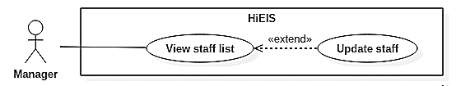

Figure 26. <Manager> Update staff

**Use Case Specification**

|  |  |  |  |
| --- | --- | --- | --- |
| **USE CASE – UC_EIS_20** | | | |
| **Use Case No.** | 20 | **Use Case Version** | 1.0 |
| **Use Case Name** | Update staff | | |
| **Author** | GiangHNM | | |
| **Date** | 03/06/2018 | **Priority** | Normal |
| **Actor:**  Manager  **Summary:**  This use case allows manager to update a staff’s information.  **Goal:**  Staff account information is updated.  **Triggers:**  Click on “Sửa” button (pencil icon) in the last column of a staff row.  **Preconditions:**  User is logged in as company’s manager.  The chosen staff already exists in the system.  **Post Conditions:**  **Success:** Staff’s information is updated.  **Fail:** Show error message.  **Main Success Scenario:**   |  |  |  | | --- | --- | --- | | Step | Actor Action | System Response | | 1 | Access staff list page and click on “Sửa” button (pencil icon) in the last column of a staff row. | Redirect to update page with staff information automatically filled in. | | 2 | Change information and click on “Lưu” button. | Update staff.  Redirect to staff list page with a toast message “Đã cập nhật nhân viên”. |   **Alternative:** N/A  **Exceptions:**   |  |  |  | | --- | --- | --- | | No | Cause | System Response | | 1 | Required fields are missing or fields are invalid. | Show instruction message below those input fields. | | 2 | Database occurs exception. | Show error message and ask user to try again later. |   **Relationships:** Extended from View Staff List use case.  **Business Rules:**  Validation:   * Require name and email fields. * Selecting multiple roles is allowed. * Cannot change role of manager. | | | |

Table 28. <Manager> Update staff

* + - 1. <Manager> Delete staff

**Use Case Diagram**

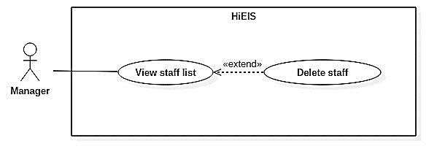

Figure 27. <Manager> Delete staff

**Use Case Specification**

|  |  |  |  |
| --- | --- | --- | --- |
| **USE CASE – UC_EIS_21** | | | |
| **Use Case No.** | 21 | **Use Case Version** | 1.0 |
| **Use Case Name** | Delete staff | | |
| **Author** | GiangHNM | | |
| **Date** | 03/06/2018 | **Priority** | Normal |
| **Actor:**  Manager  **Summary:**  This use case allows manager to delete staff.  **Goal:**  Staff account is deactivated in database.  **Triggers:**  Click on "Xóa" button (trash icon) in the last column of a staff row.  **Preconditions:**  User is logged in as company’s manager.  **Post Conditions:**  **Success:** Staff is deleted and staff list is reloaded.  **Fail:** Show error message.  **Main Success Scenario:**   |  |  |  | | --- | --- | --- | | Step | Actor Action | System Response | | 1 | Click on “Xóa” button (trash icon) in the last colum of a staff row. | Show a popup for confirmation. | | 2 | Choose “Có” to confirm. | Delete the chosen staff account. Staff list is reloaded.  [Exception] |   **Alternative:** N/A  **Exceptions:**   |  |  |  | | --- | --- | --- | | No | Cause | System Response | | 1 | Database occurs exception. | Show error message and ask user to try again later. |   **Relationships:** Extended from View Staff List use case.  **Business Rules:**  If an employee account is deleted, his/her company will decide by themselves how to hand over the remaining work to another employee (account). | | | |

Table 29. <Manager> Delete staff

* + - 1. <Manager> View customer list

**Use Case Diagram**

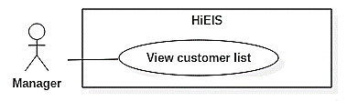

Figure 28. <Manager> View customer list

**Use Case Specification**

|  |  |  |  |
| --- | --- | --- | --- |
| **USE CASE – UC_EIS_22** | | | |
| **Use Case No.** | 22 | **Use Case Version** | 1.0 |
| **Use Case Name** | View customer list | | |
| **Author** | AnhDT | | |
| **Date** | 03/06/2018 | **Priority** | Normal |
| **Actor:** Manager  **Summary:** This use case allows user to view customer list.  **Goal:** User can see a list of company’s customers.  **Triggers:** Click on “Khách hàng” menu.  **Preconditions:**  User is logged in as company’s manager.  **Post Conditions:**  **Success:** Navigate to customer list page.  **Fail:** Show error message.  **Main Success Scenario:**   |  |  |  | | --- | --- | --- | | Step | Actor Action | System Response | | 1 | Click on “Khách hàng” menu on the left sidebar. | Navigate to customer list page.  [Exception] |   **Alternative:** N/A  **Exceptions:**   |  |  |  | | --- | --- | --- | | No | Cause | System Response | | 1 | Database occurs exception. | Show error message and ask user to try again later. |   **Relationships:** N/A  **Business Rules:** N/A | | | |

Table 30. <Manager> View customer list

* + - 1. <Manager> Add customer

**Use Case Diagram**

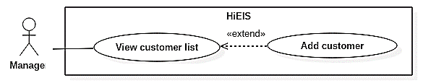

Figure 29. <Manager> Add customer

**Use Case Specification**

|  |  |  |  |
| --- | --- | --- | --- |
| **USE CASE – UC_EIS_23** | | | |
| **Use Case No.** | 23 | **Use Case Version** | 1.0 |
| **Use Case Name** | Add customer | | |
| **Author** | AnhDT | | |
| **Date** | 03/06/2018 | **Priority** | Normal |
| **Actor:**  Manager  **Summary:**  This use case allows manager to add new customer.  **Goal:**  New customer is added to company’s customer list.  **Triggers:**  Click on “Thêm khách hàng” button in company’s customer list page.  **Preconditions:**  User is logged in as company’s manager.  **Post Conditions:**  **Success:** New customer is added to customer list.  **Fail:** Show error message.  **Main Success Scenario:**   |  |  |  | | --- | --- | --- | | Step | Actor Action | System Response | | 1 | Click on “Thêm khách hàng” button in customer list page. | Navigate to search customer page. | | 2 | Input customer’s information and click on “Tìm” button. | Show a list of matching results. | | 3 | Choose “Thêm” button (plus icon) in the last column of an account row. | Show popup for confirmation. | | 4 | Choose “Có” to confirm. | Add customer to company’s customer list.  Remove the chosen row from search result list. Show success message.  [Exception] |   **Alternative:** N/A  **Exceptions:**   |  |  |  | | --- | --- | --- | | No | Cause | System Response | | 1 | Database occurs exception. | Show error message and ask user to try again later. |   **Relationships:** Extended from View Customer List use case.  **Business Rules:** N/A | | | |

Table 31. <Manager> Add customer

* + - 1. <Manager> Add customer’s product

**Use Case Diagram**

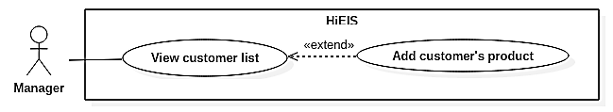

Figure 30. <Manager> Add customer’s product

**Use Case Specification**

|  |  |  |  |
| --- | --- | --- | --- |
| **USE CASE – UC_EIS_24** | | | |
| **Use Case No.** | 24 | **Use Case Version** | 1.0 |
| **Use Case Name** | Add customer’s product | | |
| **Author** | AnhDT | | |
| **Date** | 03/06/2018 | **Priority** | Normal |
| **Actor:**  Manager  **Summary:**  This use case allows manager to add products for a customer.  **Goal:**  Product is added to customer’s product list. Accountants can create proforma invoice monthly for customer who has products.  **Triggers:**  Click on “Chi tiết sản phẩm” button in the last column of a customer row, choose a product and click on “Thêm” button.  **Preconditions:**  User is logged in as company’s manager.  **Post Conditions:**  **Success:** New product is added to customer’s product list.  **Fail:** Show error message.  **Main Success Scenario:**   |  |  |  | | --- | --- | --- | | Step | Actor Action | System Response | | 1 | Click on “Chi tiết sản phẩm” (info icon) in the last column of a customer row. | Show popup of customer’s product list and a product input form below. | | 2 | Select a product from product dropdown list.  Change quantity (optional) and click on “Thêm” button. | [Exception]  Show success message. New product is added to customer’s product list. |   **Alternative:** N/A  **Exceptions:**   |  |  |  | | --- | --- | --- | | No | Cause | System Response | | 1 | Quantity field is empty or invalid. | Show instruction message below quantity input field. | | 2 | Database occurs exception. | Show error message and ask user to try again later. |   **Relationships:** Extended from View Customer List use case.  **Business Rules:**  Validation:   * Quantity must be a number greater than 0.   If user chooses a product that already exists in customer’s product list, system will update quantity of the existing one instead of adding a new row. | | | |

Table 32. <Manager> Add customer’s product

* + - 1. <Manager> Remove customer’s product

**Use Case Diagram**

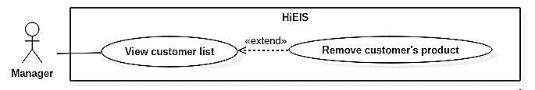

Figure 31. <Manager> Remove customer’s product

**Use Case Specification**

|  |  |  |  |
| --- | --- | --- | --- |
| **USE CASE – UC_EIS_25** | | | |
| **Use Case No.** | 25 | **Use Case Version** | 1.0 |
| **Use Case Name** | Remove customer’s product | | |
| **Author** | AnhDT | | |
| **Date** | 03/06/2018 | **Priority** | Normal |
| **Actor:** Manager  **Summary:**  This use case allows manager to remove a product from customer’s product list.  **Goal:**  Product is removed from customer’s product list. When creating new proforma invoice for that customer, the removed product will not be displayed.  **Triggers:**  Click on “Chi tiết sản phẩm” button in the last column of a customer row and choose “Xóa” button in a product row.  **Preconditions:**  User is logged in as company’s manager.  **Post Conditions:**  **Success:** The chosen product is removed from customer’s product list.  **Fail:** Show error message.  **Main Success Scenario:**   |  |  |  | | --- | --- | --- | | Step | Actor Action | System Response | | 1 | Click on “Chi tiết sản phẩm” (info icon) in the last column of a customer row. | Show popup of customer’s product list. | | 2 | Click on “Xóa” button (trash icon) in the last column of a product row. | Remove the chosen product. Product list is reloaded.  Show success message.  [Exception] |   **Alternative:** N/A  **Exceptions:**   |  |  |  | | --- | --- | --- | | No | Cause | System Response | | 1 | Database occurs exception. | Show error message and ask user to try again later. |   **Relationships:** Extended from View Customer List use case.  **Business Rules:** N/A | | | |

Table 33. <Manager> Remove customer’s product

* + - 1. <Manager> View template release list

**Use Case Diagram**

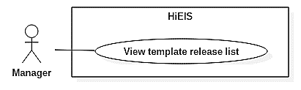

Figure 32. <Manager> View template release list

**Use Case Specification**

|  |  |  |  |
| --- | --- | --- | --- |
| **USE CASE – UC_EIS_26** | | | |
| **Use Case No.** | 26 | **Use Case Version** | 1.0 |
| **Use Case Name** | View template release list | | |
| **Author** | AnhDT | | |
| **Date** | 03/06/2018 | **Priority** | Normal |
| **Actor:** Manager  **Summary:** This use case allows user to view template release list page.  **Goal:** User can see a list of company’s template releases.  **Triggers:**  Click on “Mẫu hóa đơn” menu.  **Preconditions:**  User is logged in as company’s manager.  **Post Conditions:**  **Success:** Navigate to template release list page.  **Fail:** Show error message.  **Main Success Scenario:**   |  |  |  | | --- | --- | --- | | Step | Actor Action | System Response | | 1 | Click on “Mẫu hóa đơn” menu on the left sidebar. | Navigate to template release list page.  [Exception] |   **Alternative:** N/A  **Exceptions:**   |  |  |  | | --- | --- | --- | | No | Cause | System Response | | 1 | Database occurs exception. | Show error message and ask user to try again later. |   **Relationships:** N/A  **Business Rules:** N/A | | | |

Table 34. <Manager> View template release list

* + - 1. <Manager> Create template release

**Use Case Diagram**

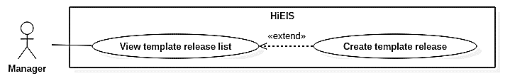

Figure 33. <Manager> Create template release

**Use Case Specification**

|  |  |  |  |
| --- | --- | --- | --- |
| **USE CASE – UC_EIS_27** | | | |
| **Use Case No.** | 27 | **Use Case Version** | 1.0 |
| **Use Case Name** | Create template release | | |
| **Author** | AnhDT | | |
| **Date** | 03/06/2018 | **Priority** | Normal |
| **Actor:**  Manager  **Summary:**  This use case allows user to create new invoice template.  **Goal:**  User can create new template release for invoices.  **Triggers:**  Click on “Thêm mẫu hóa đơn” button in template list page.  **Preconditions:**  User is logged in as company’s manager.  **Post Conditions:**  **Success:** New template is added to database and a new row appears on template list.  **Fail:** Show error message.  **Main Success Scenario:**   |  |  |  | | --- | --- | --- | | Step | Actor Action | System Response | | 1 | Click on “Thêm mẫu hóa đơn” button in template list page. | Navigate to create template page. | | 2 | Fill in required information and click on “Lưu” button. | [Exception]  Create new template with inputted information.  Redirect to list page with a toast message “Đã tạo mới mẫu hóa đơn”. |   **Alternative:** N/A  **Exceptions:**   |  |  |  | | --- | --- | --- | | No | Cause | System Response | | 1 | Required fields are missing or fields are invalid. | Show instruction message below those input fields. | | 2 | Database occurs exception. | Show error message and ask user to try again later. |   **Relationships:** Extended from View Template Release List use case.  **Business Rules:**  Validation:   * Require form, serial, quantity, start number, start date, invoice template (pdf file), release announcement (pdf file) fields. * Start date is not in the past. | | | |

Table 35. <Manager> Create template release

* + - 1. <Manager> Delete block

**Use Case Diagram**

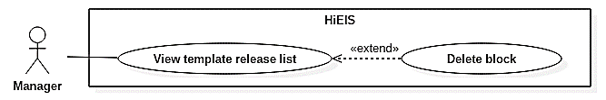

Figure 34. <Manager> Delete block

**Use Case Specification**

|  |  |  |  |
| --- | --- | --- | --- |
| **USE CASE – UC_EIS_28** | | | |
| **Use Case No.** | 28 | **Use Case Version** | 1.0 |
| **Use Case Name** | Delete block | | |
| **Author** | AnhDT | | |
| **Date** | 03/06/2018 | **Priority** | Normal |
| **Actor:**  Manager  **Summary:**  This use case allow user to delete a template block.  **Goal:**  Template block is removed.  **Triggers:**  Click on "Xóa" button (trash icon) in the last column of a block row.  **Preconditions:**  User is logged in as company’s manager.  **Post Conditions:**  **Success:** Template block is deleted and template list is reloaded.  **Fail:** Show error message.  **Main Success Scenario:**   |  |  |  | | --- | --- | --- | | Step | Actor Action | System Response | | 1 | Click on “Xóa” button (trash icon) in the last colum of a template block row. | Show a popup for confirmation. | | 2 | Choose “Có” to confirm. | Delete the chosen template block. Template block list is reloaded.  [Exception] |   **Alternative:** N/A  **Exceptions:**   |  |  |  | | --- | --- | --- | | No | Cause | System Response | | 1 | Database occurs exception. | Show error message and ask user to try again later. |   **Relationships:** Extended from View Template Release List use case.  **Business Rules:** N/A | | | |

Table 36. <Manager> Delete block

* + - 1. <Manager> Add more block

**Use Case Diagram**

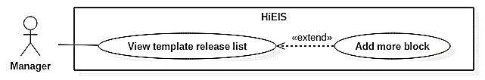

Figure 35. <Manager> Add more block

**Use Case Specification**

|  |  |  |  |
| --- | --- | --- | --- |
| **USE CASE – UC_EIS_29** | | | |
| **Use Case No.** | 29 | **Use Case Version** | 1.0 |
| **Use Case Name** | Add more block | | |
| **Author** | AnhDT | | |
| **Date** | 03/06/2018 | **Priority** | Normal |
| **Actor:**  Manager  **Summary:**  This use case allows manager to add a new block for a template release.  **Goal:**  User can add more block with the same information as the chosen template release.  **Triggers:**  Click on “Chi tiết mẫu hóa đơn” button, fill in new block information and click on “Lưu” button.  **Preconditions:**  User is logged in as company’s manager.  **Post Conditions:**  **Success:** New block is added to template release block list.  **Fail:** Show error message.  **Main Success Scenario:**   |  |  |  | | --- | --- | --- | | Step | Actor Action | System Response | | 1 | Click on “Chi tiết mẫu hóa đơn” (info icon) in the last column of a template row. | Show popup of template block list and a block input form below. | | 2 | Fill in required information and click on “Lưu” button. | [Exception]  Show success message. New block row is added to template block list. |   **Alternative:** N/A  **Exceptions:**   |  |  |  | | --- | --- | --- | | No | Cause | System Response | | 1 | Required fields are missing or fields are invalid. | Show instruction message below those input fields. | | 2 | Database occurs exception. | Show error message and ask user to try again later. |   **Relationships:** Extended from View Template Release List use case.  **Business Rules:**  Validation:   * Require quantity, start date and release announcement (pdf file) fields. * Quantity must be a number greater than 0. * Start date is not in the past.   New blocks are not available to use until the current block runs out of numbers. | | | |

Table 37. <Manager> Add more block

* + - 1. <Manager> View product list

**Use Case Diagram**

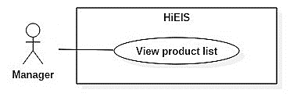

Figure 36. <Manager> View product list

**Use Case Specification**

|  |  |  |  |
| --- | --- | --- | --- |
| **USE CASE – UC_EIS_30** | | | |
| **Use Case No.** | 30 | **Use Case Version** | 1.0 |
| **Use Case Name** | View product list | | |
| **Author** | GiangHNM | | |
| **Date** | 03/06/2018 | **Priority** | Normal |
| **Actor:** Manager  **Summary:** This use case allows manager to view product list.  **Goal:** Manager can see a list of company’s products.  **Triggers:** Click on “Sản phẩm” menu.  **Preconditions:**  User is logged in as company’s manager.  **Post Conditions:**  **Success:** Navigate to product list page.  **Fail:** Show error message.  **Main Success Scenario:**   |  |  |  | | --- | --- | --- | | Step | Actor Action | System Response | | 1 | Click on “Sản phẩm” menu on the left sidebar. | Navigate to product list page.  [Exception] |   **Alternative:** N/A  **Exceptions:**   |  |  |  | | --- | --- | --- | | No | Cause | System Response | | 1 | Database occurs exception. | Show error message and ask user to try again later. |   **Relationships:** N/A  **Business Rules:** N/A | | | |

Table 38. <Manager> View product list

* + - 1. <Manager> Create product

**Use Case Diagram**

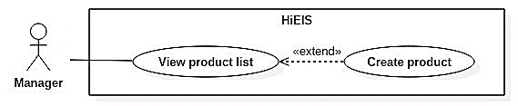

Figure 37. <Manager> Create product

**Use Case Specification**

|  |  |  |  |
| --- | --- | --- | --- |
| **USE CASE – UC_EIS_31** | | | |
| **Use Case No.** | 31 | **Use Case Version** | 1.0 |
| **Use Case Name** | Create product | | |
| **Author** | GiangHNM | | |
| **Date** | 03/06/2018 | **Priority** | Normal |
| **Actor:**  Manager  **Summary:**  This use case allows manager to create new product.  **Goal:**  New product is added to database.  **Triggers:**  Click on “Tạo sản phẩm” button in product list page.  **Preconditions:**  User is logged in as company’s manager.  **Post Conditions:**  **Success:** New product is added to database and a new row appears on product list.  **Fail:** Show error message.  **Main Success Scenario:**   |  |  |  | | --- | --- | --- | | Step | Actor Action | System Response | | 1 | Click on “Tạo sản phẩm” button in product list page. | Navigate to create product page. | | 2 | Fill in required information and click on “Lưu” button. | [Exception]  Create new product with inputted information.  Redirect to list page with a toast message “Đã tạo mới sản phẩm”. |   **Alternative:** N/A  **Exceptions:**   |  |  |  | | --- | --- | --- | | No | Cause | System Response | | 1 | Required fields are missing or fields are invalid. | Show instruction message below those input fields. | | 2 | Database occurs exception. | Show error message and ask user to try again later. |   **Relationships:** Extended from View Product List use case.  **Business Rules:**  Validation:   * Require product name, unit price, VAT rate fields. * Unit price must be a number greater than 0. | | | |

Table 39. <Manager> Create product

* + - 1. <Manager> Update product

**Use Case Diagram**

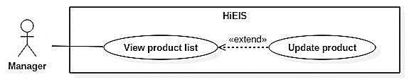

Figure 38. <Manager> Update product

**Use Case Specification**

|  |  |  |  |
| --- | --- | --- | --- |
| **USE CASE – UC_EIS_32** | | | |
| **Use Case No.** | 32 | **Use Case Version** | 1.0 |
| **Use Case Name** | Update product | | |
| **Author** | GiangHNM | | |
| **Date** | 03/06/2018 | **Priority** | Normal |
| **Actor:**  Manager  **Summary:**  This use case allows manager to edit product.  **Goal:**  Product information is updated.  **Triggers:**  Click on “Sửa” button (pencil icon) in the last column of a product row.  **Preconditions:**  User is logged in as company’s manager.  **Post Conditions:**  **Success:** New product information is updated.  **Fail:** Show error message.  **Main Success Scenario:**   |  |  |  | | --- | --- | --- | | Step | Actor Action | System Response | | 1 | Click on “Sửa” button (pencil icon) in the last column of a product row. | Redirect to update page with product information automatically filled in. | | 2 | Change information and click on “Lưu” button. | [Exception]  Update product.  Redirect to product list page with a toast message “Đã cập nhật sản phẩm”. |   **Alternative:** N/A  **Exceptions:**   |  |  |  | | --- | --- | --- | | No | Cause | System Response | | 1 | Required fields are missing or fields are invalid. | Show instruction message below those input fields. | | 2 | Database occurs exception. | Show error message and ask user to try again later. |   **Relationships:** Extended from View Product List use case.  **Business Rules:**  Validation:   * Require product name, unit price, VAT rate fields. * Unit price must be a number greater than 0. | | | |

Table 40. <Manager> Update product

* + - 1. <Manager> Delete product

**Use Case Diagram**

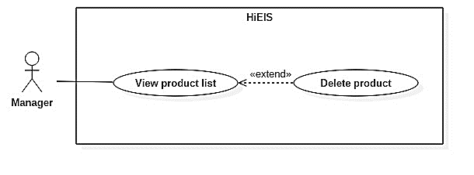

Figure 39. <Manager> Delete product

**Use Case Specification**

|  |  |  |  |
| --- | --- | --- | --- |
| **USE CASE – UC_EIS_33** | | | |
| **Use Case No.** | 33 | **Use Case Version** | 1.0 |
| **Use Case Name** | Delete product | | |
| **Author** | GiangHNM | | |
| **Date** | 03/06/2018 | **Priority** | Normal |
| **Actor:**  Manager  **Summary:**  This use case allows manager to delete product.  **Goal:**  Product is deactivated in database.  **Triggers:**  Click on "Xóa" button (trash icon) in the last column of a product row.  **Preconditions:**  User is logged in as company’s manager.  **Post Conditions:**  **Success:** Product is deleted and product list is reloaded.  **Fail:** Show error message.  **Main Success Scenario:**   |  |  |  | | --- | --- | --- | | Step | Actor Action | System Response | | 1 | Click on “Xóa” button (trash icon) in the last colum of a product row. | Show a popup for confirmation. | | 2 | Choose “Có” to confirm. | Delete the chosen product. Product list is reloaded.  [Exception] |   **Alternative:** N/A  **Exceptions:**   |  |  |  | | --- | --- | --- | | No | Cause | System Response | | 1 | Database occurs exception. | Show error message and ask user to try again later. |   **Relationships:** Extended from View Product List use case.  **Business Rules:** N/A | | | |

Table 41. <Manager> Delete product

* + - 1. Liability Accountant Overview Use Cases

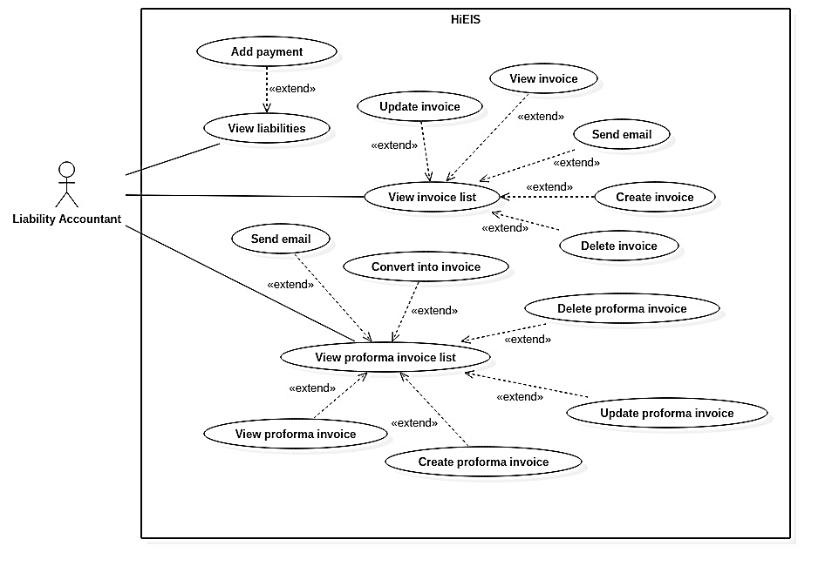

Figure 40. Liability accountant overview use cases

* + - 1. <Liability Accountant, Payable Accountant, Accounting Manager, Customer> View invoice list

**Use Case Diagram**

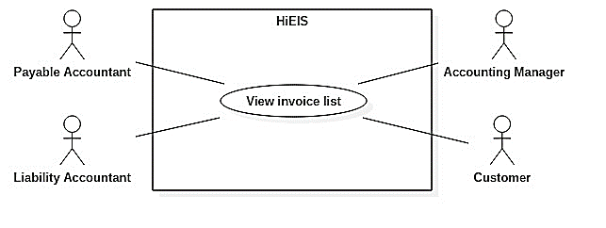

Figure 41. <Liability Accountant, Payable Accountant, Accounting Manager, Customer> View invoice list

**Use Case Specification**

|  |  |  |  |
| --- | --- | --- | --- |
| **USE CASE – UC_EIS_34** | | | |
| **Use Case No.** | 34 | **Use Case Version** | 1.0 |
| **Use Case Name** | View invoice list | | |
| **Author** | GiangHNM | | |
| **Date** | 03/06/2018 | **Priority** | Normal |
| **Actor:**  Liability accountant, payable accountant, accounting manager, customer  **Summary:**  This use case allows users to view invoice list.  **Goal:**  Users can see a list of invoices.  **Triggers:**  Click on “Hóa đơn” menu.  **Preconditions:**  User is logged in as one of company’s accountant roles or customer.  **Post Conditions:**  **Success:** Navigate to invoice list page.  **Fail:** Show error message.  **Main Success Scenario:**   |  |  |  | | --- | --- | --- | | Step | Actor Action | System Response | | 1 | Click on “Hóa đơn” menu on the left sidebar. | Navigate to invoice list page.  [Exception] |   **Alternative:** N/A  **Exceptions:**   |  |  |  | | --- | --- | --- | | No | Cause | System Response | | 1 | Database occurs exception. | Show error message and ask user to try again later. |   **Relationships:** N/A  **Business Rules:**  If user is logged in as one of company’s accountant roles, display a list of customers’ invoices belonging to that company.  If user is logged in as customer, display invoices belonging to that customer. | | | |

Table 42. <Liability Accountant, Payable Accountant, Accounting Manager, Customer> View invoice list

* + - 1. <Liability Accountant, Payable Accountant> Create invoice

**Use Case Diagram**

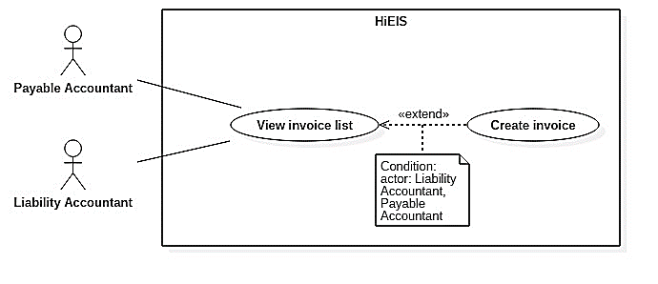

Figure 42. <Liability Accountant, Payable Accountant> Create invoice

**Use Case Specification**

|  |  |  |  |
| --- | --- | --- | --- |
| **USE CASE – UC_EIS_35** | | | |
| **Use Case No.** | 35 | **Use Case Version** | 1.0 |
| **Use Case Name** | Create invoice | | |
| **Author** | GiangHNM | | |
| **Date** | 04/06/2017 | **Priority** | High |
| **Actor:** Liability accountant, payable accountant  **Summary:** This use case allows the user to create new invoice.  **Goal:** Invoice is added to database.  **Triggers:** Click on “Tạo hóa đơn” button in invoice list page.  **Preconditions:**  User is logged in as liability accountant or payable accountant.  **Post Conditions:**  **Success:** New invoice is added to database and a new row appears on invoice list.  **Fail:** Show error message.  **Main Success Scenario:**   |  |  |  | | --- | --- | --- | | Step | Actor Action | System Response | | 1 | Click on “Tạo hóa đơn” button in invoice list page. | Navigate to create invoice page. | | 2 | Fill in customer’s address.  or [Alternative 1]  or [Alternative 2]  Fill in other input fields (optional). |  | | 3 | Click on “Thêm sản phẩm” button. | [Exception 1]  Show product popup. | | 4 | Select a product from product dropdown list. Change unit price and quantity (optional) and click on “Lưu” button. | [Exception 2]  Add new row with information of the chosen product to invoice item table.  Calculate sub total, VAT amount and total. | | 4 | [Alternative 3]  or [Alternative 4]  Select an option from VAT rate dropdown list (optional). | Re-calculate sub total, VAT amount and total. | | 5 | Click on “Lưu” button. | [Exception 3]  [Exception 5]  Save invoice to database.  Redirect to list page with a toast message “Đã tạo hóa đơn”. |   **Alternative:**  [Alternative 1]   |  |  |  | | --- | --- | --- | | Step | Actor Action | System Response | | 1 | Fill in “Mã số thuế” input field and click on “Lấy thông tin” button. | Find information from Department of Taxation API and then auto-fill the information into “Tên đơn vị and “Địa chỉ” input fields.  [Exception 4] |   [Alternative 2]   |  |  |  | | --- | --- | --- | | Step | Actor Action | System Response | | 1 | Fill in “Tên đơn vị” input field. | Search from company’s customer list by enterprise field.  Return results in form of a dropdown list. | | 2 | Select an option from suggestion dropdown list. | Auto-fill customer’s information into other fields. |   [Alternative 3]   |  |  |  | | --- | --- | --- | | Step | Actor Action | System Response | | 1 | Click on “Sửa” button (pencil icon) in the last column of an item row. | Show popup with information of the chosen product already filled in. | | 2 | Change quantity, unit price and click on “Lưu” button. | [Exception 2]  Close popup. Reload invoice item table.  Re-calculate sub total, VAT amount and total. |   [Alternative 4]   |  |  |  | | --- | --- | --- | | Step | Actor Action | System Response | | 1 | Click on “Xóa” button (trash icon) in the last column of an item row. | Show a popup for confirmation. | | 2 | Choose “Có” to confirm. | Remove the chosen row from invoice item table.  Re-calculate sub total, VAT amount and total. |   **Exceptions:**   |  |  |  | | --- | --- | --- | | No | Cause | System Response | | 1 | Address is empty. | Show warning message and request to fill in address field. | | 2 | Quantity or unit price is empty or invalid. | Show instruction message below those input fields. | | 3 | No product is selected. | Show warning message and request to choose at least one product. | | 4 | Tax number does not exist. | Show error message. | | 5 | Database occurs exception. | Show error message and ask user to try again later. |   **Relationships:**  Extended from View Invoice List use case.  **Business Rules:**  Validation:   * Require address field. * Due date (optional) is not in the past. * Unit price, quantity must be valid number greater than 0. * Cannot select a product that already exists in the item list.   Only liability accountant or payable accountant can create invoice. | | | |

Table 43. <Liability Accountant, Payable Accountant> Create invoice

* + - 1. <Liability Accountant, Payable Accountant> Update invoice

Usecase Diagram

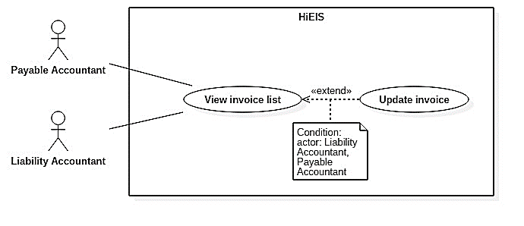

Figure 43. <Liability Accountant, Payable Accountant> Update invoice

**Use Case Specification**

|  |  |  |  |
| --- | --- | --- | --- |
| **USE CASE – UC_EIS_36** | | | |
| **Use Case No.** | 36 | **Use Case Version** | 1.0 |
| **Use Case Name** | Update invoice | | |
| **Author** | GiangHNM | | |
| **Date** | 04/06/2017 | **Priority** | High |
| **Actor:** Liability accountant, payable accountant  **Summary:** This use case allows actors to edit an invoice.  **Goal:** Invoice information is updated.  **Triggers:** Click on “Sửa” button (pencil icon) in the last column of an invoice row.  **Preconditions:** User is logged in as liability accountant or payable accountant.  **Post Conditions:**  **Success:** Invoice information is updated.  **Fail:** Show error message.  **Main Success Scenario:**   |  |  |  | | --- | --- | --- | | Step | Actor Action | System Response | | 1 | Click on “Sửa” button (pencil icon) in the last column of an invoice row. | Redirect to update page with invoice information automatically filled in.  . | | 2 | Change receiver’s information.  or [Alternative 1]  or [Alternative 2]  or [Alternative 3]  or [Alternative 4] | Re-calculate sub total, VAT amount and total. | | 3 | Click on “Lưu” button. | [Exception 3]  [Exception 5]  Update invoice.  Redirect to list page with a toast message “Đã cập nhật hóa đơn”. |   **Alternative:** [Alternative 1]   |  |  |  | | --- | --- | --- | | Step | Actor Action | System Response | | 1 | Click on “Thêm sản phẩm” button. | [Exception 1]  Show product popup. | | 2 | Select a product from product dropdown list. Change unit price and quantity (optional) and click on “Lưu” button. | [Exception 2]  Add new row with information of the chosen product to invoice item table.  Re-calculate sub total, VAT amount and total. |   [Alternative 2]   |  |  |  | | --- | --- | --- | | Step | Actor Action | System Response | | 1 | Click on “Sửa” button (pencil icon) in the last column of a product row. | Show popup with information of the chosen product already filled in. | | 2 | Change quantity, unit price and click on “Lưu” button. | [Exception 2]  Close popup. Reload invoice item table.  Re-calculate sub total, VAT amount and total. |   [Alternative 3]   |  |  |  | | --- | --- | --- | | Step | Actor Action | System Response | | 1 | Click on “Xóa” button (trash icon) in the last column of an invoice item row. | Show a popup for confirmation. | | 2 | Choose “Có” to confirm. | Remove the chosen row from invoice item table.  Re-calculate sub total, VAT amount and total. |   [Alternative 4]   |  |  |  | | --- | --- | --- | | Step | Actor Action | System Response | | 1 | Select an option from VAT rate dropdown list (optional). | Re-calculate sub total, VAT amount and total. |   **Exceptions:**   |  |  |  | | --- | --- | --- | | No | Cause | System Response | | 1 | Address is empty. | Show warning message and request to fill in address field. | | 2 | Quantity or unit price is empty or invalid. | Show instruction message below those input fields. | | 3 | No product is selected. | Show warning message and request to choose at least one product. | | 4 | Tax number does not exist. | Show error message. | | 5 | Database occurs exception. | Show error message and ask user to try again later. |   **Relationships:**  Extended from View Invoice List use case.  **Business Rules:** Validation:   * Require address field. * Due date (optional) is not in the past. * Unit price, quantity must be valid number greater than 0. * Cannot select a product that already exists in the item list.   Only liability accountant or payable accountant can update invoice. | | | |

Table 44. <Liability Accountant, Payable Accountant> Update invoice

* + - 1. <Liability Accountant, Payable Accountant, Accounting Manager, Customer> View invoice

Usecase Diagram

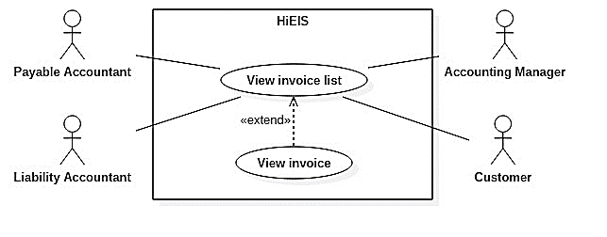

Figure 44. <Liability Accountant, Payable Accountant, Accounting Manager, Customer> View invoice

**Use Case Specification**

|  |  |  |  |
| --- | --- | --- | --- |
| **USE CASE – UC_EIS_37** | | | |
| **Use Case No.** | **37** | **Use Case Version** | 1.0 |
| **Use Case Name** | View invoice | | |
| **Author** | GiangHNM | | |
| **Date** | 02/06/2018 | **Priority** | Normal |
| **Actor:**  Liability accountant, payable accountant, accounting manager, customer  **Summary:**  This use case allows user to view invoice.  **Goal:**  User can view invoice details in form of pdf file.  **Triggers:**  Click on lookup code of an invoice, which contains a link to open a popup.  **Preconditions:**  User is logged in as one of company’s accountant roles or customer.  **Post Conditions:**  **Success:** Show popup containing invoice pdf.  **Fail:** Show error message.  **Main Success Scenario:**   |  |  |  | | --- | --- | --- | | Step | Actor Action | System Response | | 1 | Click on lookup code of an invoice row in invoice list page. | Show a popup containing pdf of the chosen invoice.  [Exception] |   **Alternative:** N/A  **Exceptions:**   |  |  |  | | --- | --- | --- | | No | Cause | System Response | | 1 | Database occurs exception. | Show error message and ask user to try again later. |   **Relationships:**  Extended from View Invoice List use case.  **Business Rules:** N/A | | | |

Table 45. <Liability Accountant, Payable Accountant, Accounting Manager, Customer> View invoice

* + - 1. <Liability Accountant, Payable Accountant> Delete invoice

Usecase Diagram

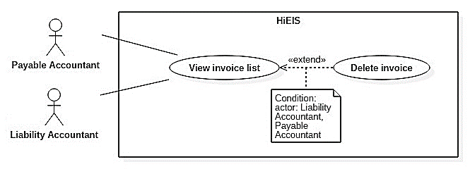

Figure 45. <Liability Accountant, Payable Accountant> Delete invoice

Use Case Specification

|  |  |  |  |
| --- | --- | --- | --- |
| **USE CASE – UC_EIS_38** | | | |
| **Use Case No.** | **38** | **Use Case Version** | 1.0 |
| **Use Case Name** | Delete invoice | | |
| **Author** | GiangHNM | | |
| **Date** | 04/06/2018 | **Priority** | Normal |
| **Actor:**  Liability accountant, payable accountant  **Summary:**  This use case allows user to delete invoice.  **Goal:**  Invoice is removed.  **Triggers:**  Click on “Xóa” button (trash icon) in the last column of a new invoice row.  **Preconditions:**  User is logged in as liablitiy accountant or payable accountant.  Invoice status is “Mới tạo”.  **Post Conditions:**  **Success:** The chosen invoice is deleted and invoice list is reloaded.  **Fail:** Show error message.  **Main Success Scenario:**   |  |  |  | | --- | --- | --- | | Step | Actor Action | System Response | | 1 | Click on “Xóa” button (trash icon) in the last colum of an invoice row. | Show a popup for comfirmation. | | 2 | Choose “Có” to confirm. | [Exception]  Delete the chosen invoice. Invoice list is reloaded. |   **Alternative:** N/A  **Exceptions:**   |  |  |  | | --- | --- | --- | | No | Cause | System Response | | 1 | Database occurs exception. | Show error message and ask user to try again later. |   **Relationships:**  Extended from View Invoice List use case.  **Business Rules:**  Only invoice with “Mới tạo” status can be deleted.  Only liability accountant or payable accountant can delete invoice. | | | |

Table 46. <Liability Accountant, Payable Accountant> Delete invoice

* + - 1. <Liability Accountant, Payable Accountant> Send email

Usecase Diagram

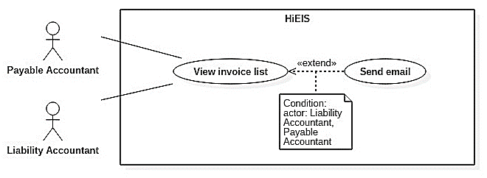

Figure 46. <Liability Accountant, Payable Accountant> Send email

Use Case Specification

|  |  |  |  |
| --- | --- | --- | --- |
| **USE CASE – UC_EIS_39** | | | |
| **Use Case No.** | **39** | **Use Case Version** | 1.0 |
| **Use Case Name** | Send email | | |
| **Author** | GiangHNM | | |
| **Date** | 04/06/2018 | **Priority** | Normal |
| **Actor:**  Liability accountant, payable accountant  **Summary:**  This use case allows user to send email about invoice to customer.  **Goal:**  Email notification containing invoice lookup code is sent to customer.  **Triggers:**  Click on “Gửi email” button (send icon) in the last column of an invoice row.  **Preconditions:**  User is logged in as liablitiy accountant or payable accountant.  **Post Conditions:**  **Success:** Email is sent to customer.  **Fail:** Show error message.  **Main Success Scenario:**   |  |  |  | | --- | --- | --- | | Step | Actor Action | System Response | | 1 | Click on “Gửi email” button (send icon) in the last colum of an invoice row. | Show a popup with customer’s email already filled in. | | 2 | Change to another email address (optional).  Click on “Gửi” button. | [Exception]  Send email to the inputted address. |   **Alternative:** N/A  **Exceptions:**   |  |  |  | | --- | --- | --- | | No | Cause | System Response | | 1 | Email field is empty. | Show warning message. | | 2 | Database occurs exception. | Show error message and ask user to try again later. |   **Relationships:**  Extended from View Invoice List use case.  **Business Rules:**  Email contains information of the company, invoice form, serial, lookup code.  User can send invoice that hasn’t been approved yet, but this invoice has no use value.  Only liability accountant or payable accountant can send email. | | | |

Table 47. <Liability Accountant, Payable Accountant> Send email

* + - 1. <Liability Accountant, Payable Accountant, Accounting Manager, Customer> View proforma invoice list

**Use Case Diagram**

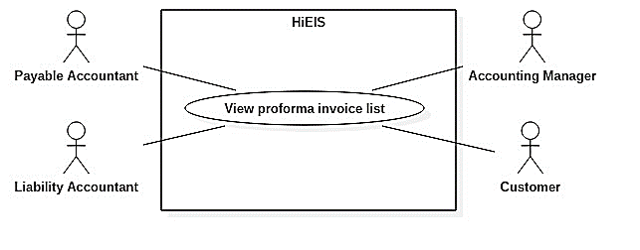

Figure 47. <Liability Accountant, Payable Accountant, Accounting Manager, Customer> View proforma invoice list

**Use Case Specification**

|  |  |  |  |
| --- | --- | --- | --- |
| **USE CASE – UC_EIS_40** | | | |
| **Use Case No.** | 40 | **Use Case Version** | 1.0 |
| **Use Case Name** | View proforma invoice list | | |
| **Author** | AnhDT | | |
| **Date** | 03/06/2018 | **Priority** | Normal |
| **Actor:**  Liability accountant, payable accountant, accounting manager, customer  **Summary:**  This use case allows users to view proforma invoice list.  **Goal:**  Users can see a list of proforma invoices.  **Triggers:**  Click on “Thông báo phí” menu.  **Preconditions:**  User is logged in as one of company’s accountant roles or customer.  **Post Conditions:**  **Success:** Navigate to proforma invoice list page.  **Fail:** Show error message.  **Main Success Scenario:**   |  |  |  | | --- | --- | --- | | Step | Actor Action | System Response | | 1 | Click on “Thông báo phí” menu on the left sidebar. | Navigate to proforma invoice list page.  [Exception] |   **Alternative:** N/A  **Exceptions:**   |  |  |  | | --- | --- | --- | | No | Cause | System Response | | 1 | Database occurs exception. | Show error message and ask user to try again later. |   **Relationships:** N/A  **Business Rules:**  If user is logged in as one of company’s accountant roles, display a list of customers’ proforma invoices belonging to that company.  If user is logged in as customer, display proforma invoices belonging to that customer. | | | |

Table 48. <Liability Accountant, Payable Accountant, Accounting Manager, Customer> View proforma invoice list

* + - 1. <Liability Accountant> Create proforma invoice

**Use Case Diagram**

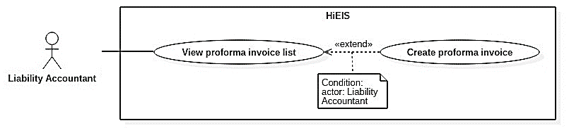

Figure 48. <Liability Accountant> Create proforma invoice

**Use Case Specification**

|  |  |  |  |
| --- | --- | --- | --- |
| **USE CASE – UC_EIS_41** | | | |
| **Use Case No.** | 41 | **Use Case Version** | 1.0 |
| **Use Case Name** | Create proforma invoice | | |
| **Author** | AnhDT | | |
| **Date** | 04/06/2017 | **Priority** | High |
| **Actor:** Liability accountant  **Summary:** This use case allows user to create new proforma invoice.  **Goal:** Proforma invoice is added to database.  **Triggers:** Click on “Tạo thông báo phí” button in proforma invoice list page.  **Preconditions:** User is logged in as liability accountant.  **Post Conditions:**  **Success:** New proforma invoice is added to database and a new row appears on proforma invoice list.  **Fail:** Show error message.  **Main Success Scenario:**   |  |  |  | | --- | --- | --- | | Step | Actor Action | System Response | | 1 | Click on “Tạo thông báo phí” button in proforma invoice list page. | Navigate to create proforma invoice page. | | 2 | Fill in “Tên đơn vị” input field. | Search from company’s customer list by enterprise field.  Return results in form of a dropdown list. | | 3 | Select an option from suggestion dropdown list. | Auto-fill customer’s information into other fields. | | 4 | Select due date from datepicker. |  | | 5 | Click on “Thêm sản phẩm” button. | [Exception 1]  Show product popup. | | 6 | Select a product from product dropdown list.  Fill in required information.  Change unit price and quantity (optional).  Click on “Lưu” button. | [Exception 2]  Add new row with information of the chosen product to proforma invoice item table.  Calculate sub total, VAT amount and total (sub total + VAT amount + liabilities). | | 7 | [Alternative 1]  or [Alternative 2] | Re-calculate sub total, VAT amount and total. | | 8 | Click on “Lưu” button. | [Exception 3]  [Exception 4]  Save proforma invoice to database.  Redirect to list page with a toast message “Đã tạo thông báo phí”. |   **Alternative:**  [Alternative 1]   |  |  |  | | --- | --- | --- | | Step | Actor Action | System Response | | 1 | Click on “Sửa” button (pencil icon) in the last column of an item row. | Show popup with information of the chosen product already filled in. | | 2 | Change information and click on “Lưu” button. | [Exception 2]  Close popup. Reload proforma invoice item table.  Re-calculate sub total, VAT amount and total. |   [Alternative 2]   |  |  |  | | --- | --- | --- | | Step | Actor Action | System Response | | 1 | Click on “Xóa” button (trash icon) in the last column of an item row. | Show a popup for confirmation. | | 2 | Choose “Có” to confirm. | Remove the chosen row from proforma invoice item table.  Re-calculate sub total, VAT amount and total. |   **Exceptions:**   |  |  |  | | --- | --- | --- | | No | Cause | System Response | | 1 | Customer’s information is empty or customer does not exist. | Show warning message and request to fill in valid customer’s information again. | | 2 | Required fields are missing or fields are invalid. | Show instruction message below those input fields. | | 3 | No product is selected. | Show warning message and request to choose at least one product. | | 4 | Database occurs exception. | Show error message and ask user to try again later. |   **Relationships:**  Extended from View Proforma Invoice List use case.  **Business Rules:**  Validation:   * Require valid customer’s information (customer exists in database), due date, from date and to date. * Due date is not in the past. * Unit price, new number must be valid number greater than 0. * New number must be greater than old number. * From date and to date field must be valid date format. * To date field must be after from date field. * Cannot select a product that already exists in the item list.   Only liability accountant can create proforma invoice. | | | |

Table 49. <Liability Accountant> Create proforma invoice

* + - 1. <Liability Accountant> Update proforma invoice

**Use Case Diagram**

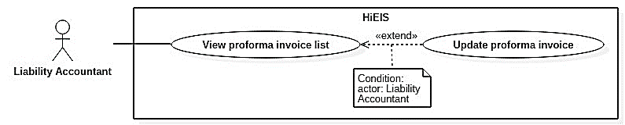

Figure 49. <Liability Accountant> Update proforma invoice

**Use Case Specification**

|  |  |  |  |
| --- | --- | --- | --- |
| **USE CASE – UC_EIS_42** | | | |
| **Use Case No.** | 42 | **Use Case Version** | 1.0 |
| **Use Case Name** | Update proforma invoice | | |
| **Author** | AnhDT | | |
| **Date** | 04/06/2017 | **Priority** | High |
| **Actor:**  Liability accountant  **Summary:**  This use case allows user to update proforma invoice.  **Goal:**  Proforma invoice information is updated.  **Triggers:**  Click on “Sửa” button (pencil icon) in the last column of a proforma invoice row.  **Preconditions:**  User is logged in as liability accountant.  Proforma invoice status is “Mới tạo”.  **Post Conditions:**  **Success:** Proforma invoice information is updated.  **Fail:** Show error message.  **Main Success Scenario:**   |  |  |  | | --- | --- | --- | | Step | Actor Action | System Response | | 1 | Click on “Sửa” button (pencil icon) in the last column of a proforma invoice row. | Redirect to update page with proforma invoice information automatically filled in. | | 2 | [Alternative 1]  or [Alternative 2]  or [Alternative 3] | Re-calculate sub total, VAT amount and total. | | 3 | Click on “Lưu” button. | [Exception 3]  [Exception 4]  Save proforma invoice to database.  Redirect to list page with a toast message “Đã cập nhật thông báo phí”. |   **Alternative:**  [Alternative 1]   |  |  |  | | --- | --- | --- | | Step | Actor Action | System Response | | 1 | Click on “Thêm sản phẩm” button. | [Exception 1]  Show product popup. | | 2 | Select a product from product dropdown list.  Fill in required information.  Change unit price and quantity (optional).  Click on “Lưu” button. | [Exception 2]  Add new row with information of the chosen product to proforma invoice item table.  Re-calculate sub total, VAT amount and total (sub total + VAT amount + liabilities). |   [Alternative 2]   |  |  |  | | --- | --- | --- | | Step | Actor Action | System Response | | 1 | Click on “Sửa” button (pencil icon) in the last column of an item row. | Show popup with information of the chosen product already filled in. | | 2 | Change information and click on “Lưu” button. | [Exception 2]  Close popup. Reload proforma invoice item table.  Re-calculate sub total, VAT amount and total. |   [Alternative 3]   |  |  |  | | --- | --- | --- | | Step | Actor Action | System Response | | 1 | Click on “Xóa” button (trash icon) in the last column of an item row. | Show a popup for confirmation. | | 2 | Choose “Có” to confirm. | Remove the chosen row from proforma invoice item table.  Re-calculate sub total, VAT amount and total. |   **Exceptions:**   |  |  |  | | --- | --- | --- | | No | Cause | System Response | | 1 | Customer’s information is empty or customer does not exist. | Show warning message and request to fill in valid customer’s information again. | | 2 | Required fields are missing or fields are invalid. | Show instruction message below those input fields. | | 3 | No product is selected. | Show warning message and request to choose at least one product. | | 4 | Database occurs exception. | Show error message and ask user to try again later. |   **Relationships:**  Extended from View Proforma Invoice List use case.  **Business Rules:**  Validation:   * Require valid customer’s information (customer exists in database), due date, from date and to date. * Due date is not in the past. * Unit price, new number must be valid number greater than 0. * New number must be greater than old number. * From date and to date field must be valid date format. * To date field must be after from date field. * Cannot select a product that already exists in the item list.   Only liability accountant can update proforma invoice.  Only proforma invoice with “Mới tạo” status can be edited. | | | |

Table 50. <Liability Accountant> Update proforma invoice

* + - 1. <Liability Accountant, Payable Accountant, Accounting Manager, Customer> View proforma invoice

**Use Case Diagram**

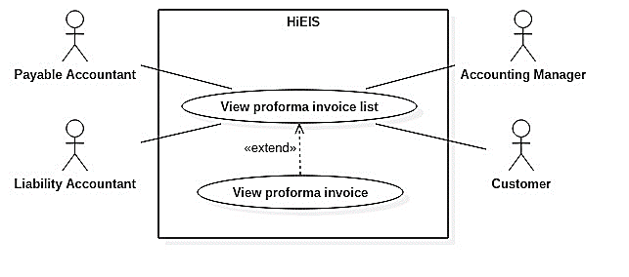

Figure 50. <Liability Accountant, Payable Accountant, Accounting Manager, Customer> View proforma invoice

**Use Case Specification**

|  |  |  |  |
| --- | --- | --- | --- |
| **USE CASE – UC_EIS_43** | | | |
| **Use Case No.** | **43** | **Use Case Version** | 1.0 |
| **Use Case Name** | View proforma invoice | | |
| **Author** | AnhDT | | |
| **Date** | 02/06/2018 | **Priority** | Normal |
| **Actor:**  Liability accountant, payable accountant, accounting manager, customer  **Summary:**  This use case allows user to view proforma invoice.  **Goal:**  User can view proforma invoice details.  **Triggers:**  User clicks on lookup code of a proforma invoice, which contains a link to open a popup.  **Preconditions:**  User is logged in as one of company’s accountant roles or customer.  **Post Conditions:**  **Success:** Show popup containing proforma invoice pdf.  **Fail:** Show error message.  **Main Success Scenario:**   |  |  |  | | --- | --- | --- | | Step | Actor Action | System Response | | 1 | Click on lookup code of a proforma invoice row in proforma invoice list page. | Show a popup containing pdf of the chosen proforma invoice. |   **Alternative:** N/A  **Exceptions:**   |  |  |  | | --- | --- | --- | | No | Cause | System Response | | 1 | Database occurs exception. | Show error message and ask user to try again later. |   **Relationships:**  Extended from View Proforma Invoice List use case.  **Business Rules:** N/A | | | |

Table 51. <Liability Accountant, Payable Accountant, Accounting Manager, Customer> View proforma invoice

* + - 1. <Liability Accountant> Delete proforma invoice

**Use Case Diagram**

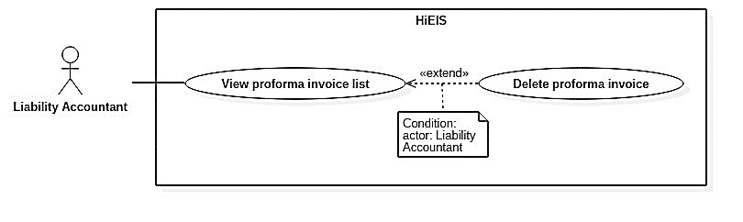

Figure 51. <Liability Accountant> Delete proforma invoice

**Use Case Specification**

|  |  |  |  |
| --- | --- | --- | --- |
| **USE CASE – UC_EIS_44** | | | |
| **Use Case No.** | **44** | **Use Case Version** | 1.0 |
| **Use Case Name** | Delete proforma invoice | | |
| **Author** | AnhDT | | |
| **Date** | 04/06/2018 | **Priority** | Normal |
| **Actor:** Liability accountant  **Summary:** This use case allows user to delete proforma invoice.  **Goal:** Proforma invoice is removed.  **Triggers:**  Click on “Xóa” button (trash icon) in the last column of a proforma invoice row.  **Preconditions:**  User is logged in as liability accountant.  Proforma invoice status is “Mới tạo”.  **Post Conditions:**  **Success:** The chosen roforma invoice is deleted and proforma invoice list is reloaded.  **Fail:** Show error message.  **Main Success Scenario:**   |  |  |  | | --- | --- | --- | | Step | Actor Action | System Response | | 1 | Click on “Xóa” button (trash icon) in the last colum of a proforma invoice row. | Show a popup for comfirmation. | | 2 | Choose “Có” to confirm. | [Exception]  Delete the chosen proforma invoice. Proforma invoice list is reloaded. |   **Alternative:** N/A  **Exceptions:**   |  |  |  | | --- | --- | --- | | No | Cause | System Response | | 1 | Database occurs exception. | Show error message and ask user to try again later. |   **Relationships:**  Extended from View Proforma Invoice List use case.  **Business Rules:**  Only liability accountant can delete proforma invoice.  Only proforma invoice with “Mới tạo” status can be deleted. | | | |

Table 52. <Liability Accountant> Delete proforma invoice

* + - 1. <Liability Accountant, Payable Accountant> Convert into invoice

**Use Case Diagram**

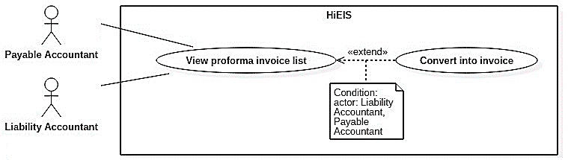

Figure 52. <Liability Accountant, Payable Accountant> Convert into invoice

**Use Case Specification**

|  |  |  |  |
| --- | --- | --- | --- |
| **USE CASE – UC_EIS_45** | | | |
| **Use Case No.** | **45** | **Use Case Version** | 1.0 |
| **Use Case Name** | Convert into invoice | | |
| **Author** | GiangHNM | | |
| **Date** | 02/06/2018 | **Priority** | Normal |
| **Actor:**  Liability accountant, payable accountant  **Summary:**  This use case allows user to convert proforma invoice to invoice.  **Goal:**  Proforma invoice is converted to invoice, displayed on create invoice page.  **Triggers:**  Click on “Chuyển thành hóa đơn” button in the last column of a proforma invoice row.  **Preconditions:**  User is logged in as liability accountant or payable accoutant.  Proforma invoice status is “Đã duyệt”.  **Post Conditions:**  **Success:** Proforma invoice is converted to invoice and displayed in create invoice page.  **Fail:** Show error message.  **Main Success Scenario:**   |  |  |  | | --- | --- | --- | | Step | Actor Action | System Response | | 1 | Click on “Chuyển thành hóa đơn” button in the last column of a proforma invoice row. | [Exception] Convert proforma invoice to invoice and display it on create invoice page. |   **Alternative:** N/A  **Exceptions:**   |  |  |  | | --- | --- | --- | | No | Cause | System Response | | 1 | Database occurs exception. | Show error message and ask user to try again later. |   **Relationships:**  Extended from View Proforma Invoice List use case.  **Business Rules:**  Only liability accountant or payable accountant can convert proforma invoice.  Only customer’s information and item list are converted to invoice (no liabilities). | | | |

Table 53. <Liability Accountant, Payable Accountant> Convert into invoice

* + - 1. <Liability Accountant, Payable Accoutant> Send email

**Use Case Diagram**

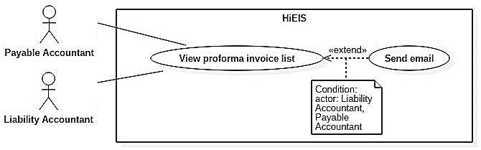

Figure 53. <Liability Accountant, Payable Accountant> Send email

**Use Case Specification**

|  |  |  |  |
| --- | --- | --- | --- |
| **USE CASE – UC_EIS_46** | | | |
| **Use Case No.** | **46** | **Use Case Version** | 1.0 |
| **Use Case Name** | Send email | | |
| **Author** | AnhDT | | |
| **Date** | 02/06/2018 | **Priority** | Normal |
| **Actor:**  Liabilities accountant, payable accountant  **Summary:**  This use case allows user to send email about proforma invoice to customer.  **Goal:**  Email notification containing proforma invoice lookup code is sent to customer.  **Triggers:**  Click on “Gửi email” button (send icon) in the last column of a proforma invoice row.  **Preconditions:**  User is logged in as liability accountant or payable accountant.  **Post Conditions:**  **Success:** Email is sent to customer.  **Fail:** Show error message.  **Main Success Scenario:**   |  |  |  | | --- | --- | --- | | Step | Actor Action | System Response | | 1 | Click on “Gửi email” button (send icon) in the last colum of a proforma invoice row. | Show a popup with customer’s email already filled in. | | 2 | Change to another email address (optional).  Click on “Gửi” button. | [Exception]  Send email to the inputted address. |   **Alternative:** N/A  **Exceptions:**   |  |  |  | | --- | --- | --- | | No | Cause | System Response | | 1 | Email field is empty. | Show warning message. | | 2 | Database occurs exception. | Show error message and ask user to try again later. |   **Relationships:**  Extended from View Proforma Invoice List use case.  **Business Rules:**  Email contains information of the company, invoice form, serial, lookup code.  Only liability accountant or payable accountant can send email. | | | |

Table 54. <Liability Accountant, Payable Accountant> Send email

* + - 1. <Liability Accountant, Payable Accountant, Accounting Manager, Customer> View liabilities

**Use Case Diagram**

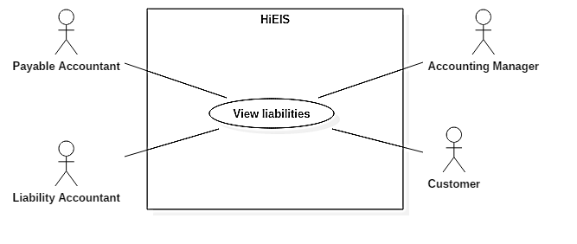

Figure 54. <Liability Accountant, Payable Accountant, Accounting Manager, Customer> View liabilities

**Use Case Specification**

|  |  |  |  |
| --- | --- | --- | --- |
| **USE CASE – UC_EIS_47** | | | |
| **Use Case No.** | **47** | **Use Case Version** | 1.0 |
| **Use Case Name** | View liabilities | | |
| **Author** | AnhDT | | |
| **Date** | 02/06/2018 | **Priority** | Normal |
| **Actor:**  Liabilities accountant, payable accountant, accounting manager, customer  **Summary:**  This use case allows user to view liabilties and payment details.  **Goal:**  User can view liabilities/payment/transaction details.  **Triggers:**  Click on “Xem chi tiết” button (eye icon) in the last column of a liability row.  **Preconditions:**  User is logged in as one of company’s accountant roles or customer.  **Post Conditions:**  **Success:** User can view liabilities details.  **Fail:** Show error message.  **Main Success Scenario:**   |  |  |  | | --- | --- | --- | | Step | Actor Action | System Response | | 1 | Click on “Xem chi tiết” button (eye icon) in the last column of a liability row in liability list page. | Redirect to liabilities detail page. |   **Alternative:** N/A  **Exceptions:**   |  |  |  | | --- | --- | --- | | No | Cause | System Response | | 1 | Database occurs exception. | Show error message and ask user to try again later. |   **Relationships:** N/A  **Business Rules:**  Details are grouped by year (default by current year) and sorted by date ascending. | | | |

Table 55. <Liability Accountant, Payable Accountant, Accounting Manager, Customer> View liabilities

* + - 1. <Liability Accountant> Add payment

**Use Case Diagram**

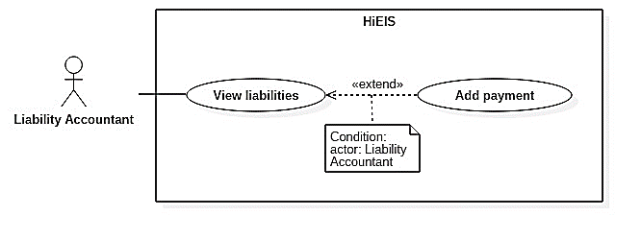

Figure 55. <Payable Accountant> Add payment

**Use Case Specification**

|  |  |  |  |
| --- | --- | --- | --- |
| **USE CASE – UC_EIS_48** | | | |
| **Use Case No.** | **48** | **Use Case Version** | 1.0 |
| **Use Case Name** | Add payment | | |
| **Author** | GiangHNM | | |
| **Date** | 04/06/2018 | **Priority** | Normal |
| **Actor:**  Payable accountant  **Summary:**  This use case allows user to add payment to customer’s liabilities.  **Goal:**  Payment is added to transaction table in database and customer’s liabilities decreases by the inputted amount.  **Triggers:**  Click on “Thanh toán” button customer’s liabilities detail page.  **Preconditions:**  User is logged in as liability accountant.  Customer’s liabilities amount is larger than 0.  **Post Conditions:**  **Success:** New payment is added.  **Fail:** Show error message.  **Main Success Scenario:**   |  |  |  | | --- | --- | --- | | Step | Actor Action | System Response | | 1 | Click on “Thanh toán” button in a customer’s payment/liability detail page. | Show a popup to fill in amount of money and note. | | 2 | Input data and click on “Lưu” button. | [Exception]  Payment is saved to database.  Close popup. A new payment row with type of “Thanh toán” is added to liability detail table of the current year. |   **Alternative:** N/A  **Exceptions:**   |  |  |  | | --- | --- | --- | | No | Cause | System Response | | 1 | Payment amount is invalid. | Show instruction below amount input field. | | 2 | Database occurs exception. | Show error message and ask user to try again later. |   **Relationships:**  Extended from View Liabilities use case.  **Business Rules:**  Only liability accountant can add payment to decrease customer’s liabilities.  Payment amount must be must be number greater than 0, small or equal to remaining liablities.  User can only add payment for current year. | | | |

Table 56. <Payable Accountant> Add payment

* + - 1. Payable Accountant Overview Use Cases

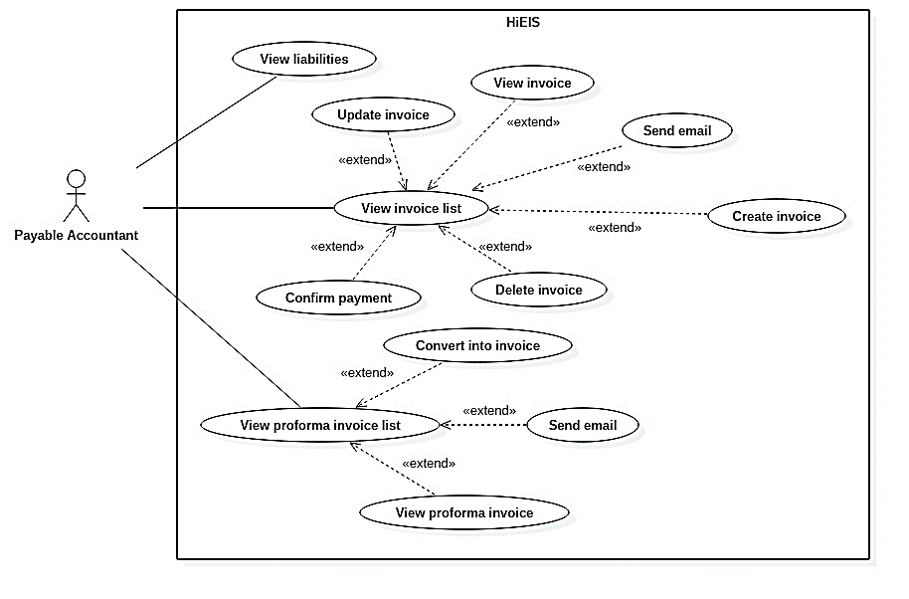

Figure 56. Payable accountant overview use cases

* + - 1. <Payable Accountant> Confirm payment

**Use Case Diagram**

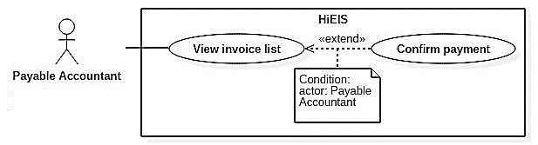

*Figure 57. <Payable Accountant> Confirm payment*

**Use Case Specification**

|  |  |  |  |
| --- | --- | --- | --- |
| **USE CASE – UC_EIS_49** | | | |
| **Use Case No.** | **49** | **Use Case Version** | 1.0 |
| **Use Case Name** | Confirm payment | | |
| **Author** | GiangHNM | | |
| **Date** | 04/06/2018 | **Priority** | Normal |
| **Actor:** Payable accountant  **Summary:** This use case allows user to confirm payment of an invoice.  **Goal:** Invoice is numbered, payment status is updated.  **Triggers:** Click on “Xác nhận thanh toán” button (check icon) in the last column of an invoice row.  **Preconditions:** User is logged in as payable accountant.  Invoice status is “Mới tạo”.  **Post Conditions:**  **Success:** Invoice is numbered, payment status is changed to “Đã thanh toán” and status is changed to “Chờ duyệt”.  **Fail:** Show error message.  **Main Success Scenario:**   |  |  |  | | --- | --- | --- | | Step | Actor Action | System Response | | 2 | Click on “Xác nhận thanh toán” button (check icon) in the last column of an invoice row in invoice list page. | Show a popup to confirm. | | 3 | Choose “Đồng ý” to confirm. | Show success message.  Payment status is changed to “Đã thanh toán”. Invoice is numbered and status is changed to “Chờ duyệt”.  [Exception] |   **Alternative:** N/A  **Exceptions:**   |  |  |  | | --- | --- | --- | | No | Cause | System Response | | 1 | Database occurs exception. | Show error message and ask user to try again later. |   **Relationships:**  Extended from View Invoice List use case.  **Business Rules:**  Only invoice with “Mới tạo” status can be confirmed payment.  Only payable accountant can confirm payment for an invoice. | | | |

Table 57. <Payable Accountant> Confirm payment

* + - 1. Accounting Manager Overview Use Cases

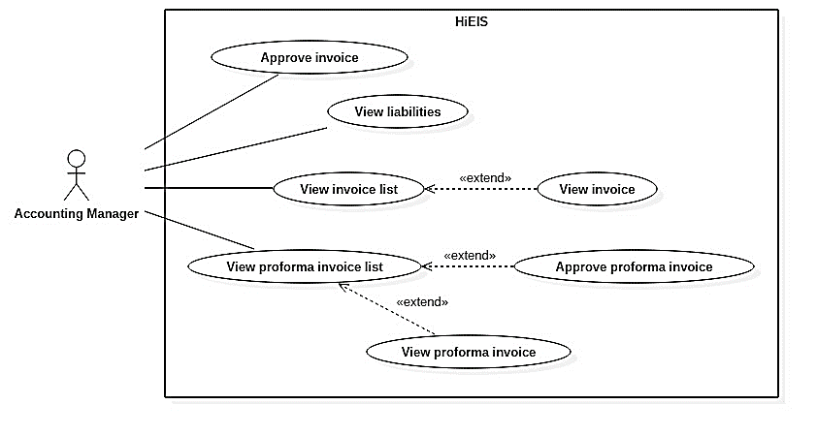

Figure 58. Accounting manager overview use cases

* + - 1. <Accounting Manager> Approve proforma invoice

**Use Case Diagram**

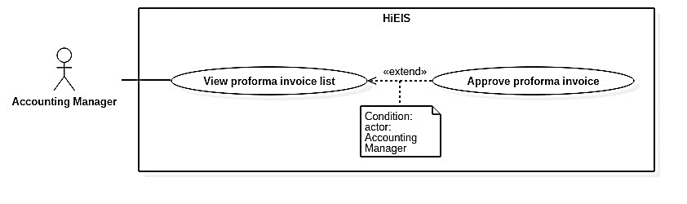

Figure 59. <Accounting Manager> Approve proforma invoice

**Use Case Specification**

|  |  |  |  |
| --- | --- | --- | --- |
| **USE CASE – UC_EIS_50** | | | |
| **Use Case No.** | **50** | **Use Case Version** | 1.0 |
| **Use Case Name** | Approve proforma invoice | | |
| **Author** | AnhDT | | |
| **Date** | 02/06/2018 | **Priority** | Normal |
| **Actor:** Accounting manager  **Summary:**  This use case allows user to approve proforma invoice and publish proforma invoice to customer.  **Goal:** The chosen proforma invoice is approved and notification is sent to customer via email.  **Triggers:**  Click on “Duyệt và phát hành” button (sign icon) in the last column of a proforma invoice row.  **Preconditions:** User is logged in as company’s accounting manager.  **Post Conditions:**  **Success:** The chosen proforma invoice status is changed to “Đã duyệt”, notification email is sent.  **Fail:** Show error message.  **Main Success Scenario:**   |  |  |  | | --- | --- | --- | | Step | Actor Action | System Response | | 1 | Click on “Duyệt” button (sign icon) in the last column of a proforma invoice row. | Show a popup to confirm. | | 2 | Choose “Có” to confirm. | Change status of the chosen proforma invoice from “Chờ duyệt” to “Đã duyệt”.  Email is sent to customer.  [Exception] |   **Alternative:** N/A  **Exceptions:**   |  |  |  | | --- | --- | --- | | No | Cause | System Response | | 1 | Database occurs exception. | Show error message and ask user to try again later. |   **Relationships:**  Extended from View Profoma Invoice List use case.  **Business Rules:**  Only Accounting Manager can approve proforma invoice. | | | |

Table 58. <Accounting Manager> Approve proforma invoice

* + - 1. <Accounting Manager> Approve Invoice

**Use Case Diagram**

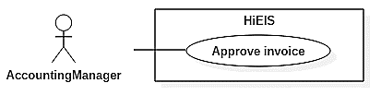

Figure 60. <Accounting Manager> Approve invoice

**Use Case Specification**

|  |  |  |  |
| --- | --- | --- | --- |
| **USE CASE – UC_EIS_51** | | | |
| **Use Case No.** | **51** | **Use Case Version** | 1.0 |
| **Use Case Name** | Approve invoice | | |
| **Author** | AnhDT | | |
| **Date** | 04/06/2018 | **Priority** | Normal |
| **Actor:**  Accounting manager  **Summary:** This use case allows user to approve and publish invoice to customer.  **Goal:** Invoice is signed with digital signature and notification is sent to customer via email.  **Triggers:** Choose an invoice row in Sign window application and click on “Ký” button.  **Preconditions:**  User is logged in as company’s accounting manager.  Invoice status is “Chờ ký”.  **Post Conditions:**  **Success:** Invoice is signed and sent to customer via email.  **Fail:** Show error message.  **Main Success Scenario:**   |  |  |  | | --- | --- | --- | | Step | Actor Action | System Response | | 1 | Choose an invoice row in window app. | Show PDF file of invoice. | | 2 | Click on “Ký” button. | Sign invoice and change status of the chosen invoice from “Chờ ký” to “Đã ký”.  Send email notification to customer.  [Exception] |   **Alternative:** N/A  **Exceptions:**   |  |  |  | | --- | --- | --- | | No | Cause | System Response | | 1 | Database occurs exception. | Show error message and ask user to try again later. | | 2 | Digital signature is not available. | Show error message. |   **Relationships:**  N/A  **Business Rules:**  Only Accounting Manager can approve invoice with digital signature. | | | |

Table 59. <Accounting Manager> Approve invoice

* + - 1. System Overview Use Cases

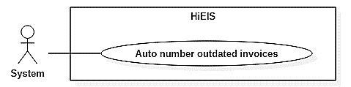

Figure 61. System overview use cases

* + - 1. <System> Auto-number outdated invoices

**Use Case Diagram**



Figure 62. <System> Auto-number outdated invoices

**Use Case Specification**

|  |  |  |  |
| --- | --- | --- | --- |
| **USE CASE – UC_EIS_52** | | | |
| **Use Case No.** | 52 | **Use Case Version** | 1.0 |
| **Use Case Name** | Auto number oudated invoices | | |
| **Author** | GiangHNM | | |
| **Date** | 03/06/2018 | **Priority** | Normal |
| **Actor:** System  **Summary:** System finds all outdated invoices everyday, numbers them and increases customer’s liabilities by the amount of money.  **Goal:** Outdated invoices are automatically numbered and added to liabilities.  **Triggers:** System checks timeline everyday.  **Preconditions:** N/A  **Post Conditions:**  **Success:** Number invoices and transform them into liabilites.  **Fail:** Log errors.  **Main Success Scenario:**   |  |  |  | | --- | --- | --- | | Step | Actor Action | System Response | | 1 | System checks timeline everyday. | Number invoices at 6am and 6pm.  [Exception] |   **Alternative:** N/A  **Exceptions:**   |  |  |  | | --- | --- | --- | | No | Cause | System Response | | 1 | Database occurs exception. | Log errors. |   **Relationships:** N/A  **Business Rules:** N/A | | | |

Table 60. <System> Auto-number outdated invoice

1. **Software System Attributes** 
   1. Usability
      1. Graphic User Interface

* All textboxes, labels, alerts and messages are written in Vietnamese. GUI for web application is designed based on material design with navigation bar on the left and main content box on the right.
  + 1. Usability
* The application is assumed to have basic information of invoices, proforma invoices, etc. which allows user to view and perform actions.
* The application has friendly and clear interfaces and features to use easily.
  1. Reliability
* Data should be backed up once a day.
  1. Availability
* System must be available 24/7.
* System can handle a large number of requests.
  1. **Security**
* User password is encrypted in database.
* Each role of a user has specific permission to interact with the system.
* All input data should be validated before saving to database.
  1. **Maintainability**
* The system is divided into separated modules.
* When a module is down, it is easy to take it down to fix without impacting other functions.
* Code is easy to maintain and upgrade.
  1. Portability
* Website runs on Chrome version 50 or above, or other common browsers.
  1. Performance
* All requests are handled in maximum time of 5 seconds.

1. Conceptual Diagram

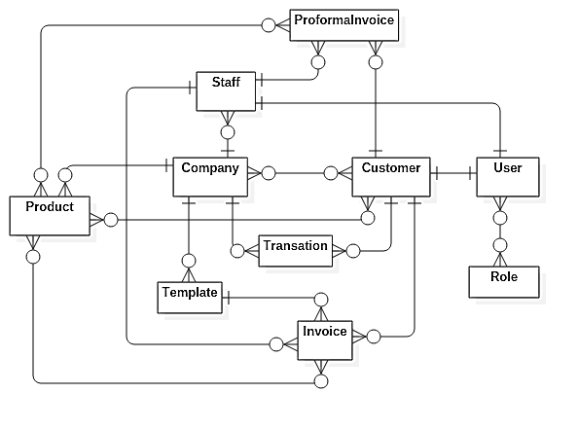

Figure 63. Conceptual diagram

# D. Software Design Description

**1. Design Overview**

This document describes the technical and user interface design of HiEIS system. It includes architectural design, detail design of common functions, business functions and design of database model. Document overview:

Section 2: Overall description of system architecture design.

Section 3: Component diagrams that describe the connection and integration of the system.

Section 4: Detail design description including class diagram, class explanation, and sequence diagram to application function details.

Section 5: Screen designs.

Section 6: Attributed ERD.

**2. System Architectural Design**

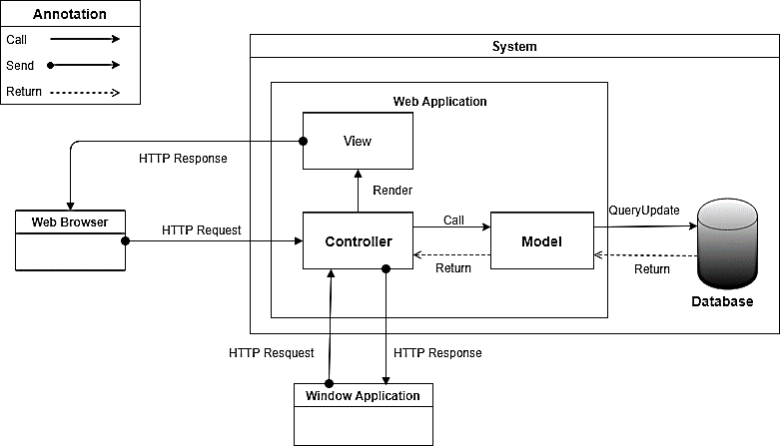

Figure 64. System architectural design

In Web Application, the system is developed under MVC architecture style. This project follows MVC architecture with following components:

* Controller handles user interaction. Typically, controller reads data from a request, calls appropriate business method, selects and renders view for user.
* View is a user interface. It is responsible for rendering the model data and generating HTML output that client's browser can interpret.
* Model is responsible for managing data of the application. It responds to requests from view and also to instructions from controller to update itself. Model objects store and retrieve model state in a database.

**3. Component Diagram**

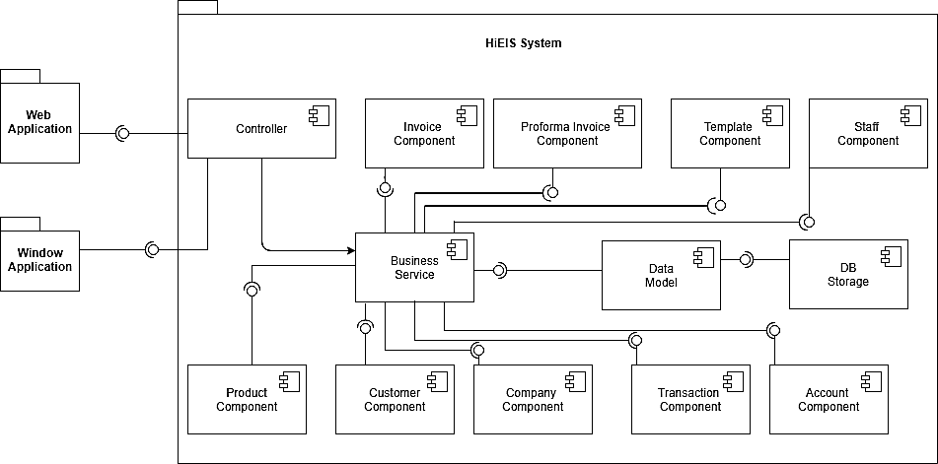

Figure 65. Component diagram

|  |  |
| --- | --- |
| COMPONENT DICTIONARY: DESCRIBES COMPONENTS | |
| HiEIS System | Corporate Electricity Invoice System |
| Web Application | Web application package contains operation of HiEIS on web |
| Window Application | Window application package contains operations to read digital signature and sign pdf. |
| Controller | Handle requests and responses; accept input and convert it to commands for model and view. |
| Business Service | Handle system’s business operations |
| Data Model | Present the interaction between the system and database. |
| DB Storage | Store data of system. |
| Invoice Component | Handle invoice activities in the system |
| Proforma Invcoie Component | Handle author proforma invoice in the system |
| Template Component | Handle template activities in the system |
| Account Component | Handle account activities in the system |
| Staff Component | Handle staff activities in the system |
| Customer Component | Handle customer activities in the system |
| Company Component | Handle company activities in the system |
| Product Component | Handle product activities in the system |
| Transaction Component | Handle transaction activities in the system |

Table 61. Component diagram dictionary

**4. Detail Description**

**4.1 Class Diagram**

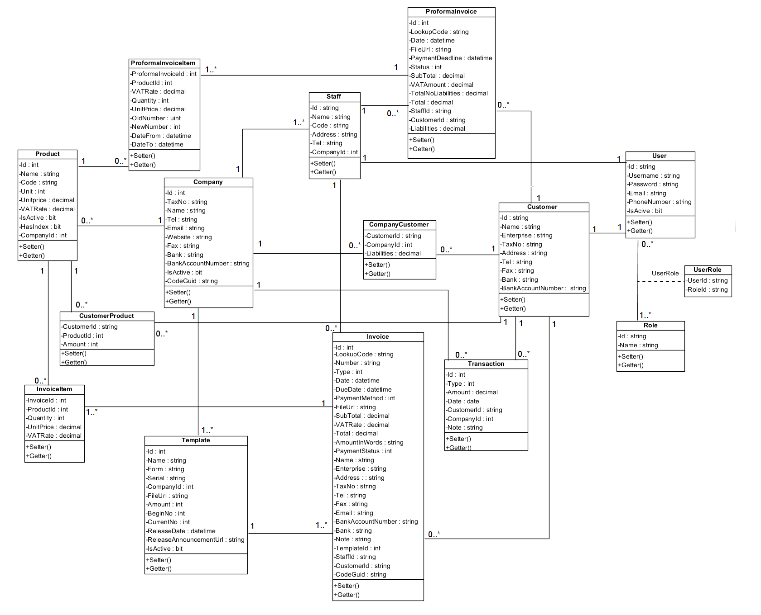<blob:file:///9df17a75-c62e-4913-accb-4c80b5327d05>

*Figure 66. Class diagram*

|  |  |  |
| --- | --- | --- |
| **CLASS DICTIONARY: DESCRIBE CLASS** | | |
| **Class Name** | **Mapping column with Conceptual diagram** | **Description** |
| **User** | User | Contain account information |
| **Role** | Role | Contain role information |
| **UserRole** | N/A | Not exist in conceptual diagram but we need this table to contain information of a user and user’s role. |
| **Company** | Company | Contain company information |
| **Staff** | Staff | Contain staff’s information |
| **Customer** | Customer | Contain customer’s information |
| **CompanyCustomer** | N/A | Not exist in conceptual diagram but we need this table to contain information of customer and company |
| **Product** | Product | Contain product information |
| **CustomerProduct** | N/A | Not exist in conceptual diagram but we need this table to contain information of customer and customer’s product |
| **Transaction** | Transaction | Contain transaction information |
| **Template** | Template | Contain template information |
| **Invoice** | Invoice | Contain invoice information |
| **InvoiceItem** | N/A | Not exist in the conceptual diagram but we need this table to contain information of products in invoices. |
| **ProformaInvoice** | ProformaInvoice | Contain proforma invoice information |
| **ProformaInvoiceItem** | N/A | Not exist in the conceptual diagram but we need this table to contain information of products in proforma invoices. |

Table 62. Class Diagram Dictionary

**4.2 Class Diagram Explanation**

1. **User**

|  |  |  |  |
| --- | --- | --- | --- |
| **Attribute** | **Type** | **Visibility** | **Description** |
| Id | String | Private | Unique identifier of a user |
| Username | String | Private | User’s username |
| Password | String | Private | User’s password |
| Email | String | Private | User’s email |
| PhoneNumber | String | Private | User’s phone number |
| IsActive | bit | Private | User is active or deactive |

Table 63. <Class Diagram Attributes> User

|  |  |  |  |
| --- | --- | --- | --- |
| **Method** | **Redirect Type** | **Visibility** | **Description** |
| Getter | Attribute Type | Public | Get attribute value |
| Setter | Void | Public | Set attribute value |

Table 64. <Class Diagram Methods> User

1. **Role**

|  |  |  |  |
| --- | --- | --- | --- |
| **Attribute** | **Type** | **Visibility** | **Description** |
| Id | String | Private | Unique identifier of a role |
| Name | String | Private | Role name |

Table 65. <Class Diagram Attributes> Role

|  |  |  |  |
| --- | --- | --- | --- |
| **Method** | **Redirect Type** | **Visibility** | **Description** |
| Getter | Attribute Type | Public | Get attribute value |
| Setter | Void | Public | Set attribute value |

Table 66. <Class Diagram Methods> Role

1. **UserRole**

|  |  |  |  |
| --- | --- | --- | --- |
| **Attribute** | **Type** | **Visibility** | **Description** |
| UserId | String | Private | Identifier of a user |
| RoleId | String | Private | Identifier of a role |

Table 67. < Class Diagram Attributes> UserRole

1. **Company**

|  |  |  |  |
| --- | --- | --- | --- |
| **Attribute** | **Type** | **Visibility** | **Description** |
| Id | Int | Private | Unique identifier of a company |
| TaxNo | String | Private | Company’s tax number |
| Tel | String | Private | Company’s telephone number |
| Email | String | Private | Company’s email |
| Website | String | Private | Company’s website |
| Fax | String | Private | Company’s fax number |
| Bank | String | Private | Company’s bank |
| BankAccountNumber | String | Private | Company’s bank account number |
| IsActive | Bit | Private | Company’s status |
| CodeGuid | String | Private | Company’s code guid |

Table 68. <Class Diagram Attributes> Company

|  |  |  |  |
| --- | --- | --- | --- |
| **Method** | **Redirect Type** | **Visibility** | **Description** |
| Getter | Attribute Type | Public | Get attribute value |
| Setter | Void | Public | Set attribute value |

Table 69. <Class Diagram Methods> Company

1. **Staff**

|  |  |  |  |
| --- | --- | --- | --- |
| **Attribute** | **Type** | **Visibility** | **Description** |
| Id | String | Private | Unique identifier of a staff |
| Name | String | Private | Staff’s name |
| Code | String | Private | Staff’s code |
| Address | String | Private | Staff’s address |
| Tel | String | Private | Staff’s phone number |
| CompanyId | int | Private | Id of company that staff belongs to |

Table 70. <Class Diagram Attributes> Staff

|  |  |  |  |
| --- | --- | --- | --- |
| **Method** | **Redirect Type** | **Visibility** | **Description** |
| Getter | Attribute Type | Public | Get attribute value |
| Setter | Void | Public | Set attribute value |

Table 71. <Class Diagram Methods> Staff

1. **Customer**

|  |  |  |  |
| --- | --- | --- | --- |
| **Attribute** | **Type** | **Visibility** | **Description** |
| Id | String | Private | Unique identifier of a customer |
| Name | String | Private | Customer’s name |
| Enterprise | String | Private | Customer’s enterprise |
| TaxNo | String | Private | Customer’s tax number |
| Address | String | Private | Customer’s address |
| Tel | String | Private | Customer’s phone number |
| Fax | String | Private | Customer’s fax number |
| Bank | String | Private | Customer’s bank |
| BankAccountNumber | String | Private | Customer’s bank account number |

Table 72. <Class Diagram Attributes> Customer

|  |  |  |  |
| --- | --- | --- | --- |
| **Method** | **Redirect Type** | **Visibility** | **Description** |
| Getter | Attribute Type | Public | Get attribute value |
| Setter | Void | Public | Set attribute value |

Table 73. <Class Diagram Methods> Customer

1. **CompanyCustomer**

|  |  |  |  |
| --- | --- | --- | --- |
| **Attribute** | **Type** | **Visibility** | **Description** |
| CustomerId | String | Private | Identifier of a Customer |
| CompanyId | Int | Private | Identifier of a Company |
| Liabilities | Decimal | Private | Customer’s Liabilities |

Table 74. <Class Diagram Attributes> Company Customer

|  |  |  |  |
| --- | --- | --- | --- |
| **Method** | **Redirect Type** | **Visibility** | **Description** |
| Getter | Attribute Type | Public | Get attribute value |
| Setter | Void | Public | Set attribute value |

Table 75. <Class Diagram Methods> Company Customer

1. **Product**

|  |  |  |  |
| --- | --- | --- | --- |
| **Attribute** | **Type** | **Visibility** | **Description** |
| Id | Int | Private | Unique identifier of a staff |
| Name | String | Private | Product name |
| Code | String | Private | Product code |
| Unit | Int | Private | Product unit |
| UnitPrice | Decimal | Private | Price per unit of product |
| VATRate | Decimal | Private | Product VAT rate |
| IsActive | bit | Private | Product is active or deactive |
| HasIndex | bit | Private | Product has index (water, electricity, etc.) |
| CompanyId | bit | Private | Id of company that product belongs to |

Table 76. <Class Diagram Attributes> Product

|  |  |  |  |
| --- | --- | --- | --- |
| **Method** | **Redirect Type** | **Visibility** | **Description** |
| Getter | Attribute Type | Public | Get attribute value |
| Setter | Void | Public | Set attribute value |

Table 77. <Class Diagram Methods> Product

1. **CustomerProduct**

|  |  |  |  |
| --- | --- | --- | --- |
| **Attribute** | **Type** | **Visibility** | **Description** |
| CustomerId | String | Private | Identifier of a Customer |
| ProductId | Int | Private | Identifier of a Product |
| Amount | Int | Private | Product amount |

Table 78. <Class Diagram Attributes> CustomerProduct

|  |  |  |  |
| --- | --- | --- | --- |
| **Method** | **Redirect Type** | **Visibility** | **Description** |
| Getter | Attribute Type | Public | Get attribute value |
| Setter | Void | Public | Set attribute value |

Table 79. <Class Diagram Methods> CustomerProduct

1. **Transaction**

|  |  |  |  |
| --- | --- | --- | --- |
| **Attribute** | **Type** | **Visibility** | **Description** |
| Id | Int | Private | Unique identifier of a transaction |
| Type | Int | Private | Transaction type |
| Amount | Decimal | Private | Amount of money |
| Date | Date | Private | Transaction date |
| CustomerId | String | Private | Id of customer that the transaction belongs to |
| CompanyId | Int | Private | Id of company that the transaction belongs to |
| Note | String | Private | Transaction note |

Table 80. <Class Diagram Attributes> Transaction

|  |  |  |  |
| --- | --- | --- | --- |
| **Method** | **Redirect Type** | **Visibility** | **Description** |
| Getter | Attribute Type | Public | Get attribute value |
| Setter | Void | Public | Set attribute value |

Table 81. <Class Diagram Methods> Transaction

1. **Template**

|  |  |  |  |
| --- | --- | --- | --- |
| **Attribute** | **Type** | **Visibility** | **Description** |
| Id | Int | Private | Unique identifier of a template |
| Name | String | Private | Template name |
| Form | String | Private | Template form |
| Serial | String | Private | Template serial |
| CompanyId | Int | Private | Id of company that template belongs to |
| FileUrl | String | Private | Template file url |
| Amount | Int | Private | Template amount |
| BeginNo | Int | Private | Template begin number |
| CurrentNo | Int | Private | Template current number |
| ReleaseDate | Datetime | Private | Template release date |
| ReleaseAnnouncementUrl | String | Private | Template release annountcement url |
| IsActive | Bit | Private | Template status |

Table 82. <Class Diagram Attributes> Template

|  |  |  |  |
| --- | --- | --- | --- |
| **Method** | **Redirect Type** | **Visibility** | **Description** |
| Getter | Attribute Type | Public | Get attribute value |
| Setter | Void | Public | Set attribute value |

Table 83. <Class Diagram Methods> Template

1. **Invoice**

|  |  |  |  |
| --- | --- | --- | --- |
| **Attribute** | **Type** | **Visibility** | **Description** |
| Id | Int | Private | Unique identifier of an invoice |
| LookupCode | String | Private | Invoice lookup code (unique) |
| Number | String | Private | Invoice number |
| Type | Int | Private | Invoice type |
| Date | Datetime | Private | Invoice date |
| DueDate | Datetime | Private | Invoice |
| PaymentMethod | Int | Private | Invoice payment method |
| FileUrl | String | Private | Invoice file url |
| SubTotal | Decimal | Private | Invoice sub total |
| VATRate | Decimal | Private | Invoice VAT rate |
| Total | Decimal | Private | Invoice total |
| AmountInWords | String | Private | Invoice amount in words |
| PaymentStatus | Int | Private | Invoice payment status |
| Name | String | Private | Customer’s name |
| Enterprise | String | Private | Customer’s enterprise |
| Address | String | Private | Customer’s address |
| TaxNo | String | Private | Customer’s tax number |
| Tel | String | Private | Customer’s tel |
| Fax | String | Private | Customer’s fax |
| Email | String | Private | Customer’s email |
| BankAccountNumber | String | Private | Customer’s bank |
| Bank | String | Private | Customer’s bank account number |
| Note | String | Private | Invoice note |
| TemplateId | Int | Private | Id of template that invoice uses |
| StaffId | String | Private | Id of staff that creates, updates or approves invoice |
| CustomerId | String | Private | Id of customer that invoice belongs to |
| CodeGuid | String | Private | Invoice’s code guid |

Table 84. <Class Diagram Attributes> Invoice

|  |  |  |  |
| --- | --- | --- | --- |
| **Method** | **Redirect Type** | **Visibility** | **Description** |
| Getter | Attribute Type | Public | Get attribute value |
| Setter | Void | Public | Set attribute value |

Table 85. <Class Diagram Methods> Invoice

1. **InvoiceItem**

|  |  |  |  |
| --- | --- | --- | --- |
| **Attribute** | **Type** | **Visibility** | **Description** |
| InvoiceId | String | Private | Identifier of an invoice |
| ProductId | Int | Private | Identifier of a Product |
| Quantity | Int | Private | Product quantity |
| UnitPrice | Decimal | Private | Product unit price |
| VATRate | Decimal | Private | Product VAT rate |

Table 86. <Class Diagram Attributes> InvoiceItem

|  |  |  |  |
| --- | --- | --- | --- |
| **Method** | **Redirect Type** | **Visibility** | **Description** |
| Getter | Attribute Type | Public | Get attribute value |
| Setter | Void | Public | Set attribute value |

Table 87. <Class Diagram Methods> Invoice Item

1. **ProformaInvoice**

|  |  |  |  |
| --- | --- | --- | --- |
| **Attribute** | **Type** | **Visibility** | **Description** |
| Id | Int | Private | Unique identifier of a proforma invoice |
| LookupCode | String | Private | Proforma invoice lookup code |
| Date | datetime | Private | Proforma invoice date |
| FileUrl | String | Private | Proforma invoice file url |
| PaymentDeadline | datetime | Private | Proforma invoice payment deadline |
| Status | Int | Private | Proforma invoice status |
| SubTotal | Decimal | Private | Proforma invoice sub total |
| VATAmount | Decimal | Private | Proforma invoice VAT amount |
| TotalNoLiabilities | Decimal | Private | Proforma invoice total no liabilities |
| Total | Decimal | Private | Proforma invoice total |
| StaffId | String | Private | Id of staff that creates, updates or confirms proforma invoice |
| CustomerId | String | Private | Id of customer that proforma invoice belongs to |
| Liabilities | Decimal | Private | Proforma invoice liabilities |

Table 88. <Class Diagram Attributes> ProformaInvoice

|  |  |  |  |
| --- | --- | --- | --- |
| **Method** | **Redirect Type** | **Visibility** | **Description** |
| Getter | Attribute Type | Public | Get attribute value |
| Setter | Void | Public | Set attribute value |

Table 89. <Class Diagram Methods> ProformaInvoice

1. **ProformaInvoiceItem**

|  |  |  |  |
| --- | --- | --- | --- |
| **Attribute** | **Type** | **Visibility** | **Description** |
| ProformaInvoiceId | Int | Private | Identifier of a Proforma Invoice |
| ProductId | Int | Private | Identifier of a Product |
| VATRate | Decimal | Private | Product VAT rate |
| Quantity | Int | Private | Product quantity |
| UnitPrice | Decimal | Private | Product unit price |
| OldNumber | Int | Private | Product old number |
| NewNumber | Int | Private | Product new number |
| DateFrom | Datetime | Private | Start date of using product |
| DateTo | Datetime | Private | End date of using product |

Table 90. <Class Diagram Attributes> ProformaInvoiceItem

|  |  |  |  |
| --- | --- | --- | --- |
| **Method** | **Redirect Type** | **Visibility** | **Description** |
| Getter | Attribute Type | Public | Get attribute value |
| Setter | Void | Public | Set attribute value |

Table 91. <Class Diagram Methods> ProformaInvoiceItem

* 1. Interaction Diagram
     1. <Payable Accountant, Liability Accountant> Create invoice

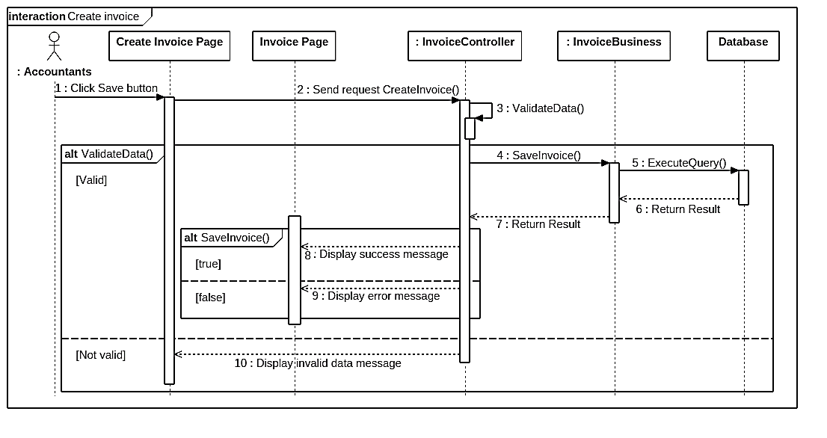

Figure 67. <Sequence Diagram><Payable Accountant, Liability Accountant> Create invoice

* + 1. <Payable Accountant > Confirm payment

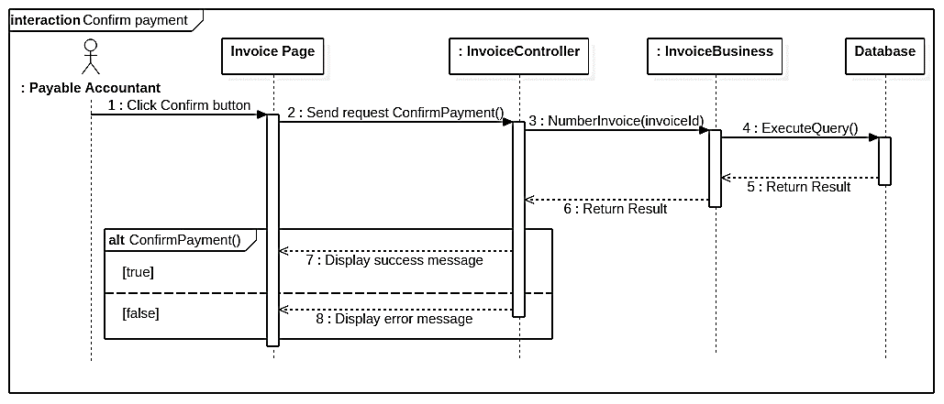

Figure 68. <Sequence Diagram><Payable Accountant > Confirm payment

* + 1. <Accounting Manager> Approve invoice

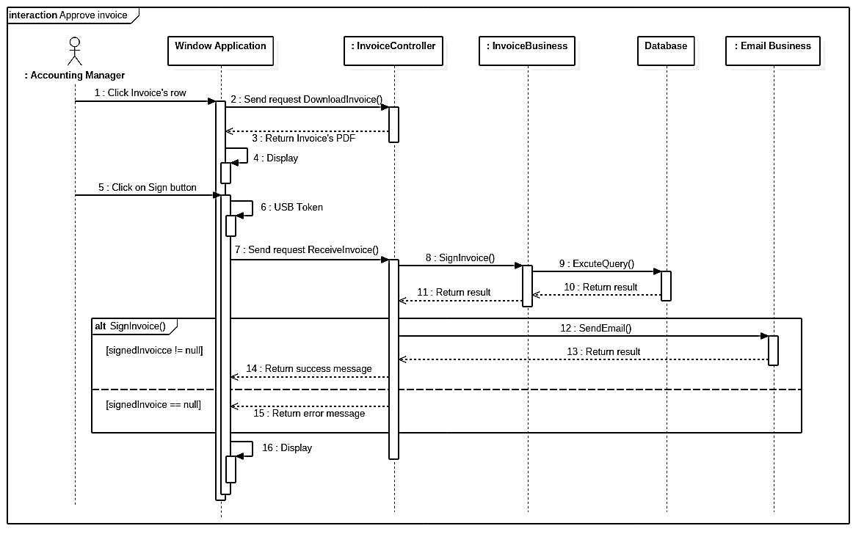

Figure 69. <Sequence Diagram><Accounting Manager> Approve invoice

* + 1. <Liability Accountant> Create proforma invoice

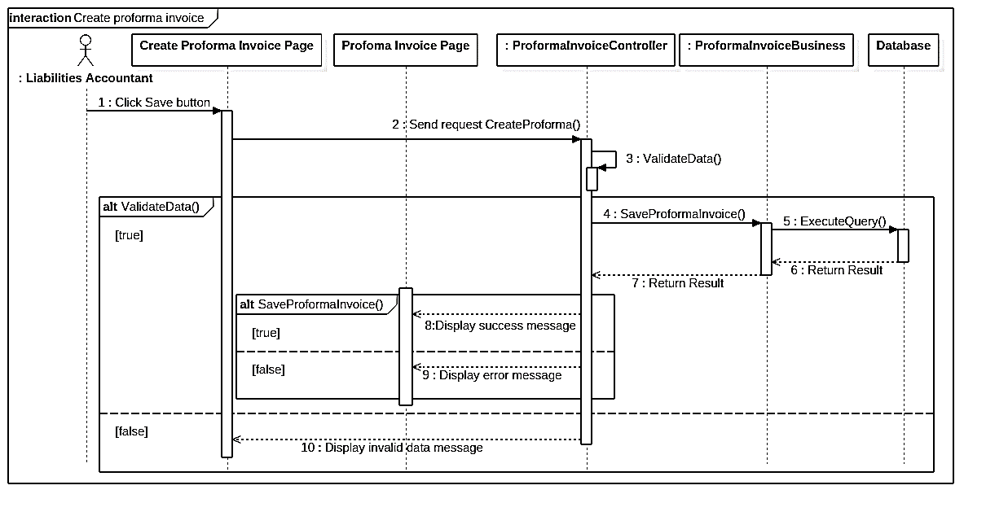

Figure 70. <Sequence Diagram><Liability Accountant> Create proforma invoice

* + 1. <Accounting Manager> Approve proforma invoice

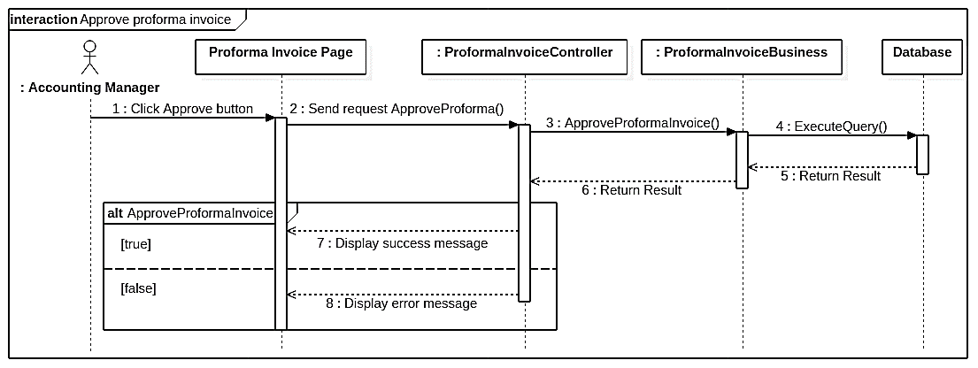

Figure 71. <Sequence Diagram><Accounting Manager> Approve proforma invoice

* + 1. <Payable Accountant, Liability Accountant> Convert proforma invoice into invoice

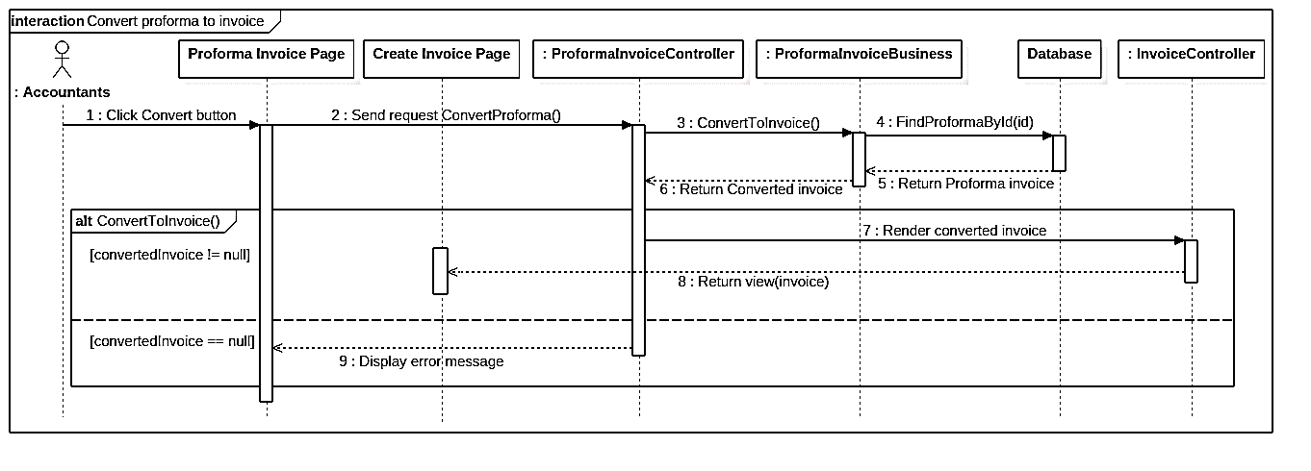

Figure 72. <Sequence Diagram><Payable, Liability Accountant> Convert proforma invoice into invoice

* + 1. <Payable Accountant > Add payment

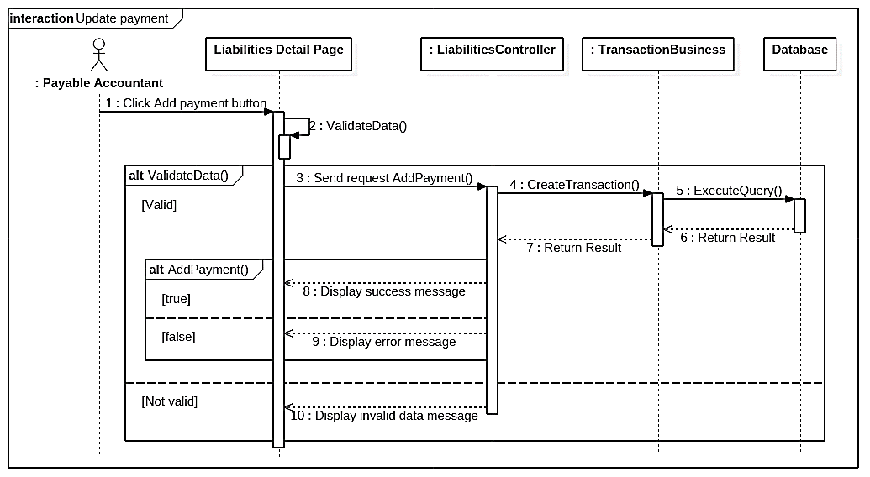

Figure 73. <Sequence Diagram><Payable Accountant > Add payment

1. User Interface Design
   1. Home Page

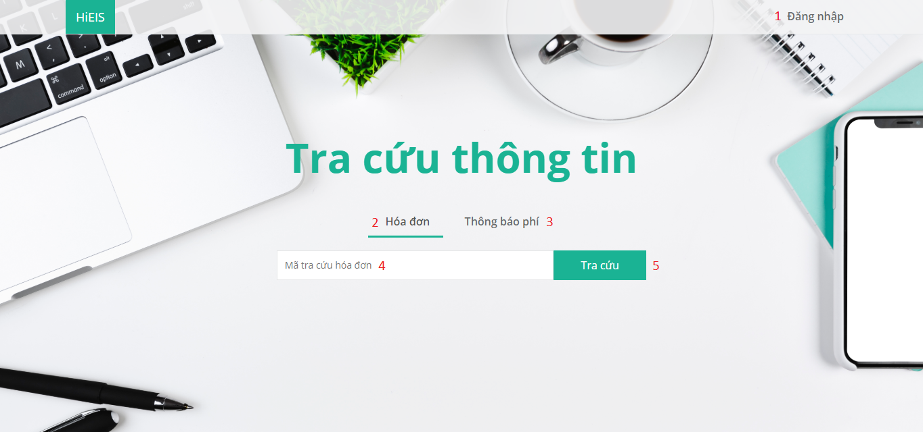

Figure 74. Home page

**Fields**

|  |  |  |  |  |  |  |
| --- | --- | --- | --- | --- | --- | --- |
| **No** | **Field Name** | **Description** | **Read only** | **Mandatory** | **Control Type** | **Data Type** |
| 4 | Lookup code | Fill lookup code | No | Yes | TextBox | String |

Table 92. <Fields> Home page

**Buttons/Hyperlinks:**

|  |  |  |  |  |
| --- | --- | --- | --- | --- |
| **No** | **Function** | **Description** | **Validation** | **Outcome** |
| 1 | Login | Login page | N/A | Navigate to login page |
| 2 | Invoice | Invoice tab | N/A | Switch to invoice tab |
| 3 | Proforma Invoice | Proforma Invoice Tab | N/A | Switch to proforma Invoice tab |
| 5 | Lookup | Search by lookup code | N/A | Show invoice or proforma invoice result popup |

Table 93. <Buttons/Hyperlinks> Home page

* 1. Login Page



Figure 75. Login page

**Fields**

|  |  |  |  |  |  |  |
| --- | --- | --- | --- | --- | --- | --- |
| **No** | **Field Name** | **Description** | **Read only** | **Mandatory** | **Control Type** | **Data Type** |
| 1 | Username | Username to login | No | Yes | TextBox | String |
| 2 | Password | Password to login | No | Yes | TextBox | String |

Table 94. <Fields> Login page

**Buttons/Hyperlinks:**

|  |  |  |  |  |
| --- | --- | --- | --- | --- |
| **No** | **Function** | **Description** | **Validation** | **Outcome** |
| 3 | Login | Login into the system | Required | Redirect to default page |

Table 95. <Buttons/Hyperlinks> Login page

* 1. Personal Interface Design
     1. Personal menu

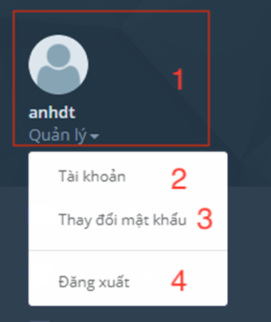

Figure 76. Personal menu

**Fields**

|  |  |  |  |  |  |  |
| --- | --- | --- | --- | --- | --- | --- |
| **No** | **Field Name** | **Description** | **Read only** | **Mandatory** | **Control Type** | **Data Type** |
| 1 | AccountInformation | Display user’s full name and role. | Yes | Yes | Text | String |

Table 96. <Fields>Personal menu

**Buttons/Hyperlinks:**

|  |  |  |  |  |
| --- | --- | --- | --- | --- |
| **No** | **Function** | **Description** | **Validation** | **Outcome** |
| 2 | UpdateProfile | Update profile | N/A | Redirect to profile page |
| 3 | ChangePassword | Change password | N/A | Redirect to change password page |
| 4 | Logout | Logout | N/A | Logout and redirect to login page |

Table 97. <Buttons/Hyperlinks> Personal menu

* + 1. Personal information page

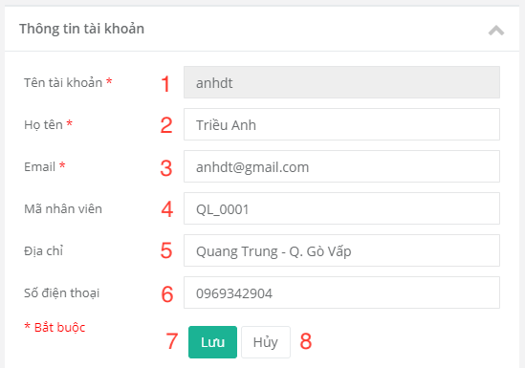

Figure 77. Personal information page

**Fields**

|  |  |  |  |  |  |  |
| --- | --- | --- | --- | --- | --- | --- |
| **No** | **Field Name** | **Description** | **Read only** | **Mandatory** | **Control Type** | **Data Type** |
| 1 | Account | Username | Yes | Yes | TextBox | String |
| 2 | Name | Name | No | Yes | TextBox | String |
| 3 | Email | Email | No | Yes | Textbox | String |
| 4 | StaffCode | Staff’ code | No | No | Textbox | String |
| 5 | Address | Address | No | No | Textbox | String |
| 6 | Phone number | Phone number | No | No | Textbox | String |

Table 98. <Fields> Personal information page

**Buttons/Hyperlinks:**

|  |  |  |  |  |
| --- | --- | --- | --- | --- |
| **No** | **Function** | **Description** | **Validation** | **Outcome** |
| 7 | Save | Save new user’s information | Validate required fields | Redirect to personal information page |
| 8 | Cancel | N/A | N/A | Redirect to perpsonal page |

Table 99. <Buttons/Hyperlinks> Personal information page

* + 1. Change password page

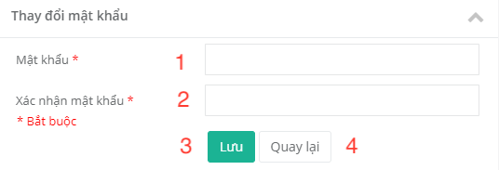

Figure 78. Change password page

**Fields**

|  |  |  |  |  |  |  |
| --- | --- | --- | --- | --- | --- | --- |
| **No** | **Field Name** | **Description** | **Read only** | **Mandatory** | **Control Type** | **Data Type** |
| 1 | Password | New password | No | Yes | TextBox | String |
| 2 | ConfirmPassword | Confirm password | No | Yes | TextBox | String |

Table 100. <Fields> Change password page

**Buttons/Hyperlinks:**

|  |  |  |  |  |
| --- | --- | --- | --- | --- |
| **No** | **Function** | **Description** | **Validation** | **Outcome** |
| 3 | Save | Save new password | Validate all required fields | Redirect to login page |
| 4 | Back | N/A | N/A | Redirect to Personal page |

Table 101. <Buttons/Hyperlinks> Change password page

* 1. Manager Interface Design
     1. Manager’s menu

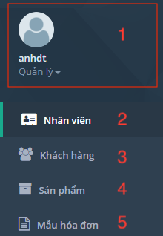

Figure 79. Manager’s menu

**Fields**

|  |  |  |  |  |  |  |
| --- | --- | --- | --- | --- | --- | --- |
| **No** | **Field Name** | **Description** | **Read only** | **Mandatory** | **Control Type** | **Data Type** |
| 1 | AccountInformation | Display user’s full name and role. | Yes | Yes | Text | String |

Table 102. <Fields> Manager’s menu

**Buttons/Hyperlinks:**

|  |  |  |  |  |
| --- | --- | --- | --- | --- |
| **No** | **Function** | **Description** | **Validation** | **Outcome** |
| 2 | Staff | Manage staff | N/A | Navigate to staff list page |
| 3 | Customer | Manage customer | N/A | Navigate to customer list page |
| 4 | Product | Manage product | N/A | Navigate to product list page |
| 5 | Template | Manage template | N/A | Navigate to template list page |

Table 103. <Buttons/Hyperlinks> Manager’s menu

* + 1. Staff management
       1. View staff list

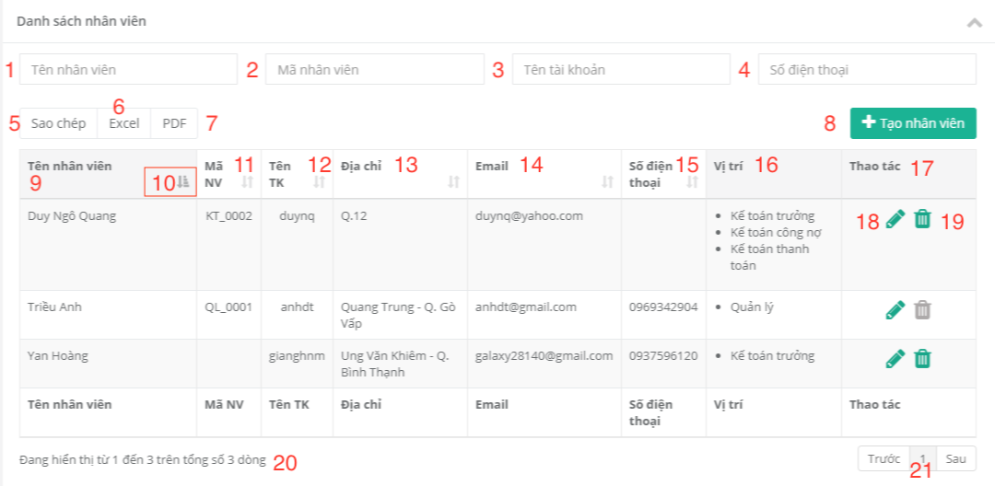

Figure 80. View staff list

**Fields**

|  |  |  |  |  |  |  |
| --- | --- | --- | --- | --- | --- | --- |
| **No** | **Field Name** | **Description** | **Read only** | **Mandatory** | **Control Type** | **Data Type** |
| 1 | SearchName | Search by staff’s name | No | Yes | TextBox | String |
| 2 | SearchCode | Search by staff’s code | No | Yes | TextBox | String |
| 3 | SearchUsername | Search by staff’s username | No | Yes | TextBox | String |
| 4 | SearchPhone | Search by staff’s phone number | No | Yes | TextBox | String |
| 9 | StaffName | Staff’s name | Yes | No | Text | String |
| 11 | StaffCode | Staff’s code | Yes | No | Text | String |
| 12 | Username | Staff’s username | Yes | No | Text | String |
| 13 | Address | Staff’s address | Yes | No | Text | String |
| 14 | Email | Staff’email | Yes | No | Text | String |
| 15 | PhoneNumber | Staff’s phone number | Yes | No | Text | String |
| 16 | Role | Staff’s role(s) | Yes | No | Text | String |
| 17 | Manipulations | Row manipulation | Yes | No | Text | String |
| 20 | NumberDisplay | Display number of staff being shown | Yes | No | Text | String |

Table 104. <Fields> View staff list

**Buttons/Hyperlinks:**

|  |  |  |  |  |
| --- | --- | --- | --- | --- |
| **No** | **Function** | **Description** | **Validation** | **Outcome** |
| 5 | Copy | Copy table to clipboard | N/A | N/A |
| 6 | Excel | Export excel file | N/A | Download excel file |
| 7 | PDF | Export PDF file | N/A | Download PDF file |
| 8 | CreateStaff | Create new staff | N/A | Navigate to create staff page |
| 10 | Filter | Sort table | N/A | Sort table by column |
| 18 | Edit | Edit staff’s information | N/A | Redirect to edit staff page |
| 19 | Delete | Delete staff | N/A | Remove staff. Reload table |
| 21 | Pagination | Pagination | N/A | N/A |

Table 105. <Buttons/Hyperlinks> View staff list

* + - 1. Create staff

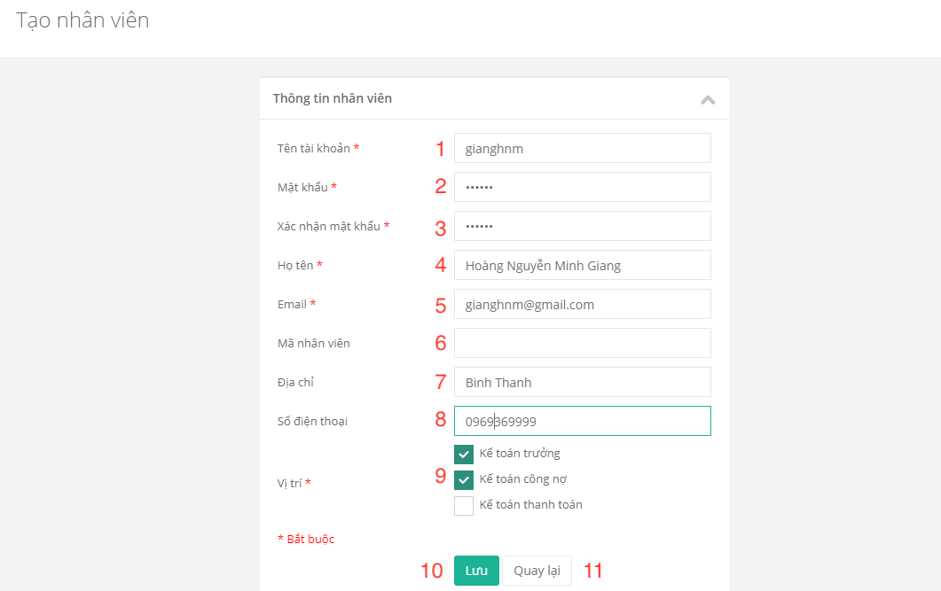

Figure 81. Create staff

**Fields**

|  |  |  |  |  |  |  |
| --- | --- | --- | --- | --- | --- | --- |
| **No** | **Field Name** | **Description** | **Read only** | **Mandatory** | **Control Type** | **Data Type** |
| 1 | Username | Staff’s username | No | Yes | Textbox | String |
| 2 | Password | Staff’s password | No | Yes | Textbox | String |
| 3 | Confirmpassword | Confirm staff’s password | No | Yes | Textbox | String |
| 4 | Name | Staff’s name | No | Yes | Textbox | String |
| 5 | Email | Staff’s email | No | Yes | Textbox | String |
| 6 | StaffCode | Staff’s code | No | No | Textbox | String |
| 7 | Address | Staff’s address | No | No | Textbox | String |
| 8 | PhoneNumber | Staff’s phone number | No | No | Textbox | String |
| 9 | Role | Staff’s role(s) | Yes | Yes | Checkbox | String |

Table 106. <Fields> Create staff

**Buttons/Hyperlinks:**

|  |  |  |  |  |
| --- | --- | --- | --- | --- |
| **No** | **Function** | **Description** | **Validation** | **Outcome** |
| 10 | Save | Save new staff | Validate required fields | Create staff.  Navigate to staff list page with success message. |
| 11 | Back | Cancel | N/A | Return to staff list page |

Table 107. <Buttons/Hyperlinks> Create staff

* + 1. Customer management
       1. View customer list

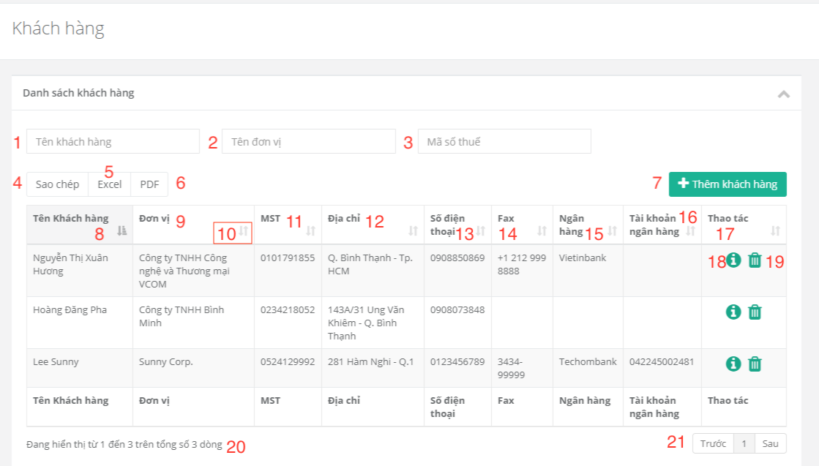

Figure 82. View customer list

**Fields**

|  |  |  |  |  |  |  |
| --- | --- | --- | --- | --- | --- | --- |
| **No** | **Field Name** | **Description** | **Read only** | **Mandatory** | **Control Type** | **Data Type** |
| 1 | SearchName | Search by customer’s name | No | Yes | TextBox | String |
| 2 | SearchEnterprise | Search by customer’s enterprise | No | Yes | TextBox | String |
| 3 | SearchTaxNo | Search by customer’s tax no | No | Yes | TextBox | String |
| 8 | CustomerName | Customer’s name | Yes | Yes | Text | String |
| 9 | Enterprise | Customer’s enterprise | Yes | Yes | Text | String |
| 11 | TaxNo | Customer’s tax no | Yes | Yes | Text | String |
| 12 | Address | Customer’s address | Yes | Yes | Text | String |
| 13 | PhoneNumber | Customer’s phone number | Yes | Yes | Text | String |
| 14 | Fax | Customer’s fax number | Yes | Yes | Text | String |
| 15 | Bank | Customer’s bank name | Yes | Yes | Text | String |
| 16 | BankAccountNo | Customer’s bank account number | Yes | Yes | Text | String |
| 17 | Manipulations | Row manipulation | Yes | Yes | Text | String |
| 20 | RowsNumber | Display number of customers | Yes | No | Text | String |

Table 108. <Fields>View customer list

**Buttons/Hyperlinks:**

|  |  |  |  |  |
| --- | --- | --- | --- | --- |
| **No** | **Function** | **Description** | **Validation** | **Outcome** |
| 4 | Copy | Copy table to clipboard | N/A | N/A |
| 5 | Excel | Export excel file | N/A | Download excel file |
| 6 | PDF | Export PDF file | N/A | Download PDF file |
| 7 | AddCustomer | Create customer | N/A | Navigate to create customer page |
| 10 | Filter | Sort table | N/A | Sort table by column |
| 18 | Information | Customer’s product information | N/A | Show customer product popup. |
| 19 | Delete | Delete customer | N/A | Remove customer. Reload table. |
| 21 | Pagination | Pagination | N/A | N/A |

Table 109. <Buttons/Hyperlinks>View customer list

* + - 1. Create customer

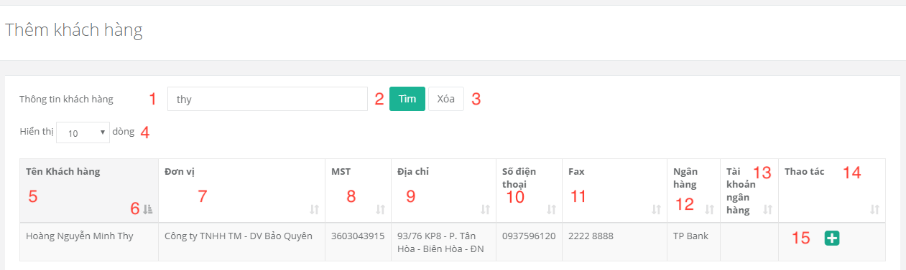

Figure 83. Create customer

**Fields**

|  |  |  |  |  |  |  |
| --- | --- | --- | --- | --- | --- | --- |
| **No** | **Field Name** | **Description** | **Read only** | **Mandatory** | **Control Type** | **Data Type** |
| 1 | Search | Search by account information | No | Yes | TextBox | String |
| 4 | RowsNumber | Number of accounts being displayed in table | No | Yes | Drop down list | String |
| 5 | CustomerName | Customer’s name | Yes | Yes | Text | String |
| 7 | Enterprise | Customer’s enterprise | Yes | Yes | Text | String |
| 8 | Tax no | Customer’s tax no | Yes | Yes | Text | String |
| 9 | Address | Customer’s address | Yes | Yes | Text | String |
| 10 | PhoneNumber | Customer’s phone number | Yes | Yes | Text | String |
| 11 | Fax | Customer’s fax number | Yes | Yes | Text | String |
| 12 | Bank | Customer’s bank name | Yes | Yes | Text | String |
| 13 | BankAccountNo | Customer’s bank account number | Yes | Yes | Text | String |
| 14 | Manipulations | Row manipulation | Yes | Yes | Text | String |

Table 110. <Fields> Create customer

**Buttons/Hyperlinks:**

|  |  |  |  |  |
| --- | --- | --- | --- | --- |
| **No** | **Function** | **Description** | **Validation** | **Outcome** |
| 2 | Search | Search account by keyword | N/A | Table of accounts that match with search keyword |
| 3 | Delete | Delete text in search textbox | N/A | N/A |
| 6 | Filter | Sort table | N/A | Table is sorted |
| 15 | Add | Add account to company’s customer list | N/A | Show success message |

Table 111. <Buttons/Hyperlinks> Create customer

* + 1. Product management
       - 1. View product list

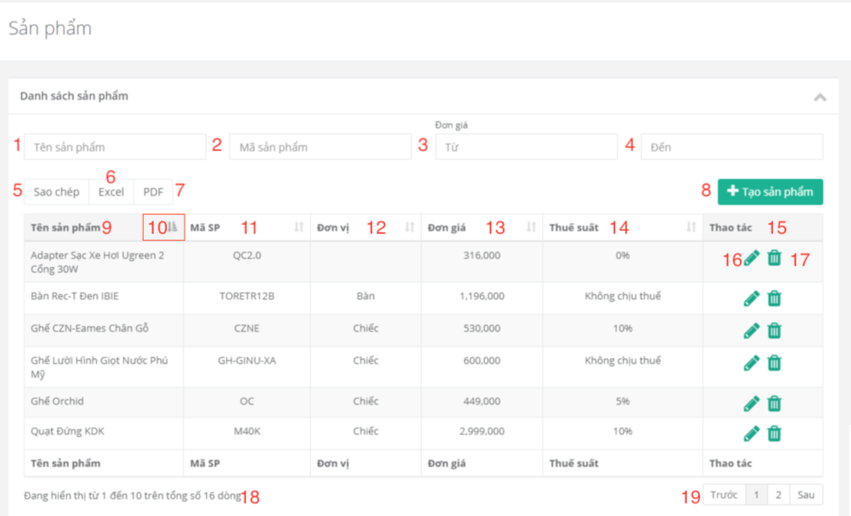

Figure 84. View product list

**Fields**

|  |  |  |  |  |  |  |
| --- | --- | --- | --- | --- | --- | --- |
| **No** | **Field Name** | **Description** | **Read only** | **Mandatory** | **Control Type** | **Data Type** |
| 1 | SearchName | Search by product name | No | Yes | TextBox | String |
| 2 | SearchCode | Search by product code | No | Yes | TextBox | String |
| 3 | PriceFrom | Search by min price | No | Yes | TextBox | String |
| 4 | PriceTo | Search by max price | No | Yes | TextBox | String |
| 9 | ProductName | Product name | Yes | Yes | Text | String |
| 11 | ProductVode | Product code | Yes | Yes | Text | String |
| 12 | Unit | Product unit | Yes | Yes | Text | String |
| 13 | UnitPrice | Product unit price | Yes | Yes | Text | String |
| 14 | VAT rate | Product VAT rate | Yes | Yes | Text | String |
| 15 | Manipulations | Row manipulation | Yes | Yes | Text | String |
| 18 | RowsNumber | Number of products being displayd in table | Yes | Yes | Text | String |

Table 112. View product list

**Buttons/Hyperlinks:**

|  |  |  |  |  |
| --- | --- | --- | --- | --- |
| **No** | **Function** | **Description** | **Validation** | **Outcome** |
| 5 | Copy | Copy all table | N/A | N/A |
| 6 | Excel | Export excel file | N/A | Download excel file |
| 7 | PDF | Export PDF file | N/A | Download PDF file |
| 8 | Add | Create product | N/A | Navigate to create product page |
| 10 | Filter | Sort table | N/A | Table is sorted |
| 16 | Edit | Edit information product | N/A | Redirect to edit product page |
| 17 | Delete | Delete product | N/A | Remove product. Reload table |
| 19 | Pagination | Pagination | N/A | N/A |

Table 113. <Buttons/Hyperlinks> View product list

* + - * 1. Create product

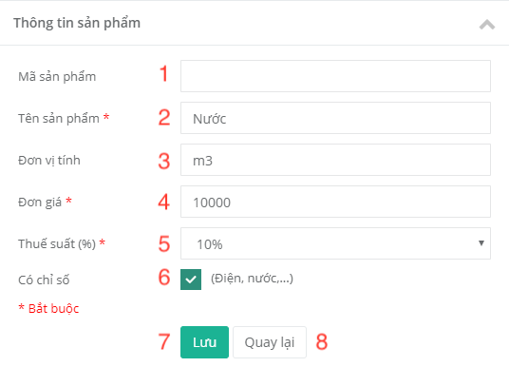

Figure 85. Create product

**Fields**

|  |  |  |  |  |  |  |
| --- | --- | --- | --- | --- | --- | --- |
| **No** | **Field Name** | **Description** | **Read only** | **Mandatory** | **Control Type** | **Data Type** |
| 1 | ProductCode | Product’s code | No | No | Textbox | String |
| 2 | ProductName | Product’s name | No | Yes | Textbox | String |
| 3 | Unit | Unit product | No | No | Textbox | String |
| 4 | UnitPrice | Unit price product | No | Yes | Textbox | String |
| 5 | VATRate | VAT rate product | No | Yes | Textbox | String |
| 6 | HasIndex | Product has index or not | No | No | Checkbox | String |

Table 114. <Fields> Create product

**Buttons/Hyperlinks:**

|  |  |  |  |  |
| --- | --- | --- | --- | --- |
| **No** | **Function** | **Description** | **Validation** | **Outcome** |
| 7 | Save | Create product | Validate required fields | Create product.  Navigate to product list page. |
| 8 | Back | Cancel create product | N/A | Return to product list page. |

Table 115. <Buttons/Hyperlinks> Create product

* + 1. Template Management
       - 1. View Template List

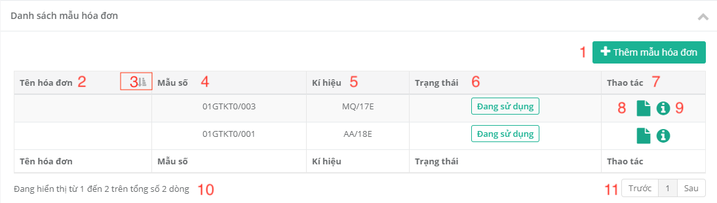

Figure 86. View template list

**Fields**

|  |  |  |  |  |  |  |
| --- | --- | --- | --- | --- | --- | --- |
| **No** | **Field Name** | **Description** | **Read only** | **Mandatory** | **Control Type** | **Data Type** |
| 2 | Name Invoice | Name Invoice | Yes | Yes | Text | String |
| 4 | Form | Template’s Form | Yes | Yes | Text | String |
| 5 | Serial | Template’s Serial | Yes | Yes | Text | String |
| 6 | Status | Template’s status | Yes | Yes | Text | String |
| 7 | Manipulations | Row manipulation | Yes | Yes | Text | String |
| 10 | RowsNumber | Number of templates being displayed in table | Yes | Yes | Text | String |

Table 116. <Fields> View template list

**Buttons/Hyperlinks:**

|  |  |  |  |  |
| --- | --- | --- | --- | --- |
| **No** | **Function** | **Description** | **Validation** | **Outcome** |
| 1 | Add | Create template invoice | N/A | Navigate to create template page |
| 3 | Filter | Sort table | N/A | Table is sorted |
| 8 | TemplateFile | File of template | N/A | Show file popup |
| 9 | Detail | Template’s detail | N/A | Show template detail popup |
| 11 | Pagination | Pagination | N/A | N/A |

Table 117. <Buttons/Hyperlinks> View template list

* + - * 1. View template detail

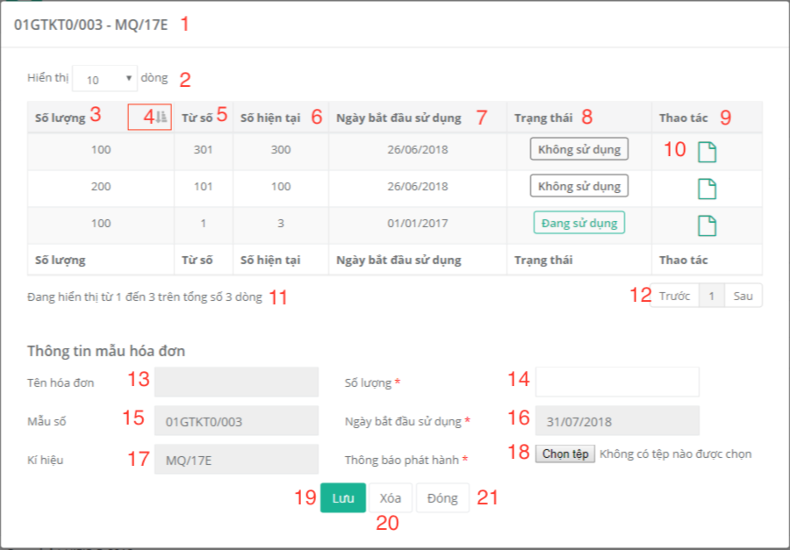

Figure 87. View template detail

**Fields**

|  |  |  |  |  |  |  |
| --- | --- | --- | --- | --- | --- | --- |
| **No** | **Field Name** | **Description** | **Read only** | **Mandatory** | **Control Type** | **Data Type** |
| 1 | Title | Template title | Yes | No | Text | String |
| 2 | Number Row | Number of rows being displayed in table | Yes | Yes | Dropdown list | String |
| 3 | Amount | Template amount | Yes | Yes | Text | String |
| 5 | BeginNo | Template begin number | Yes | Yes | Text | String |
| 6 | CurrentNo | Template current number | Yes | Yes | Text | String |
| 7 | ReleaseDate | Start date to use template | Yes | Yes | Text | String |
| 8 | Status | Tempalte status | Yes | Yes | Text | String |
| 9 | Manipulations | Row manipulation | Yes | Yes |  | String |
| 11 | RowsNumber | Display how many template is being shown | Yes | Yes | Text | String |
| 13 | TemplateName | Template name | Yes | Yes | Textbox | String |
| 14 | txtAmount | Template amount | No | Yes | Textbox | Number |
| 15 | Form | Template form | Yes | Yes | Textbox | String |
| 16 | txtReleaseDate | Start date to use template | Yes | Yes | Datetime-picker | Date-Time |
| 17 | txtSerial | Template serial | Yes | Yes | Textbox | String |

Table 118. <Fields> View template detail

**Buttons/Hyperlinks:**

|  |  |  |  |  |
| --- | --- | --- | --- | --- |
| **No** | **Function** | **Description** | **Validation** | **Outcome** |
| 4 | Filter | Sort table | N/A | Table is sorted |
| 10 | ReleaseAnnounce | Template announcement | N/A | Show release announcement file popup |
| 12 | Pagination | Pagination | N/A | N/A |
| 18 | Announcement release | Choose file announcement release | N/A | Show File Explorer popup |
| 19 | Save | Save new template information | Validate required fields | Add new block to table. Reload table. |
| 20 | Delete | Clear text | N/A | Clear all textboxes |
| 21 | Close | Close modal | N/A | Popup is closed. |

Table 119. <Buttons/Hyperlinks> View template detail

* + - * 1. Create template

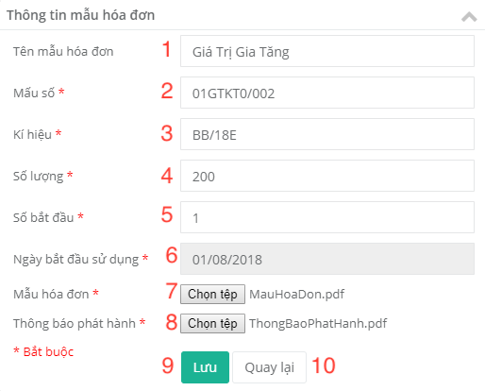

Figure 88. Create template

**Fields**

|  |  |  |  |  |  |  |
| --- | --- | --- | --- | --- | --- | --- |
| **No** | **Field Name** | **Description** | **Read only** | **Mandatory** | **Control Type** | **Data Type** |
| 1 | Name | Template name | No | Yes | Textbox | String |
| 2 | Form | Template form | No | Yes | Textbox | String |
| 3 | Serial | Template serial | No | Yes | Textbox | String |
| 4 | Amount | Template amount | No | Yes | Textbox | Number |
| 5 | BeginNo | Template begin no | No | Yes | Textbox | Number |
| 6 | Release date | Start date to use template | Yes | Yes | Datetimepicker | Date |

Table 120. <Fields> Create template

**Buttons/Hyperlinks:**

|  |  |  |  |  |
| --- | --- | --- | --- | --- |
| **No** | **Function** | **Description** | **Validation** | **Outcome** |
| 1 | TemplateFile | Choice file template | N/A | Show File Explorer popup |
| 8 | AnnouncementFile | Choice file announcement | N/A | Show File Explorer popup |
| 9 | Save | Create new template | Validate required fields | Create template.  Navigate to template list page with success message |
| 15 | Back | Cancel | N/A | Return to template list page |

Table 121. <Buttons/Hyperlinks> Create template

* 1. Accountant Interface Design
     1. Accountant’s menu

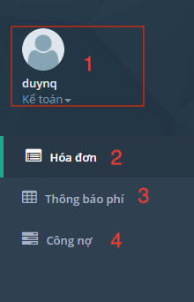

Figure 89. Accountant’s menu

**Fields**

|  |  |  |  |  |  |  |
| --- | --- | --- | --- | --- | --- | --- |
| **No** | **Field Name** | **Description** | **Read only** | **Mandatory** | **Control Type** | **Data Type** |
| 1 | Accountinformation | Display user’s name and role | Yes | Yes | Text | String |

Table 122. <Fields> Accountant’s menu

**Buttons/Hyperlinks:**

|  |  |  |  |  |
| --- | --- | --- | --- | --- |
| **No** | **Function** | **Description** | **Validation** | **Outcome** |
| 2 | Invoice | Manage invoice | N/A | Navigate to invoice list page |
| 3 | ProformaInvoice | Manage Proforma Invoice | N/A | Navigate to proforma invoice list page |
| 4 | Liabilities | Manage Liabilities | N/A | Navigate to liabilities page |

Table 123. <Buttons/Hyperlinks> Accountant’s menu

* + 1. Invoice management
       1. View invoice list

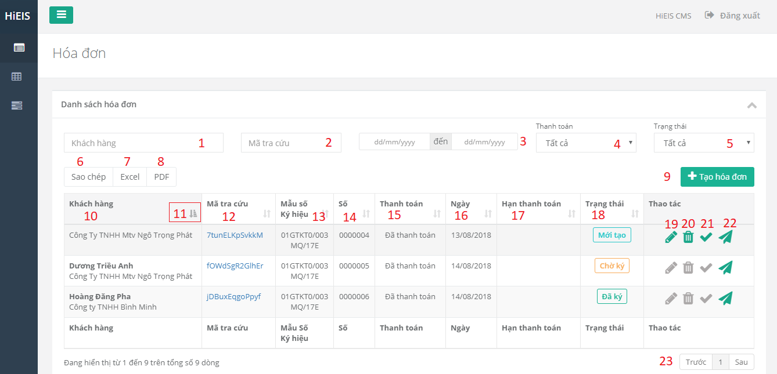

Figure 90. View invoice list

**Fields**

|  |  |  |  |  |  |  |
| --- | --- | --- | --- | --- | --- | --- |
| **No** | **Field Name** | **Description** | **Read only** | **Mandatory** | **Control Type** | **Data Type** |
| 1 | SearchName | Search by customer’s name | No | Yes | Textbox | String |
| 2 | SearchLookup | Search by lookup code | No | Yes | Textbox | String |
| 3 | SearchDate | Search by from date and to date | No | Yes | Datepicker | Date |
| 4 | SearchPaymentStatus | Search by payment status | Yes | Yes | Drop down list | String |
| 5 | SearchInvoiceStatus | Search by invoice status | Yes | Yes | Drop down list | String |
| 10 | Customer | Customer | Yes | Yes | Text | String |
| 12 | LookupCode | Invoice lookup code | Yes | Yes | Text | String |
| 13 | FormSerial | Template form and serial | Yes | Yes | Text | String |
| 14 | Number | Invoice number | Yes | Yes | Text | String |
| 15 | PaymentStatus | Payment status | Yes | Yes | Text | String |
| 16 | Date | Invoice date | Yes | Yes | Text | String |
| 17 | Duedate | Payment deadline | Yes | Yes | Text | Date |
| 18 | Status | Invoice status | Yes | Yes | Text | String |

Table 124. <Fields> View invoice list

**Buttons/Hyperlinks:**

|  |  |  |  |  |
| --- | --- | --- | --- | --- |
| **No** | **Function** | **Description** | **Validation** | **Outcome** |
| 6 | Copy | Copy all table | N/A | N/A |
| 7 | Excel | Export excel file | N/A | Download excel |
| 8 | PDF | Export PDF file | N/A | Download PDF file |
| 9 | Create | Create Invoice | N/A | Navigate to create invoice page |
| 11 | Filter | Sort table | N/A | Table is sorted |
| 19 | Edit | Edit invoice information | N/A | Redirect to edit invoice page |
| 20 | Delete | Delete invoice | N/A | Table is reloaded |
| 21 | Checkpayment | Invoice’s payment status | N/A | Payment status and invoice status are changed |
| 22 | SendEmail | Send email to customer | N/A | N/A |
| 23 | Pagination | Pagination | N/A | N/A |

Table 125. <Buttons/Hyperlinks> View invoice list

* + - 1. Create invoice
         1. Customer information

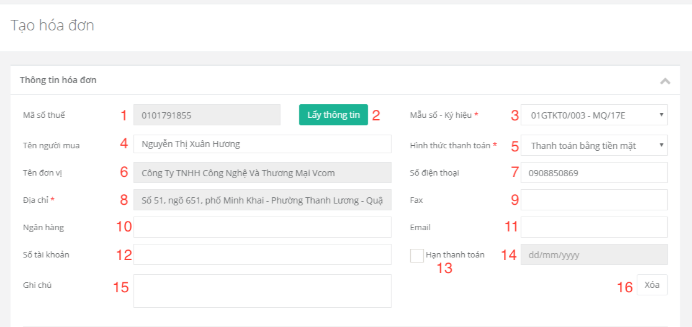

Figure 91. Customer information

**Fields**

|  |  |  |  |  |  |  |
| --- | --- | --- | --- | --- | --- | --- |
| **No** | **Field Name** | **Description** | **Read only** | **Mandatory** | **Control Type** | **Data Type** |
| 1 | TaxNo | Customer’s tax no | No | Yes | Textbox | String |
| 3 | FormSerial | Template form and serial | No | Yes | Drop down list | String |
| 4 | Name | Customer’s name | No | Yes | Textbox | String |
| 5 | PaymentMethod | Payment method | No | Yes | Drop down list | String |
| 6 | Enterprise | Enterprise | No | Yes | Textbox | String |
| 7 | Tel | Customer’s phone number | No | Yes | Textbox | String |
| 8 | Address | Customer’s address | No | Yes | Textbox | String |
| 9 | Fax | Fax number | No | Yes | Texbox | String |
| 10 | Bank | Bank name | No | Yes | Texbox | String |
| 11 | Email | Customer’s email | No | Yes | Texbox | String |
| 12 | BankAccountNo | Bank account number | No | Yes | Texbox | String |
| 13 | HasDuedate | Invoice has duedate or not | No | Yes | Checkbox | String |
| 14 | Duedate | Duedate | No | Yes | Datepicker | Date |
| 15 | Note | Note | No | No | Textbox | String |

Table 126. <Fields> Customer information

**Buttons/Hyperlinks:**

|  |  |  |  |  |
| --- | --- | --- | --- | --- |
| **No** | **Function** | **Description** | **Validation** | **Outcome** |
| 2 | Get information | Search customer’s information | Input TaxNo | Customer information textboxs are filled |
| 16 | Delete | Reset information | N/A | Clear textbox |

Table 127. <Buttons/Hyperlinks> Customer information

* + - * 1. Product information

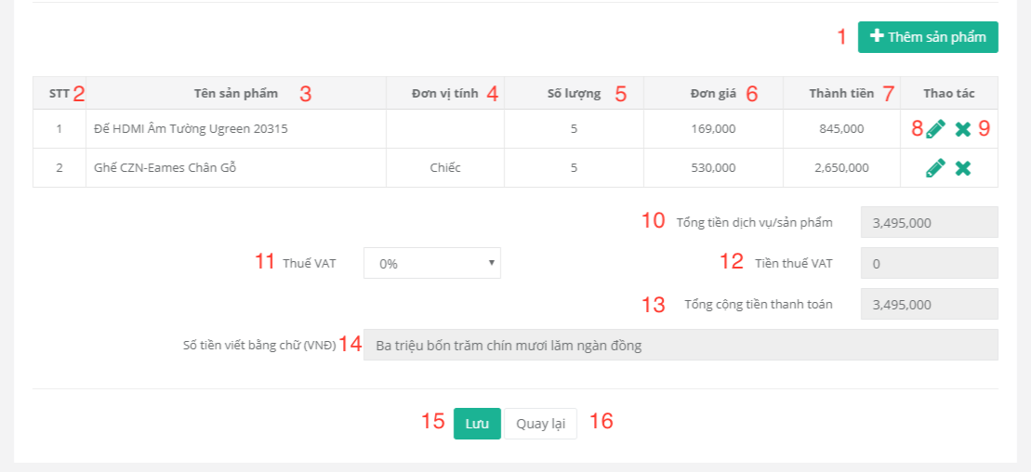

Figure 92. Product information

**Fields**

|  |  |  |  |  |  |  |
| --- | --- | --- | --- | --- | --- | --- |
| **No** | **Field Name** | **Description** | **Read only** | **Mandatory** | **Control Type** | **Data Type** |
| 2 | No | Number | Yes | Yes | Text | String |
| 3 | Productname | Product name | Yes | Yes | Text | String |
| 4 | Unit | Product unit | Yes | Yes | Text | String |
| 5 | Quantity | Product quantity | Yes | Yes | Text | String |
| 6 | UnitPrice | Product unit price | Yes | Yes | Text | String |
| 7 | ProductTotal | Product total | Yes | Yes | Text | String |
| 10 | Subtotal | Invoice subtotal | Yes | Yes | Text | String |
| 11 | VATRate | Invoice VAT rate | No | Yes | Drop down list | String |
| 12 | VATAmount | Invoice VAT amount | Yes | Yes | Text | String |
| 13 | Total | Invoice total | Yes | Yes | Text | String |
| 14 | AmountInWords | Total in words | Yes | Yes | Text | String |

Table 128. <Fields> Product information

**Buttons/Hyperlinks:**

|  |  |  |  |  |
| --- | --- | --- | --- | --- |
| **No** | **Function** | **Description** | **Validation** | **Outcome** |
| 1 | Add product | Add product | N/A | Show product popup |
| 8 | Edit | Edit product | N/A | Show edit product popup |
| 9 | Delete | Delete product | N/A | Remove product. Reload table. |
| 15 | Save | Save invoice | Validate required fields | Create invoice.  Navigate to invoice list page with success message |
| 16 | Back | Cancel | N/A | Return to invoice list page |

Table 129. <Buttons/Hyperlinks> Product information

* + - * 1. Create invoice’s product popup

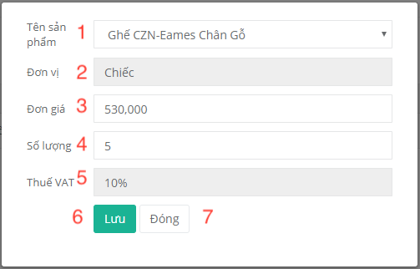

Figure 93. Create invoice’s product popup

**Fields**

|  |  |  |  |  |  |  |
| --- | --- | --- | --- | --- | --- | --- |
| **No** | **Field Name** | **Description** | **Read only** | **Mandatory** | **Control Type** | **Data Type** |
| 1 | ProductName | Product name | No | Yes | TextBox | String |
| 2 | Unit | Product unit | Yes | Yes | TextBox | String |
| 3 | UnitPrice | Product unit price | No | Yes | TextBox | String |
| 4 | Quantity | Product quantity | No | Yes | TextBox | Number |
| 5 | VATRate | Product VAT rate | Yes | Yes | TextBox | String |

Table 130. <Fields> Create invoice’s product popup

**Buttons/Hyperlinks:**

|  |  |  |  |  |
| --- | --- | --- | --- | --- |
| **No** | **Function** | **Description** | **Validation** | **Outcome** |
| 6 | Save | Add product to item list | Validate required fields | Close product popup |
| 7 | Close | Cancel | N/A | Close product popup |

Table 131. <Buttons/Hyperlinks> Create invoice’s product popup

* + 1. Proforma invoice management
       1. View proforma invoice list

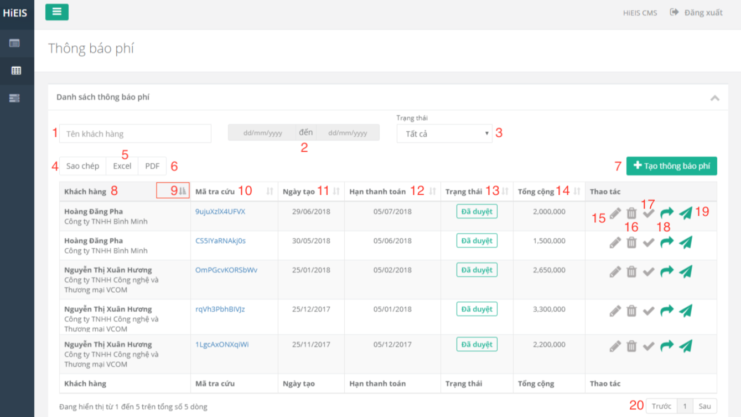

Figure 94. View proforma invoice list

**Fields**

|  |  |  |  |  |  |  |
| --- | --- | --- | --- | --- | --- | --- |
| **No** | **Field Name** | **Description** | **Read only** | **Mandatory** | **Control Type** | **Data Type** |
| 1 | SearchCustomer | Search by customer’s name | No | Yes | Text | String |
| 2 | SearchDate | Search by from date and to date | No | Yes | Datepicker | Date |
| 3 | SearchStatus | Search by status | No | Yes | Drop down list | String |
| 8 | Customer | Customer’s name | Yes | Yes | Text | String |
| 10 | Lookupcode | Lookup code | Yes | Yes | Text | String |
| 11 | Date | Date | Yes | Yes | Text | String |
| 12 | PaymentDeadline | Payment deadline | Yes | Yes | Text | String |
| 13 | Status | Status | Yes | Yes | Text | String |
| 14 | Total | Total | Yes | Yes | Text | String |

Table 132. <Fields> View proforma invoice list

**Buttons/Hyperlinks:**

|  |  |  |  |  |
| --- | --- | --- | --- | --- |
| **No** | **Function** | **Description** | **Validation** | **Outcome** |
| 4 | Copy | Copy table to clipboard | N/A | N/A |
| 5 | Excel | Export excel file | N/A | Download excel file |
| 6 | PDF | Export PDF file | N/A | Download PDF file |
| 7 | Create | Create Proforma Invoice | N/A | Navigate to create proforma invoice page |
| 9 | Filter | Sort table | N/A | Table is sorted |
| 15 | Edit | Edit proforma invoice | N/A | Redirect to edit proforma invoice page |
| 16 | Delete | Delete proformainvoice | N/A | Table is reloaded |
| 17 | Approve | Approve proforma Invoice | N/A | Proforma invoice status is changed |
| 18 | ConvertIntoInvoice | Convert proforma invoice into Invoice | N/A | Convert into invoice and transfer data to create invoice page |
| 19 | SendEmail | Send email | N/A | Email is sent to customer |
| 25 | Pagination | Pagination | N/A | N/A |

Table 133. <Buttons/Hyperlinks> View proforma invoice list

* + - 1. Create proforma invoice
         1. Proforma invoice information

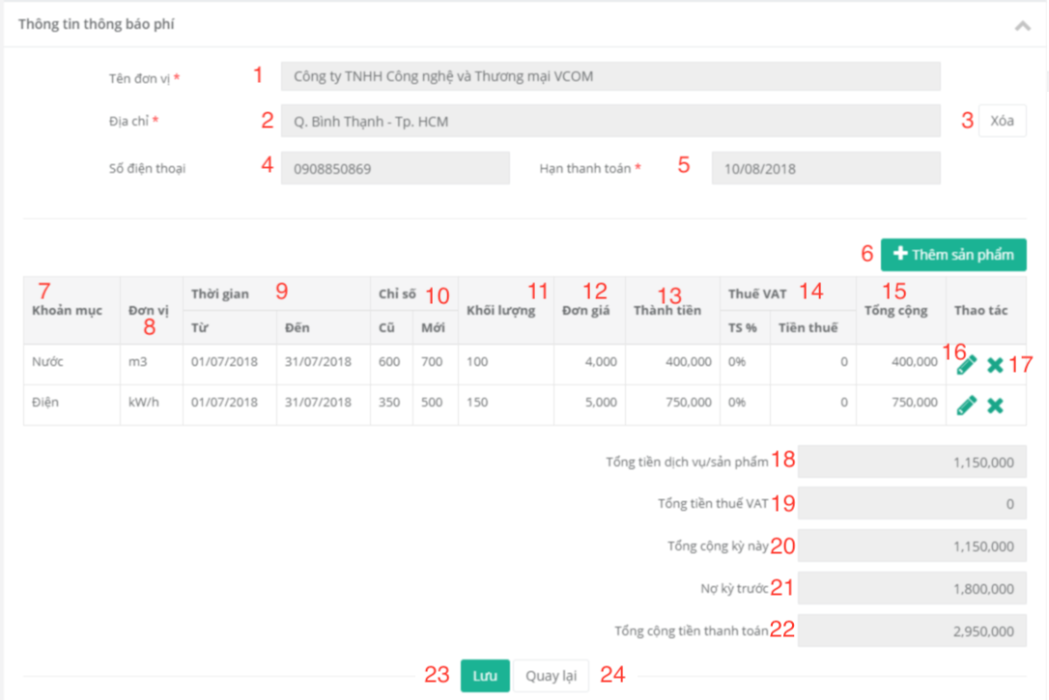

Figure 95. Proforma invoice information

**Fields**

|  |  |  |  |  |  |  |
| --- | --- | --- | --- | --- | --- | --- |
| **No** | **Field Name** | **Description** | **Read only** | **Mandatory** | **Control Type** | **Data Type** |
| 1 | Enterprise | Enterprise | No | Yes | Textbox | String |
| 2 | Address | Address | No | Yes | Textbox | Datetime |
| 4 | Tel | Phone number | No | Yes | Textbox | String |
| 5 | PaymentDeadline | Payment Deadline | Yes | Yes | Date  picker | String |
| 7 | ProductName | Product name | Yes | Yes | Text | String |
| 8 | Unit | Product unit | Yes | Yes | Text | String |
| 9 | Time | From date - to date | Yes | Yes | Text | String |
| 10 | Index | Old index - new index | Yes | Yes | Text | String |
| 11 | Quantity | Quantity | Yes | Yes | Text | String |
| 12 | UnitPrice | Price per unit | Yes | Yes | Text | String |
| 13 | ProSubTotal | Product subtotal | Yes | Yes | Text | String |
| 14 | VAT | VAT rate and VAT amount | Yes | Yes | Text | String |
| 15 | ProTotal | Product total | Yes | Yes | Text | String |
| 18 | Subtotal | Subtotal | Yes | Yes | Text | String |
| 19 | VATAmount | VAT amount | Yes | Yes | Text | String |
| 20 | TotalNoLiabitlities | Total without liabilities | Yes | Yes | Text | String |
| 21 | Liabilities | Customer’s liabilities | Yes | Yes | Text | String |
| 22 | Total | Total | Yes | Yes | Text | String |

Table 134. <Fields> Proforma invoice information

**Buttons/Hyperlinks:**

|  |  |  |  |  |
| --- | --- | --- | --- | --- |
| **No** | **Function** | **Description** | **Validation** | **Outcome** |
| 3 | Clear | Clear text | N/A | Clear textbox |
| 6 | Add product | Add proforma invoice’s product | N/A | Show product popup |
| 16 | Edit | Edit product | N/A | Show product popup |
| 17 | Delete | Delete product | N/A | Table is reloaded. |
| 23 | Save | Save proforma invoice | Validate required fields | Create proforma invoice.  Navigate to proforma invoice list page with success message. |
| 24 | Back | Cancel | N/A | Return to proforma invoice list page |

Table 135. <Buttons/Hyperlinks> Proforma invoice information

* + - * 1. Create proforma invoice’s product popup

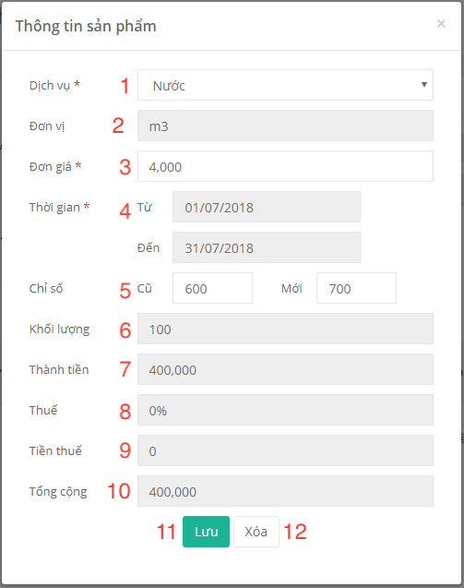

Figure 96. Create proforma invoice’s product popup

**Fields**

|  |  |  |  |  |  |  |
| --- | --- | --- | --- | --- | --- | --- |
| **No** | **Field Name** | **Description** | **Read only** | **Mandatory** | **Control Type** | **Data Type** |
| 1 | Name | Name | No | Yes | Drop down list | String |
| 2 | Unit | Unit | Yes | Yes | Textbox | String |
| 3 | UnitPrice | Unit price | No | Yes | Textbox | String |
| 4 | Time | From date - to date | No | Yes | datetimepicker | Date |
| 5 | Index | Old index - new index | No | Yes | Text | String |
| 6 | Quantity | Quantity | No | Yes | Text | String |
| 7 | Subtotal | Subtotal | Yes | Yes | Text | String |
| 8 | VATRate | VAT rate | Yes | Yes | Text | String |
| 9 | VATAmount | VAT amount | Yes | Yes | Text | String |
| 10 | Total | Total | Yes | Yes | Text | String |

Table 136. <Fields> Create proforma invoice’s product popup

**Buttons/Hyperlinks:**

|  |  |  |  |  |
| --- | --- | --- | --- | --- |
| **No** | **Function** | **Description** | **Validation** | **Outcome** |
| 11 | Save | Save product to item list | Validate required fields | Close product popup |
| 12 | Delete | Clear text | N/A | Clear textboxes |

Table 137. <Buttons/Hyperlinks> Create proforma invoice’s product popup

* + 1. Liabilities management
       1. View liabilities list

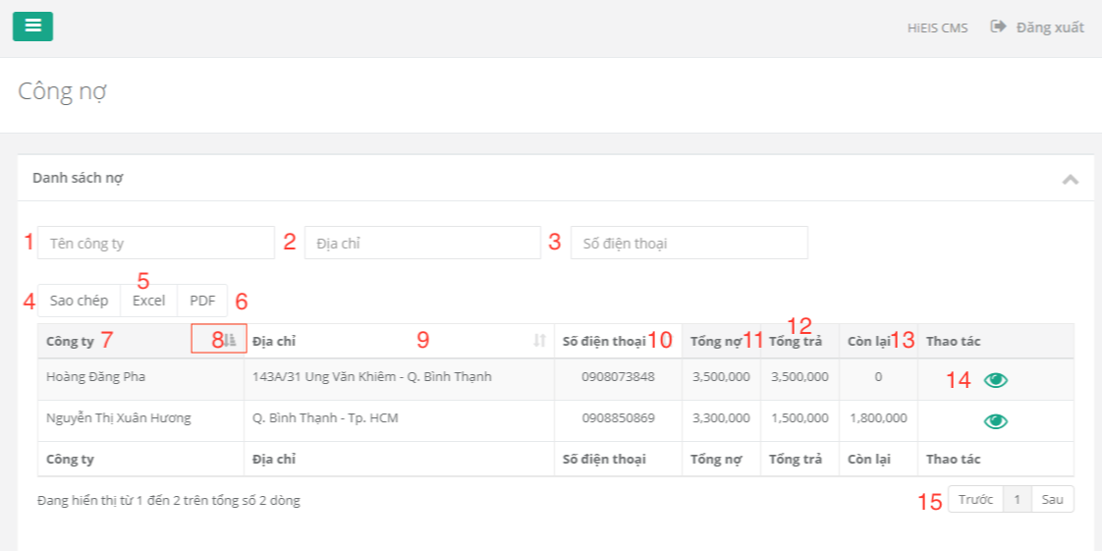

Figure 97. View liabilities list

**Fields**

|  |  |  |  |  |  |  |
| --- | --- | --- | --- | --- | --- | --- |
| **No** | **Field Name** | **Description** | **Read only** | **Mandatory** | **Control Type** | **Data Type** |
| 1 | SearchCustmer | Search by customer’s name | No | Yes | TextBox | String |
| 2 | SearchAddress | Search by address | No | Yes | TextBox | String |
| 3 | SearchPhone | Search by phone number | No | Yes | TextBox | String |
| 7 | Customer | Customer’s name | Yes | Yes | Text | String |
| 9 | Address | Customer’s address | Yes | Yes | Text | String |
| 10 | Tel | Customer’s phone | Yes | Yes | Text | String |
| 11 | TotalLiabilities | Total liabilities | Yes | Yes | Text | String |
| 12 | TotalPayment | Total payment | Yes | Yes | Text | String |
| 13 | Remain | Remain | Yes | Yes | Text | String |

Table 138. <Fields> View liabilities list

**Buttons/Hyperlinks:**

|  |  |  |  |  |
| --- | --- | --- | --- | --- |
| **No** | **Function** | **Description** | **Validation** | **Outcome** |
| 4 | Copy | Copy table to clipboard | N/A | N/A |
| 5 | Excel | Export excel file | N/A | Download xcel file |
| 6 | PDF | Export PDF file | N/A | Download PDF file |
| 14 | Details | Liabilites Detail | N/A | Redirect to liabilities detail page |
| 15 | Pagination | Pagination | N/A | N/A |

Table 139. <Buttons/Hyperlinks> View liabilities list

* + - 1. Liabilities detail

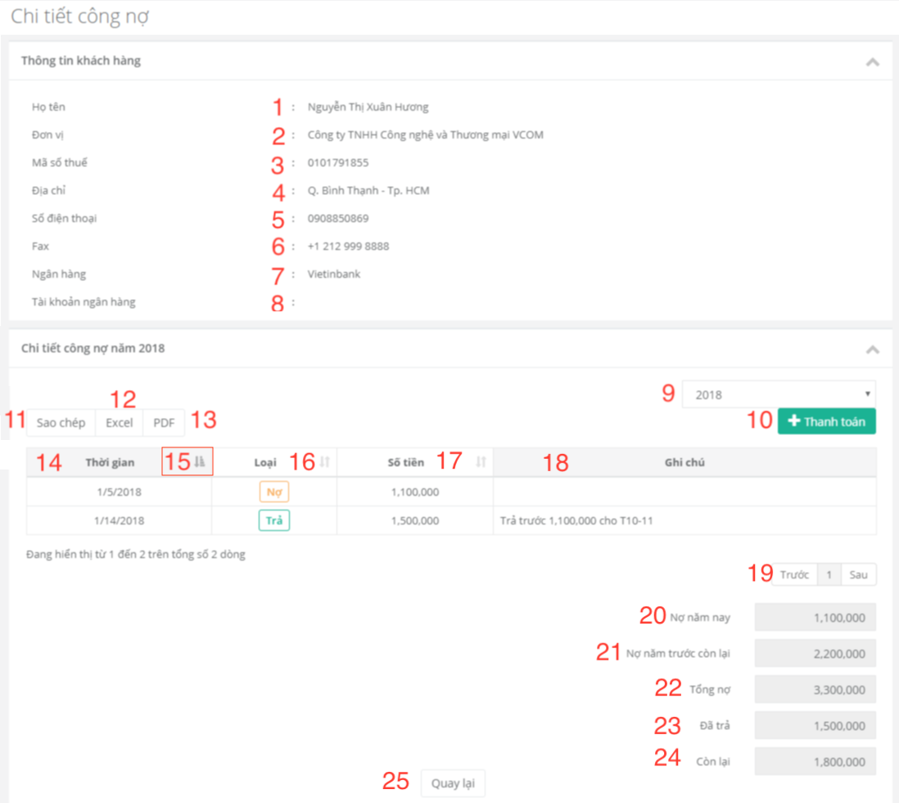

Figure 98. Liabilities detail

**Fields**

|  |  |  |  |  |  |  |
| --- | --- | --- | --- | --- | --- | --- |
| **No** | **Field Name** | **Description** | **Read only** | **Mandatory** | **Control Type** | **Data Type** |
| 1 | Name | Customer’s name | Yes | Yes | Text | String |
| 2 | Enterprise | Enterprise | Yes | Yes | Text | String |
| 3 | Taxno | Company tax no | Yes | Yes | Text | String |
| 4 | Address | Company address | Yes | Yes | Text | String |
| 5 | Phonenumber | Customer’s phone number | Yes | Yes | Text | String |
| 6 | Fax | Customer’s fax | Yes | Yes | Text | String |
| 7 | Bank | Bank | Yes | Yes | Text | String |
| 8 | Bankaccountno | Bank account number | Yes | Yes | Text | String |
| 9 | Year | Year | No | Yes | Drop down list | String |
| 14 | Date | Create date | Yes | Yes | Text | String |
| 16 | Type | Type of transaction | Yes | Yes | Text | String |
| 17 | Amount | Transaction Amount | Yes | Yes | Text | String |
| 18 | Note | Transaction note | Yes | Yes | Text | String |
| 20 | Currentliabilities | Liabilities of current year | Yes | Yes | Text | String |
| 21 | Lastyearliabilities | Liabilities of last year | Yes | Yes | Text | String |
| 22 | Totalliabilities | Total liabilities | Yes | Yes | Text | String |
| 23 | Totalpayment | Total payment | Yes | Yes | Text | String |
| 24 | Remain | Remain | Yes | Yes | Text | String |

Table 140. <Fields> Liabilities detail

**Buttons/Hyperlinks:**

|  |  |  |  |  |
| --- | --- | --- | --- | --- |
| **No** | **Function** | **Description** | **Validation** | **Outcome** |
| 10 | Payment | Add payment | N/A | Show payment modal |
| 11 | Copy | Copy table to clipboard | N/A | N/A |
| 12 | Excel | Export excel file | N/A | Download excel file |
| 13 | PDF | Export PDF file | N/A | Download PDF file |
| 15 | Filter | Sort table | N/A | Table is sorted |
| 19 | Pagination | Pagination | N/A | N/A |
| 25 | Back | Return to previous page | N/A | Return to liabilities page |

Table 141. <Buttons/Hyperlinks> Liabilities detail

* + - 1. Payment popup

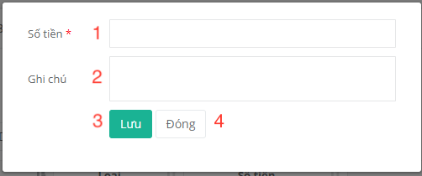

Figure 99. Payment popup

**Fields**

|  |  |  |  |  |  |  |
| --- | --- | --- | --- | --- | --- | --- |
| **No** | **Field Name** | **Description** | **Read only** | **Mandatory** | **Control Type** | **Data Type** |
| 1 | Amount | Payment amount | No | Yes | TextBox | String |
| 2 | Note | Note | No | Yes | TextBox | String |

Table 142. <Fields> Payment popup

**Buttons/Hyperlinks:**

|  |  |  |  |  |
| --- | --- | --- | --- | --- |
| **No** | **Function** | **Description** | **Validation** | **Outcome** |
| 3 | Save | Save payment | Validate required fields | Add payment transaction.  Close popup. |
| 4 | Close | Close modal | N/A | Close popup |

Table 143. <Buttons/Hyperlinks> Payment popup

* 1. Customer Interface Design
     1. Customer’s menu

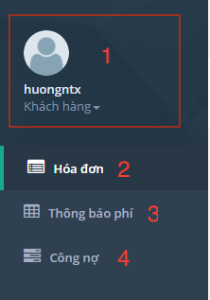

Figure 100. Customer’s menu

**Fields**

|  |  |  |  |  |  |  |
| --- | --- | --- | --- | --- | --- | --- |
| **No** | **Field Name** | **Description** | **Read only** | **Mandatory** | **Control Type** | **Data Type** |
| 1 | AccountInformation | Display user’s name and role | Yes | Yes | Textfields | String |

Table 144. <Fields> Customer’s menu

**Buttons/Hyperlinks:**

|  |  |  |  |  |
| --- | --- | --- | --- | --- |
| **No** | **Function** | **Description** | **Validation** | **Outcome** |
| 2 | Invoice | Manage invoice | N/A | Navigate to invoice list page |
| 3 | ProformaInvoice | Manage Proforma Invoice | N/A | Navigate to proforma invoice list page |
| 4 | Liabilities | Manage liabilites | N/A | Navigate to liabilities page |

Table 145. <Buttons/Hyperlinks> Customer’s menu

* + 1. Invoice list

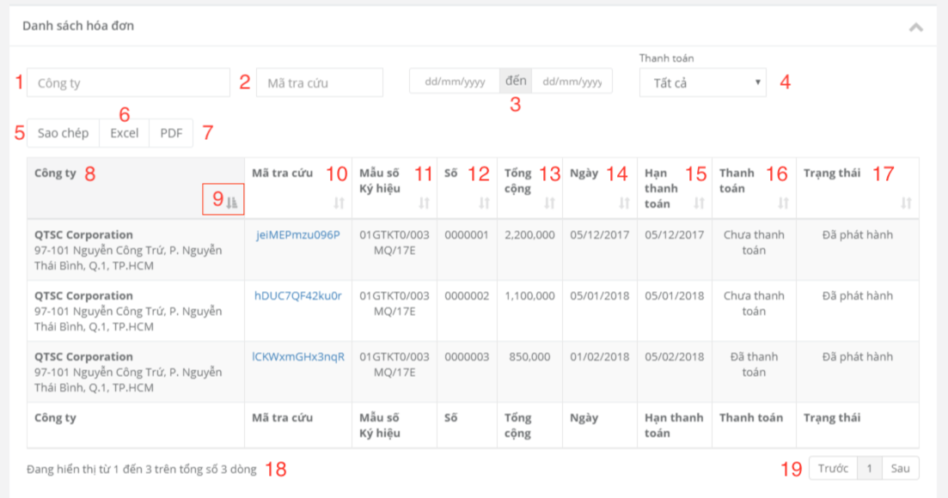

Figure 101. Invoice list

**Fields**

|  |  |  |  |  |  |  |
| --- | --- | --- | --- | --- | --- | --- |
| **No** | **Field Name** | **Description** | **Read only** | **Mandatory** | **Control Type** | **Data Type** |
| 1 | SearchName | Search by customer’s name | No | Yes | Textbox | String |
| 2 | SearchLookup | Search by lookup code | No | Yes | Textbox | String |
| 3 | SearchDate | Search by from date and to date | No | Yes | Datetimepicker | Date |
| 4 | SearchPaymentStatus | Search by payment status | Yes | Yes | Drop down list | String |
| 8 | Company | Company | Yes | Yes | Text | String |
| 10 | LookupCode | Invoice lookup code | Yes | Yes | Text | String |
| 11 | FormSerial | Template form and serial | Yes | Yes | Text | String |
| 12 | Number | Invoice number | Yes | Yes | Text | String |
| 13 | Total | Invoice total | Yes | Yes | Text | String |
| 14 | Date | Invoice date | Yes | Yes | Text | String |
| 15 | Duedate | Payment deadline | Yes | Yes | Text | Date |
| 16 | PaymentStatus | Payment status | Yes | Yes | Text | String |
| 17 | Status | Invoice status | Yes | Yes | Text | String |
| 18 | RowsNumber | Number of invoices being display in table | Yes | No | Text | String |

Table 146. <Fields> Invoice list

**Buttons/Hyperlinks:**

|  |  |  |  |  |
| --- | --- | --- | --- | --- |
| **No** | **Function** | **Description** | **Validation** | **Outcome** |
| 5 | Copy | Copy table to clipboard | N/A | N/A |
| 6 | Excel | Export excel file | N/A | Download excel file |
| 7 | PDF | Export PDF file | N/A | Download PDF file |
| 9 | Filter | Sort table | N/A | Table is sorted |
| 19 | Pagination | Pagination | N/A | N/A |

Table 147. <Buttons/Hyperlinks> Invoice list

* + 1. Proforma invoice list

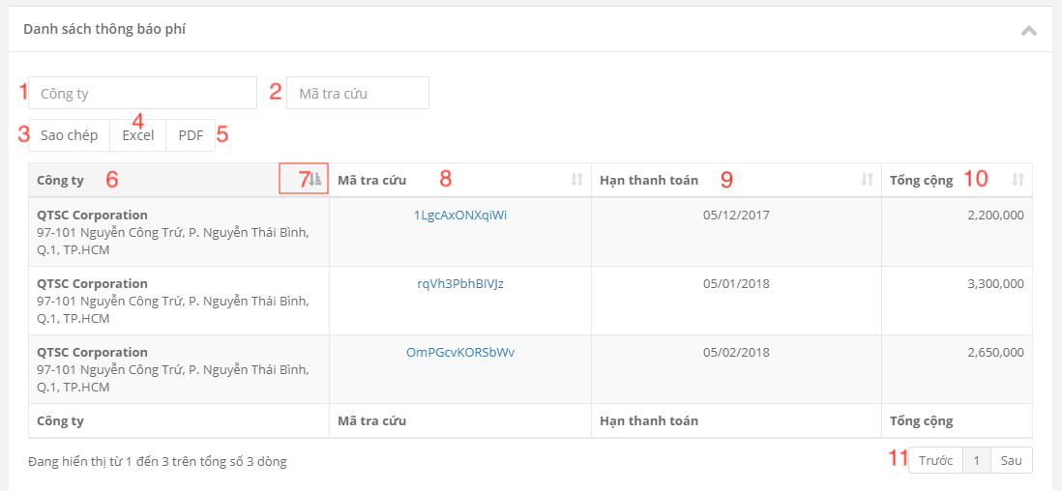

Figure 102. Proforma invoice list

**Fields**

|  |  |  |  |  |  |  |
| --- | --- | --- | --- | --- | --- | --- |
| **No** | **Field Name** | **Description** | **Read only** | **Mandatory** | **Control Type** | **Data Type** |
| 1 | SearchCompany | Search by company name | No | Yes | TextBox | String |
| 2 | SearchLookupcode | Search by lookup code | No | Yes | TextBox | String |
| 6 | Company | Company name | Yes | Yes | Text | String |
| 8 | Lookup code | Lookup code | Yes | Yes | Text | String |
| 9 | Paymentdeadline | Payment deadline | Yes | Yes | Text | String |
| 10 | Total | Total | Yes | Yes | Text | String |

Table 148. <Fields> Proforma invoice list

**Buttons/Hyperlinks:**

|  |  |  |  |  |
| --- | --- | --- | --- | --- |
| **No** | **Function** | **Description** | **Validation** | **Outcome** |
| 3 | Copy | Copy all table to clipboard | N/A | N/A |
| 4 | Excel | Export excel file | N/A | Download excel file |
| 5 | PDF | Export PDF file | N/A | Download PDF file |
| 7 | Filter | Sort table | N/A | Table is sorted |
| 11 | Pagination | Pagination | N/A | N/A |

Table 149. <Buttons/Hyperlinks> Proforma invoice list

* + 1. Liabilities

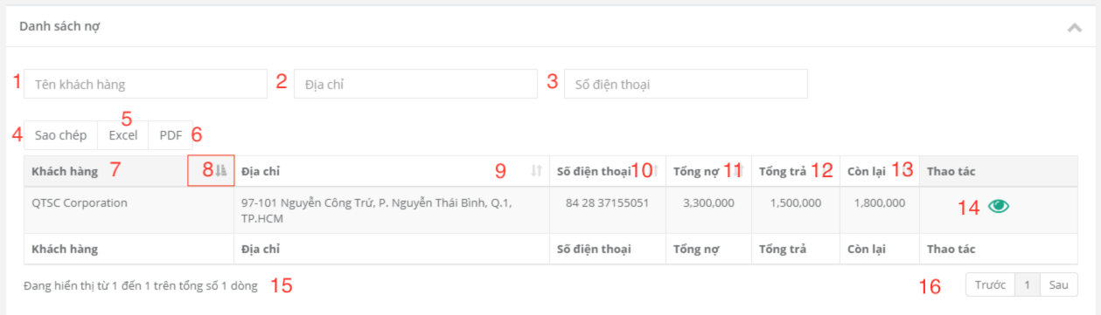

Figure 103. Liabilities

**Fields**

|  |  |  |  |  |  |  |
| --- | --- | --- | --- | --- | --- | --- |
| **No** | **Field Name** | **Description** | **Read only** | **Mandatory** | **Control Type** | **Data Type** |
| 1 | SearchCompany | Search by company name | No | Yes | Textbox | String |
| 2 | SearchAddress | Search by address | No | Yes | Textbox | String |
| 3 | SearchPhone | Search by phone number | No | Yes | date | String |
| 7 | Company | Company name | Yes | No | Text | String |
| 9 | Address | Company address | Yes | No | Text | String |
| 10 | Phonenumber | Company phone | Yes | No | Text | String |
| 11 | TotalLiabilities | Total liabilities | Yes | No | Text | String |
| 12 | TotalPayment | Total payment | Yes | No | Text | String |
| 13 | Remain | Remain | Yes | No | Text | String |
| 15 | RowsNumber | Number of transactions in table | Yes | No | Text | String |

Table 150. <Fields> Liabilities

**Buttons/Hyperlinks:**

|  |  |  |  |  |
| --- | --- | --- | --- | --- |
| **No** | **Function** | **Description** | **Validation** | **Outcome** |
| 4 | Copy | Copy all table | N/A | N/A |
| 5 | Excel | Export excel file | N/A | Download excel file |
| 6 | PDF | Export PDF file | N/A | Download PDF file |
| 8 | Details | Liabilites Detail | N/A | Redirect to liabilities detail page |
| 14 | Pagination | Pagination | N/A | N/A |
| 16 | Copy | Copy all table | N/A | N/A |

Table 151. <Buttons/Hyperlinks> Liabilities

* + 1. Liabilities detail

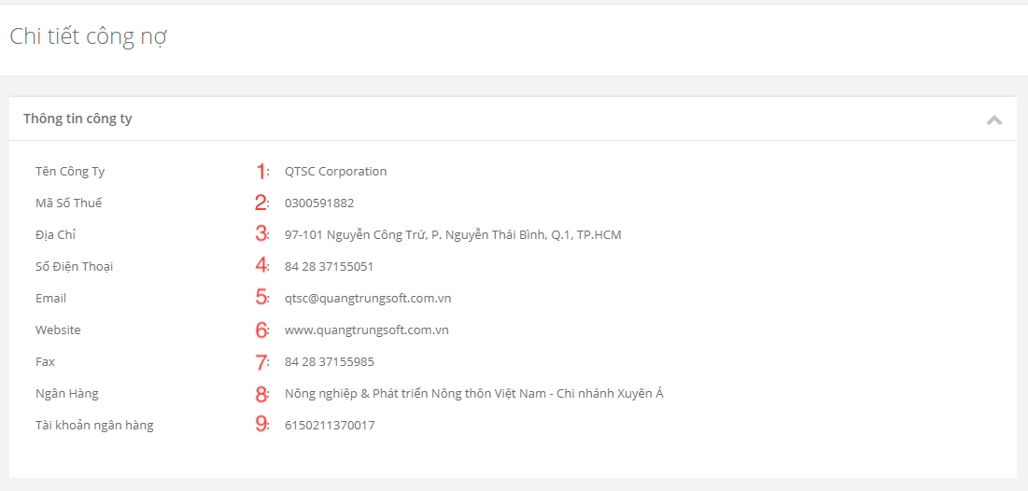

Figure 104. Liabilities detail

**Fields**

|  |  |  |  |  |  |  |
| --- | --- | --- | --- | --- | --- | --- |
| **No** | **Field Name** | **Description** | **Read only** | **Mandatory** | **Control Type** | **Data Type** |
| 1 | Name | Company name | Yes | Yes | Text | String |
| 2 | TaxNo | Company tax number | Yes | Yes | Text | String |
| 3 | Address | Company address | Yes | Yes | Text | String |
| 4 | Phone | Company phone number | Yes | Yes | Text | String |
| 5 | Email | Company email | Yes | Yes | Text | String |
| 6 | Website | Company website | Yes | Yes | Text | String |
| 7 | Fax | Company fax | Yes | Yes | Text | String |
| 8 | Bank | Bank | Yes | Yes | Text | String |
| 9 | BankAccountNo | Bank account number | Yes | Yes | Text | String |

Table 152. <Fields> Liabilities detail

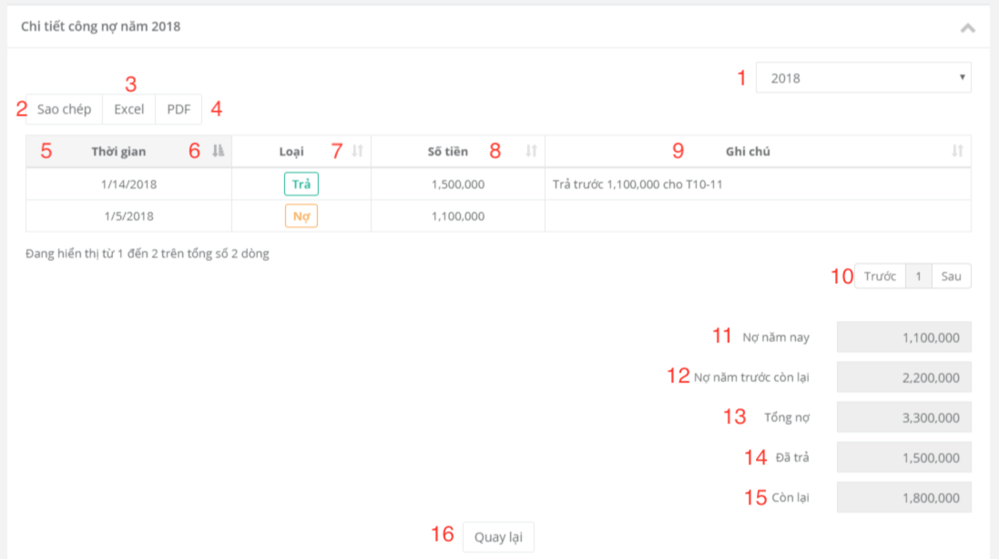

Figure 105. Liabilities detail

**Fields**

|  |  |  |  |  |  |  |
| --- | --- | --- | --- | --- | --- | --- |
| **No** | **Field Name** | **Description** | **Read only** | **Mandatory** | **Control Type** | **Data Type** |
| 1 | Year | Year | No | Yes | Drop down list | String |
| 5 | Date | Create date | Yes | Yes | Text | String |
| 7 | Type | Type of transaction | Yes | Yes | Text | String |
| 8 | Amount | Transaction amount | Yes | Yes | Text | String |
| 9 | Note | Note | Yes | Yes | Text | String |
| 11 | Currentliabilities | Liabilities of current year | Yes | Yes | Text | String |
| 12 | Lastyearliabilities | Liabilities of last year | Yes | Yes | Text | String |
| 13 | Totalliabilities | Total liabilities | Yes | Yes | Text | String |
| 14 | Totalpayment | Total payment | Yes | Yes | Text | String |
| 15 | Remain | Remain | Yes | Yes | Text | String |

Table 153. <Fields> Liabilities detail

**Buttons/Hyperlinks:**

|  |  |  |  |  |
| --- | --- | --- | --- | --- |
| **No** | **Function** | **Description** | **Validation** | **Outcome** |
| 2 | Copy | Copy table to clipboard | N/A | N/A |
| 3 | Excel | Export excel file | N/A | Download excel file |
| 4 | PDF | Export PDF file | N/A | Download PDF file |
| 6 | Filter | Sort table | N/A | Table is sorted |
| 10 | Pagination | Pagination | N/A | N/A |
| 16 | Back | Cancel | N/A | Return to liabilities page |

Table 154. <Buttons/Hyperlinks> Liabilities detail

* 1. Admin Interface Design
     1. Admin’s menu

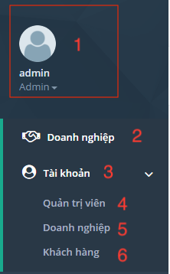

Figure 106. Admin’s menu

**Fields**

|  |  |  |  |  |  |  |
| --- | --- | --- | --- | --- | --- | --- |
| **No** | **Field Name** | **Description** | **Read only** | **Mandatory** | **Control Type** | **Data Type** |
| 1 | AccountInformation | Display user’s name and role | Yes | Yes | Text | String |

Table 155. <Fields> Admin’s menu

**Buttons/Hyperlinks:**

|  |  |  |  |  |
| --- | --- | --- | --- | --- |
| **No** | **Function** | **Description** | **Validation** | **Outcome** |
| 2 | Enterprise | Manage enterprise | N/A | Navigate to company list page |
| 3 | Account | Manage account | N/A | N/A |
| 4 | Administrator | Manage administrator | N/A | Navigate to admin list page |
| 5 | Staff | Manage staff | N/A | Navigate to staff list page |
| 6 | Customer | Manage customer | N/A | Navigate to customer list page |

Table 156. <Buttons/Hyperlinks> Admin’s menu

* + 1. Company management
       1. View company list

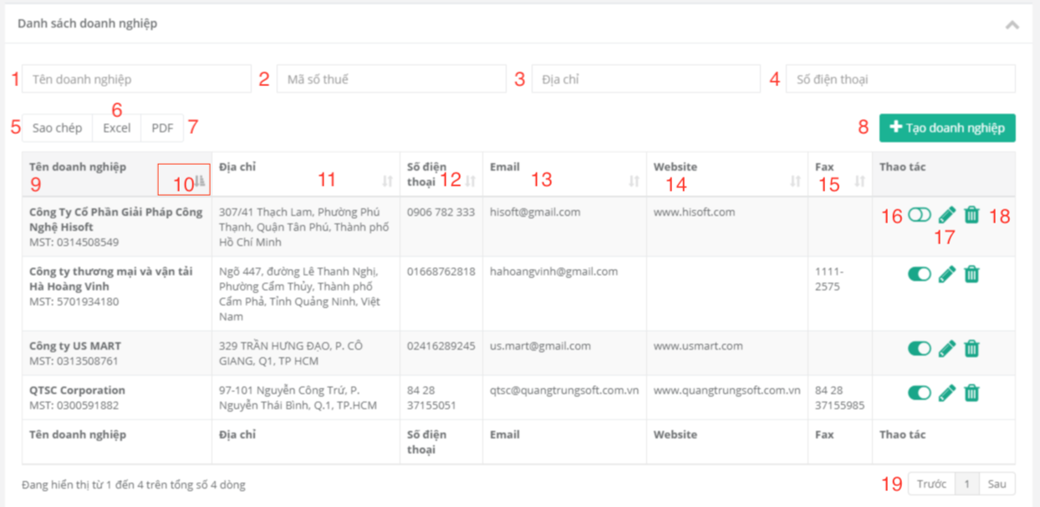

Figure 107. View company list

**Fields**

|  |  |  |  |  |  |  |
| --- | --- | --- | --- | --- | --- | --- |
| **No** | **Field Name** | **Description** | **Read only** | **Mandatory** | **Control Type** | **Data Type** |
| 1 | SearchName | Search by company name | No | Yes | TextBox | String |
| 2 | SearchTax | Search by tax no | No | Yes | TextBox | String |
| 3 | SearchAddress | Search by address | No | Yes | TextBox | String |
| 4 | SearchPhone | Search by company phone | No | Yes | TextBox | String |
| 9 | NameTax | Company name and tax no | Yes | Yes | Text | String |
| 11 | Address | Company address | Yes | Yes | Text | String |
| 12 | Phonenumber | Company phone | Yes | Yes | Text | String |
| 13 | Email | Company email | Yes | Yes | Text | String |
| 14 | Website | Company website | Yes | Yes | Text | String |
| 15 | Fax | Company fax | Yes | Yes | Text | String |

Table 157. <Fields> View company list

**Buttons/Hyperlinks:**

|  |  |  |  |  |
| --- | --- | --- | --- | --- |
| **No** | **Function** | **Description** | **Validation** | **Outcome** |
| 5 | Copy | Copy table to clipboard | N/A | N/A |
| 6 | Excel | Export excel file | N/A | Downalod excel file |
| 7 | PDF | Export PDF file | N/A | Download PDF file |
| 8 | Add company | Create company | N/A | Navigate to create company page |
| 10 | Filter | Sort table | N/A | Table is sorted |
| 16 | Active | Active company | N/A | N/A |
| 17 | Edit | Edit enterprise information | N/A | Redirect to edit company page |
| 18 | Delete | Delete enterprise | N/A | Table is reloaded |
| 19 | Pagination | Pagination | N/A | N/A |

Table 158. <Buttons/Hyperlinks> View Company List

* + - 1. Create company

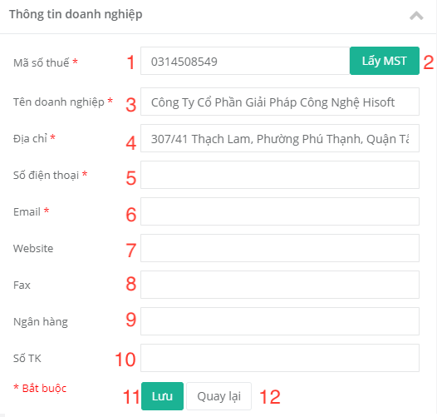

Figure 108. Create company

**Fields**

|  |  |  |  |  |  |  |
| --- | --- | --- | --- | --- | --- | --- |
| **No** | **Field Name** | **Description** | **Read only** | **Mandatory** | **Control Type** | **Data Type** |
| 1 | TaxNo | Company tax | No | Yes | TextBox | String |
| 3 | Name | Company name | No | Yes | TextBox | String |
| 4 | Address | Company address | No | Yes | TextBox | String |
| 5 | Phonenumber | Company phone | No | Yes | TextBox | String |
| 6 | Email | Company email | No | Yes | TextBox | String |
| 7 | Website | Company website | No | Yes | TextBox | String |
| 8 | Fax | Company fax | No | Yes | TextBox | String |
| 9 | Bank | Bank | No | Yes | TextBox | String |
| 10 | BankAccountNo | Bank account number | No | Yes | TextBox | String |

Table 159. <Fields> Create company

**Buttons/Hyperlinks:**

|  |  |  |  |  |
| --- | --- | --- | --- | --- |
| **No** | **Function** | **Description** | **Validation** | **Outcome** |
| 2 | GetInformation | Get company information by tax | N/A | N/A |
| 11 | Save | Create company | Validate required fields | Navigate to company list page |
| 12 | Back | Cancel | N/A | Return to company list page |

Table 160. <Buttons/Hyperlinks> Create company

* + 1. Account management
       1. View admin list

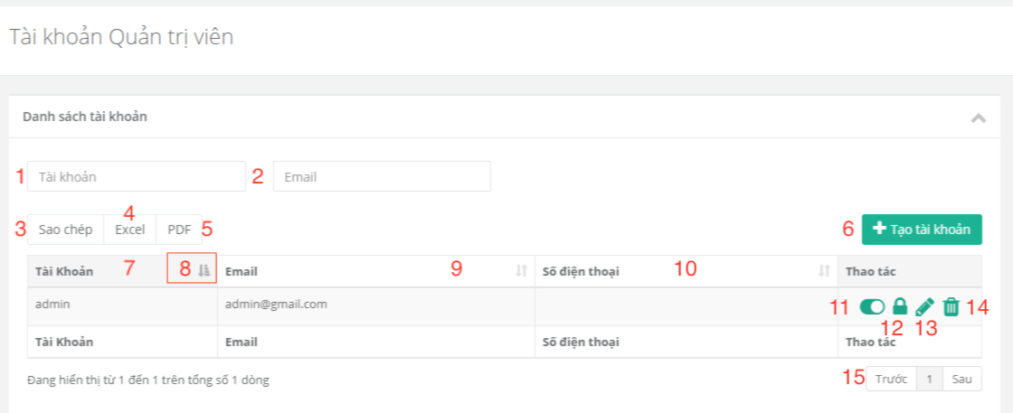

Figure 109. View admin list

**Fields**

|  |  |  |  |  |  |  |
| --- | --- | --- | --- | --- | --- | --- |
| **No** | **Field Name** | **Description** | **Read only** | **Mandatory** | **Control Type** | **Data Type** |
| 1 | SearchAccount | Search by account | No | Yes | Textbox | String |
| 2 | SearchEmail | Search by email | No | Yes | Textbox | String |
| 7 | Username | Admin’s username | Yes | Yes | Text | String |
| 9 | Email | Admin’s email | Yes | Yes | Text | String |
| 10 | Phonenumber | Admin’s phone number | Yes | No | Text | String |

Table 161. <Fields> View admin list

**Buttons/Hyperlinks:**

|  |  |  |  |  |
| --- | --- | --- | --- | --- |
| **No** | **Function** | **Description** | **Validation** | **Outcome** |
| 3 | Copy | Copy table to clipboard | N/A | N/A |
| 4 | Excel | Export excel file | N/A | Download excel file |
| 5 | PDF | Export PDF file | N/A | Download PDF file |
| 6 | Add admin | Create admin | N/A | Navigate to create admin page |
| 8 | Filter | Sort table | N/A | Table is sorted |
| 11 | Activate/Deactivate | Active/deactivate account | N/A | N/A |
| 12 | Changepassword | Change password | N/A | Redirect to change password page |
| 13 | Edit | Edit admin’s information | N/A | Redirect to edit admin page |
| 14 | Delete | Delete account | N/A | Table is reloaded |
| 15 | Pagination | Pagination | N/A | N/A |

Table 162. <Buttons/Hyperlinks> View admin list

* + - 1. Create Admin

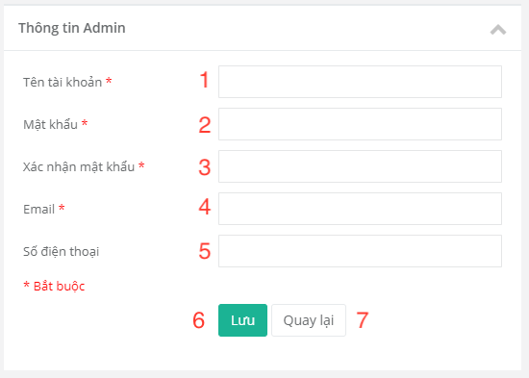

Figure 110. Create admin account

**Fields**

|  |  |  |  |  |  |  |
| --- | --- | --- | --- | --- | --- | --- |
| **No** | **Field Name** | **Description** | **Read only** | **Mandatory** | **Control Type** | **Data Type** |
| 1 | Username | Username | No | Yes | TextBox | String |
| 2 | Password | Password | No | Yes | TextBox | String |
| 3 | Confirm password | Confirm password | No | Yes | TextBox | String |
| 4 | Email | Email | No | Yes | TextBox | String |
| 5 | Phone number | Phone number | No | Yes | TextBox | String |

Table 163. <Fields> Create admin account

**Buttons/Hyperlinks:**

|  |  |  |  |  |
| --- | --- | --- | --- | --- |
| **No** | **Function** | **Description** | **Validation** | **Outcome** |
| 6 | Save | Create new account | Validate required fields | Create account.  Navigate to admin page with success message. |
| 7 | Back | Cancel | N/A | Return to admin page |

Table 164. <Buttons/Hyperlinks> Create admin account

**5.8. Windows Application**

1. **Login form**

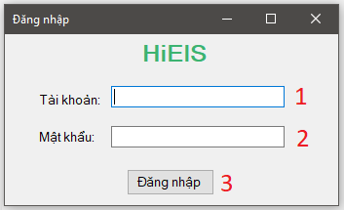

Figure 111. Login form

**Fields**

|  |  |  |  |  |  |  |
| --- | --- | --- | --- | --- | --- | --- |
| **No** | **Field Name** | **Description** | **Read only** | **Mandatory** | **Control Type** | **Data Type** |
| 1 | Username | Username to login | No | Yes | TextBox | String |
| 2 | Password | Password to login | No | Yes | TextBox | String |

Table 165. <Fields> Login form

**Buttons/Hyperlinks:**

|  |  |  |  |  |
| --- | --- | --- | --- | --- |
| **No** | **Function** | **Description** | **Validation** | **Outcome** |
| 3 | btnLogin_Cilck | Login into the system | N/A | SignDialog is showed |

Table 166. <Buttons/Hyperlinks> Login form

1. **Sign form**

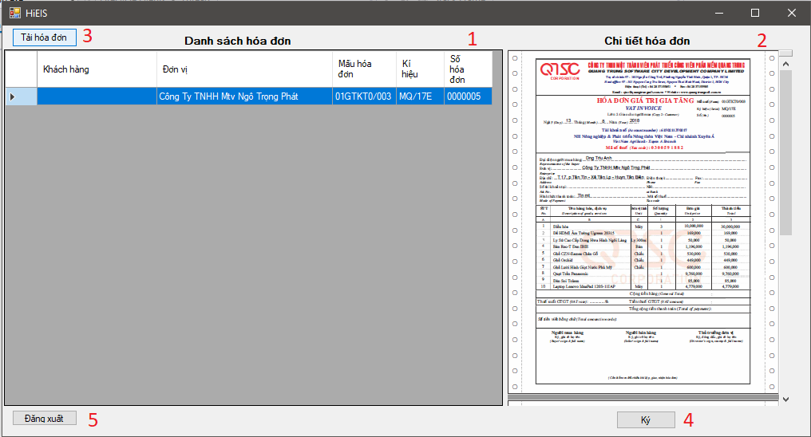

Figure 112. Sign form

**Fields**

|  |  |  |  |  |  |  |
| --- | --- | --- | --- | --- | --- | --- |
| **No** | **Field Name** | **Description** | **Read only** | **Mandatory** | **Control Type** | **Data Type** |
| 1 | tblInvoice | Table of Invoice | No | Yes | TextBox | String |
| 2 | pdf | Show invoice pdf | No | Yes | TextBox | String |

Table 167. <Fields> Sign form

**Buttons/Hyperlinks:**

|  |  |  |  |  |
| --- | --- | --- | --- | --- |
| **No** | **Function** | **Description** | **Validation** | **Outcome** |
| 3 | btnReload_Cilck | Reload the invoice table | N/A | Table is reloaded |
| 4 | btnSign_Click | Sign invoice pdf | N/A | N/A |
| 5 | btnLogout_Click | Logout | N/A | Sign Dialog is closed. |

Table 168. <Buttons/Hyperlinks> Sign form

1. Database Design
2. Entity Relationship Diagram (ERD)

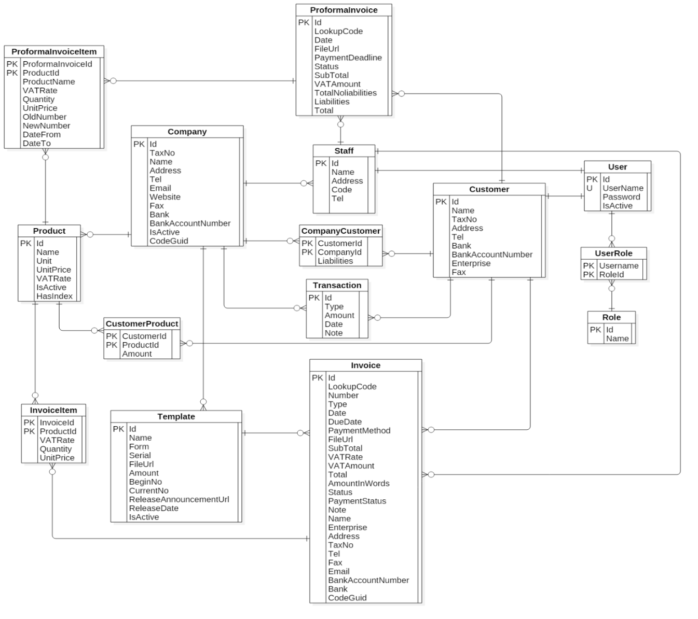<blob:file:///27fc04d7-f9e6-4d31-8e54-0e194a542963>

Figure 113. Entity relationship diagram

1. Entity Dictionary

|  |  |
| --- | --- |
| **ENTITY DATA DICTIONARY: DESCRIBE CONTENT OF ALL ENTITIES** | |
| **Entity Name** | **Description** |
| **User** | Contain user information |
| **Role** | Contain role information |
| **UserRole** | Contain information of a user and user’s role |
| **Company** | Contain company information |
| **Staff** | Contain staff’s information |
| **Customer** | Contain customer’s information |
| **CompanyCustomer** | Contain information of customer and company |
| **Product** | Contain product information |
| **CustomerProduct** | Contain information of customer and customer’s products |
| **Transaction** | Contain transaction |
| **Template** | Contain template information |
| **Invoice** | Contain invoice information |
| **InvoiceItem** | Contain product items of invoices |
| **ProformaInvoice** | Contain proforma invoice’s information |
| **ProformaInvoiceItem** | Contain product items of proforma invoices |

Table 169. Entity dictionary

1. System Implementation & Test
   1. Introduction
      1. Overview

This section describes approach and methodologies used by our team to plan, organize and manage testing process of MIS

It provides all necessary information about implementation and testing procedure of the system including test plans, test cases, test results and pass/fail criteria as well as testing flow to cover all possible cases.

* + 1. Test Approach
* **Goal:** Test main features in the whole MIS based on core flow.
* **Method:** black-box testing.
* **Technique:** check list, pair testing.

The testing process for this project consists of Integration System test level.

System testing is focused on assessing the system’s reliability and the process of testing an integrated system to verify if it meets specified requirements.

Testing will cover functionalities through the use of test interface. This process is concerned with finding errors that result from unanticipated interactions between components and component interface problems.

* 1. Database Relationship Diagram
     1. Physical Diagram

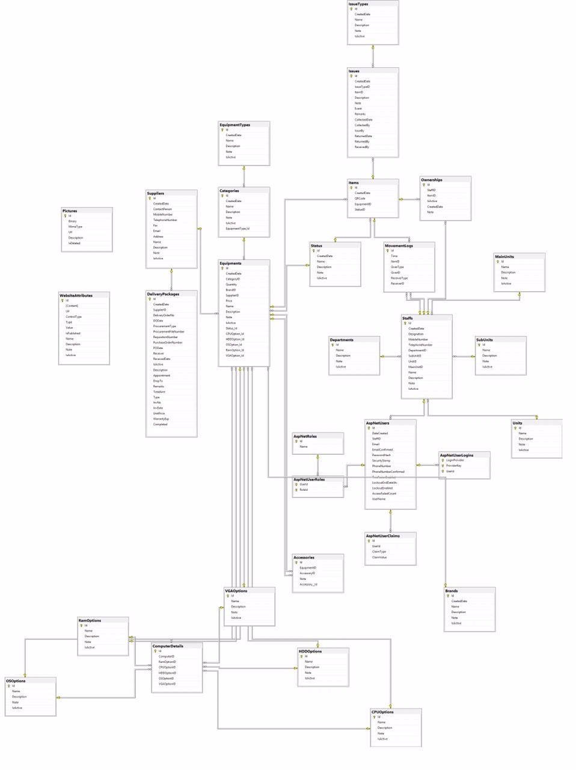

Figure 114. Physical database

* + 1. Data Dictionary

|  |  |  |
| --- | --- | --- |
| **Entity Data Dictionary: Describe content of all tables** | | |
| **No.** | **Table Name** | **Description** |
| 1 | AspNetUsers | Contain account information |
| 2 | AspNetRoles | Contain role information |
| 3 | AspNetUserRoles | Contain information about roles of each account |
| 4 | Staff | Contain staff’s information |
| 5 | Company | Contain company information |
| 6 | Customer | Contain customer’s information |
| 7 | CompanyCustomer | Cointain information about customers of each company |
| 8 | Product | Contain product information |
| 9 | CustomerProduct | Contain information about products of each customer |
| 10 | ProformaInvoice | Contain proforma invoice information |
| 11 | ProformaInvoiceItem | Contain information about items of each proforma invoice |
| 12 | Template | Contain template information |
| 13 | Invoice | Contain invoice information |
| 14 | InvoiceItem | Contain information about items of each invoice |
| 15 | Transaction | Contain transaction information of a customer (liabilities + payment) |

Table 170. Database dictionary

* 1. Test Plan

The purpose of this section is to verify and ensure that HiEIS meets its entire technical, functional and business requirements. Individual test case will be written for each version of the application that is released.

The following parts describe which features will be tested and which will be not.

* + 1. Features To Be Tested
* Liability accoutant: create proforma invoice, create invoice, convert proforma invoice into invoice.
* Payable accoutant: confirm payment, add payment.
* Accounting manager: approve proforma invoice, approve invoice.
* Manager: create template release.
  + 1. Features Not To Be Tested
* Log in, log out, update profile,…
* Admin: create company, create account,…
  1. System Testing Test Case
     1. Test Case
        + 1. Create proforma invoice

|  |  |  |  |  |  |  |
| --- | --- | --- | --- | --- | --- | --- |
| **ID** | **Test Case Description** | **Test case procedure** | **Expected output** | **Inter-test case dependence** | **Result** | **Test Date** |
| CP01 | Missing user’s information | * Click on “Tạo thông báo phí” button in proforma invoice list page. * Click on “Lưu” button. | Show warning message “Vui lòng điền thông tin và chọn sản phẩm.” | N/A | Pass | 11/08/2018 |
| CP02 | Customer not found | * Click on “Tạo thông báo phí” button in proforma invoice list page. * Click on “Thêm sản phẩm” button. | Show warning message “Khách hàng không tồn tại! Vui lòng kiểm tra lại.” | N/A | Pass | 11/08/2018 |
| CP03 | No product is selected. | * Click on “Tạo thông báo phí” button in proforma invoice list page. * Fill in valid customer’s information. * Click on “Lưu” button. | Show warning message “Vui lòng điền thông tin và chọn sản phẩm.” | N/A | Pass | 11/08/2018 |
| CP04 | No payment date is selected. | * Click on “Tạo thông báo phí” button in proforma invoice list page. * Fill in valid customer’s information. * Select at least one product. * Click on “Lưu” button. | Show warning message “Vui lòng chọn hạn thanh toán”. | N/A | Pass | 11/08/2018 |
| CP05 | Missing or invalid product information. | * Click on “Tạo thông báo phí” button in proforma invoice list page. * Fill in valid customer’s information. * Click on “Thêm sản phẩm” button to open product popup. * Click on “Lưu” button of the product popup. | Show instruction message below missing / invalid input fields. | N/A | Pass | 11/08/2018 |
| CP06 | Create proforma invoice successfully | * Click on “Tạo thông báo phí” button in proforma invoice list page. * Fill in valid customer’s information. * Select at least one product (with valid product information). * Click on “Lưu” button. | Redirect to list page and show a toast message “Đã tạo thông báo phí”. | N/A | Pass | 11/08/2018 |

Table 171. <Test case> Create proforma invoice

* + - * 1. Create invoice

|  |  |  |  |  |  |  |
| --- | --- | --- | --- | --- | --- | --- |
| **ID** | **Test Case Description** | **Test case procedure** | **Expected output** | **Inter-test case dependence** | **Result** | **Test Date** |
| CI01 | Missing receiver’s address | * Click on “Tạo hóa đơn” button in invoice list page. * Click on “Lưu” button. | Show warning message “Vui lòng điền thông tin và chọn sản phẩm. | N/A | Pass | 11/08/2018 |
| CI02 | Get information from Tax Department API by valid tax number | * Click on “Tạo hóa đơn” button in invoice list page. * Fill in valid “Mã số thuế” field. * Click on “Lấy thông tin” button. | Auto-fill information of that company into “Tên đơn vị” and “Địa chỉ” fields. | N/A | Pass | 11/08/2018 |
| CI03 | Invalid tax number | * Click on “Tạo hóa đơn” button in invoice list page. * Fill in invalid “Mã số thuế” field. * Click on “Lấy thông tin” button. | Show error message “Mã số thuế không tồn tại.” | N/A | Pass | 11/08/2018 |
| CI04 | No product is selected | * Click on “Tạo hóa đơn” button in invoice list page. * Fill in valid address field. * Click on “Lưu” button. | Show warning message “Vui lòng điền thông tin và chọn sản phẩm”. | N/A | Pass | 11/08/2018 |
| CI05 | Missing product information. | * Click on “Tạo hóa đơn” button in invoice list page. * Fill in valid address field. * Click on “Thêm sản phẩm” button to open product popup. * Click on “Lưu” button of product popup. | Show instruction message bellow missing input fields. | N/A | Pass | 11/08/2018 |
| CI06 | Select a product that already exists in item list. | * Click on “Tạo hóa đơn” button in invoice list page. * Fill in valid address field. * Click on “Thêm sản phẩm” button to open product popup. * Choose a product and click on “Lưu” button of the popup. * Choose the same product and click on “Lưu” button of the popup. | Show warning message “Sản phẩm đã tồn tại. Bạn đã thêm sản phẩm này vào hóa đơn rồi”. | N/A | Pass | 11/08/2018 |
| CI07 | Create invoice successfully | * Click on “Tạo hóa đơn” button in invoice list page. * Fill in valid address field. * Click on “Thêm sản phẩm” button to open product popup. * Select at least one product with valid information * Click on “Lưu” button. | Return to invoice list page with a toast message “Đã tạo hóa đơn”. | N/A | Pass | 11/08/2018 |

Table 172. <Test case> Create invoice

* + - * 1. Add payment

|  |  |  |  |  |  |  |
| --- | --- | --- | --- | --- | --- | --- |
| **ID** | **Test Case Description** | **Test case procedure** | **Expected output** | **Inter-test case dependence** | **Result** | **Test Date** |
| UP01 | Missing amount field. | * Go to “Công nợ page”. * Click on view button (eye icon) of a customer’s liabilities greater than 0. * Click on “Thanh toán” button to open a popup. * Click on “Lưu” button of the popup. | Show warning popup and instruction message below the amount input field. | N/A | Pass | 11/08/2018 |
| UP02 | Add payment successfully | * Go to “Công nợ page”. * Click on view button (eye icon) of a customer’s liabilities greater than 0. * Click on “Thanh toán” button to open a popup. * Fill in valid amount. * Click on “Lưu” button of the popup. | Show success message. Close popup. | N/A | Pass | 11/08/2018 |

Table 173. <Test case> Add payment

* + - * 1. Confirm payment

|  |  |  |  |  |  |  |
| --- | --- | --- | --- | --- | --- | --- |
| **ID** | **Test Case Description** | **Test case procedure** | **Expected output** | **Inter-test case dependence** | **Result** | **Test Date** |
| CP01 | Confirm payment successfully. | * Go to invoice list page. * Click on “Xác nhận thanh toán” button of an invoice row. * Click “Có” to confirm. | Show success message.  Invoice is numbered correctly.  Payment status is changed to “Đã thanh toán”.  Invoice status is changed to “Chờ ký”. | N/A | Pass | 12/08/2018 |

Table 174. <Test case> Confirm payment

* + - * 1. Approve proforma invoice

|  |  |  |  |  |  |  |
| --- | --- | --- | --- | --- | --- | --- |
| **ID** | **Test Case Description** | **Test case procedure** | **Expected output** | **Inter-test case dependence** | **Result** | **Test Date** |
| AP01 | Approve proforma invoice successfully | * Go to proforma invoice list page. * Click on “Duyệt thông báo phí” button of a proforma invoice row. * Click “Có” to confirm. | Status is changed to “Đã duyệt”.  Email notification is sent to customer. | N/A | Pass | 12/08/2018 |

Table 175. <Test case> Approve proforma invoice

* + - * 1. Convert proforma invoice into invoice

|  |  |  |  |  |  |  |
| --- | --- | --- | --- | --- | --- | --- |
| **ID** | **Test Case Description** | **Test case procedure** | **Expected output** | **Inter-test case dependence** | **Result** | **Test Date** |
| CPII01 | Convert proforma invoice into invoice successfully | * Go to proforma invoice list page. * Click on “Chuyển thành hóa đơn” button of a proforma invoice row. | Convert proforma invoice information into invoice correctly and display it on create invoice page. | N/A | Pass | 12/08/2018 |

Table 176. <Test case> Convert proforma invoice into invoice

* + - * 1. Approve invoice

|  |  |  |  |  |  |  |
| --- | --- | --- | --- | --- | --- | --- |
| **ID** | **Test Case Description** | **Test case procedure** | **Expected output** | **Inter-test case dependence** | **Result** | **Test Date** |
| AI01 | Approve invoice successfully | * Open Sign Application. * Choose the invoice. * Click on “Ký” button. | Invoice pdf is signed with company’s digital signature.  Invoice status is changed to “Đã duyệt”. | N/A | Pass | 12/08/2018 |

Table 177. <Test case> Approve invoice

* + - * 1. Create template release

|  |  |  |  |  |  |  |
| --- | --- | --- | --- | --- | --- | --- |
| **ID** | **Test Case Description** | **Test case procedure** | **Expected output** | **Inter-test case dependence** | **Result** | **Test Date** |
| CT01 | Missing all input fields. | * Click on “Thêm mẫu hóa đơn” button in template list page. * Click on “Lưu” button. | Show instruction message bellow missing fields. | N/A | Pass | 12/08/2018 |
| CT02 | Create template release successfully | * Click on “Thêm mẫu hóa đơn” button in template list page. * Fill in valid information. * Click on “Lưu” button. | Redirect to template list page with a toast message “Đã tạo mẫu hóa đơn”. | N/A | Pass | 12/08/2018 |

Table 178. <Test case> Create template release

**F1. Software User’s Manual**

**1. Installation Guide**

The specifications are based on dependencies requirements and performance test results from previous section of this document.

### 1.1. Hardware Requirement

|  |  |
| --- | --- |
| Criteria | Minimum Requirements |
| Internet Connection | Cable (4 Mbps) |
| Computer Processor | 64-bit CPU 1.4GHz with 2 cores |
| Computer Memory | 4 GB RAM |

Table 179. Hardware requirement

### 1.2. Software Requirement

|  |  |
| --- | --- |
| Name | Name/Version |
| Operating System | Windows 8 or higher |
| IDE | Visual Studio 2017 |
| DBMS | SQL Server 2014 or higher |
| Web browser | Firefox (v52 or higher), Chromes (v50 or higher) |

Table 180. Software requirement

**2. User Manual**

### 2.1. Web Application

1. **Login**

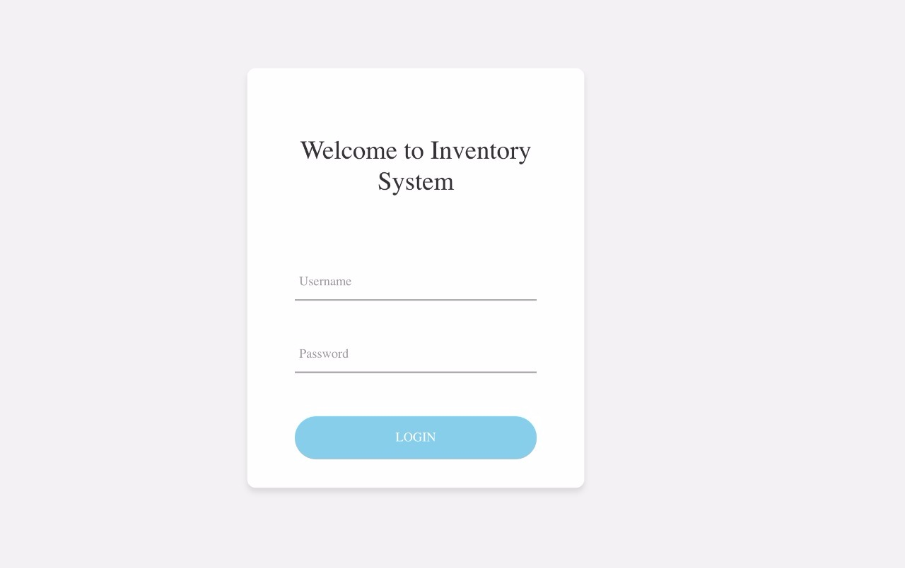

Figure 115. <User Manual> Login

|  |  |
| --- | --- |
| **Step** | **Description** |
| 1 | Enter username. |
| 2 | Enter password. |
| 3 | Click on “Đăng nhập” button |

Table 181. <User Manual> Login

1. **Create invoice**

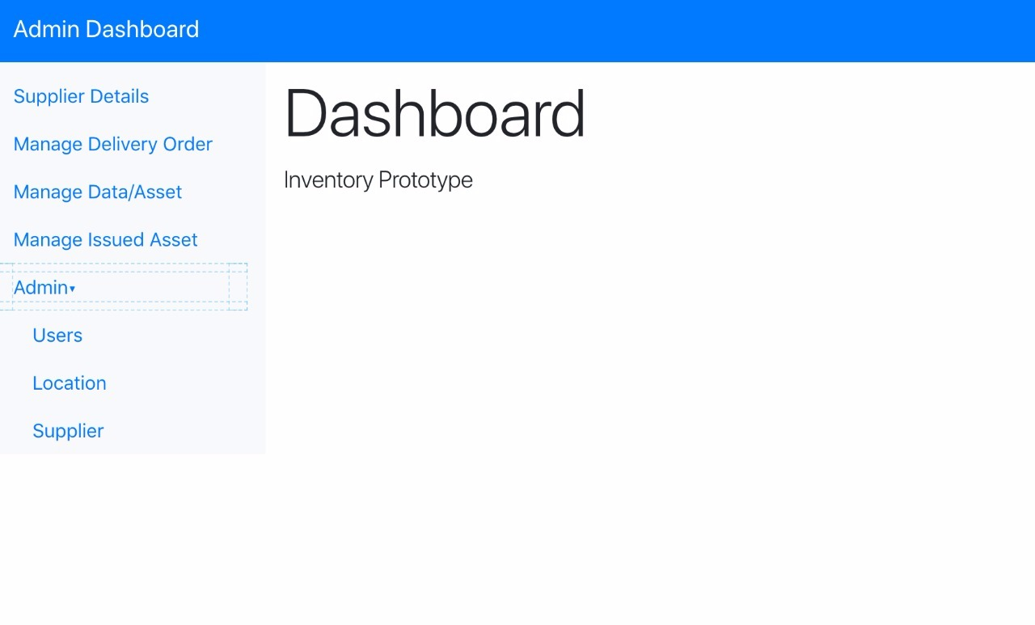

Figure 116. <User Manual> Create invoice (1)

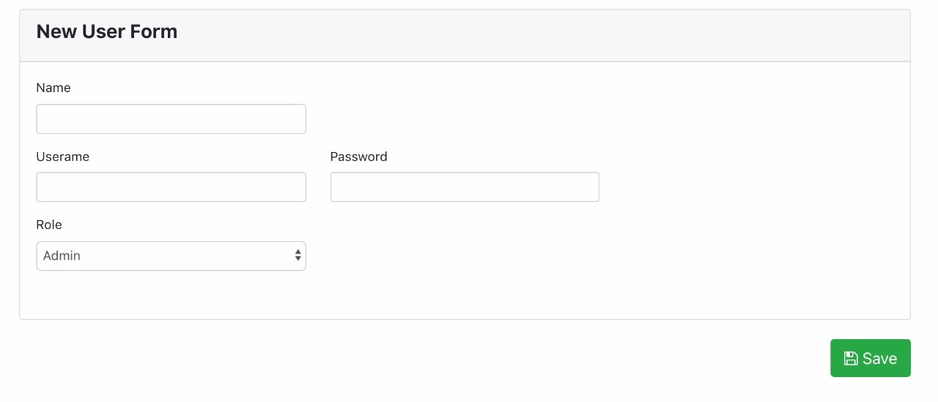

Figure 117. <User Manual> Create invoice (2)

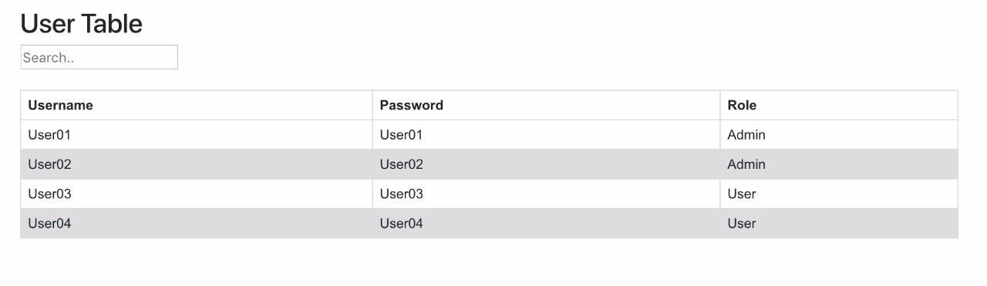

Figure 118. <User Manual> Create invoice (3)

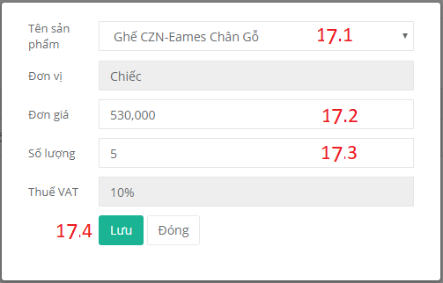

Figure 119. <User Manual> Create invoice (4)

|  |  |
| --- | --- |
| **Step** | **Description** |
| 1 | Click on “Tạo hóa đơn” button |
| 2 | Fill in tax no |
| 3 | Click on “Lấy thông tin” button |
| 4 | Select a template |
| 5 | Fill in receiver’s name (optional) |
| 6 | Select a payment method |
| 7 | Fill in receiver’s enterprise (optional) |
| 8 | Fill in receiver’s phone number (optional) |
| 9 | Fill in receiver’s address |
| 10 | Fill in receiver’s fax number (optional) |
| 11 | Fill in receiver’s bank name (optional) |
| 12 | Fill in receiver’s email (optional) |
| 13 | Fill in receiver’s bank account number (optional) |
| 14 | Tick this checkbox if invoice has payment deadline (optional) |
| 15 | Select payment deadline from datepicker (if checkbox is checked) |
| 16 | Fill in note (optional) |
| 17 | Click on “Thêm sản phẩm” button |
| 17.1 | Select a product |
| 17.2 | Change unit price (optional) |
| 17.3 | Change quantity (optional) |
| 17.4 | Click on “Lưu” button of product popup |
| 18 | Click on “Lưu” button |

Table 182. <User Manual> Create invoice

1. **Confirm payment**

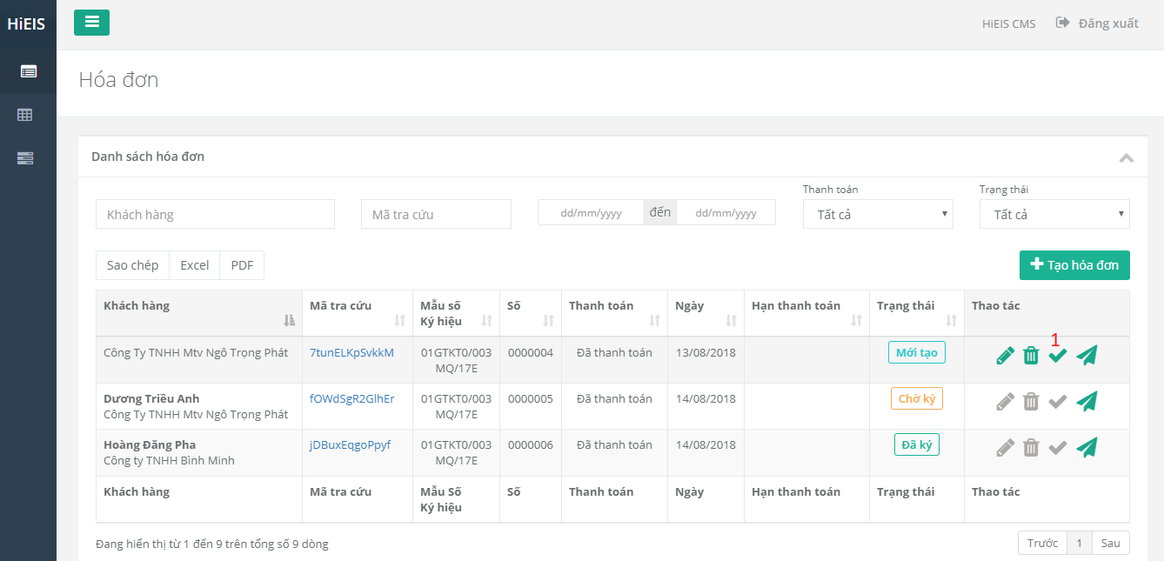

Figure 120. <User Manual> Confirm payment (1)

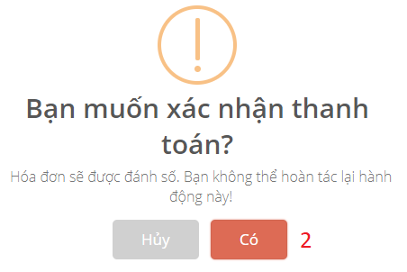

Figure 121. <User Manual> Confirm payment (2)

|  |  |
| --- | --- |
| **Step** | **Description** |
| 1 | Click on  icon. (Tooltip: “Xác nhận thanh toán”) |
| 2 | Click on “Có” button. |

Table 183. <User Manual> Confirm payment

1. **Create proforma invoice**

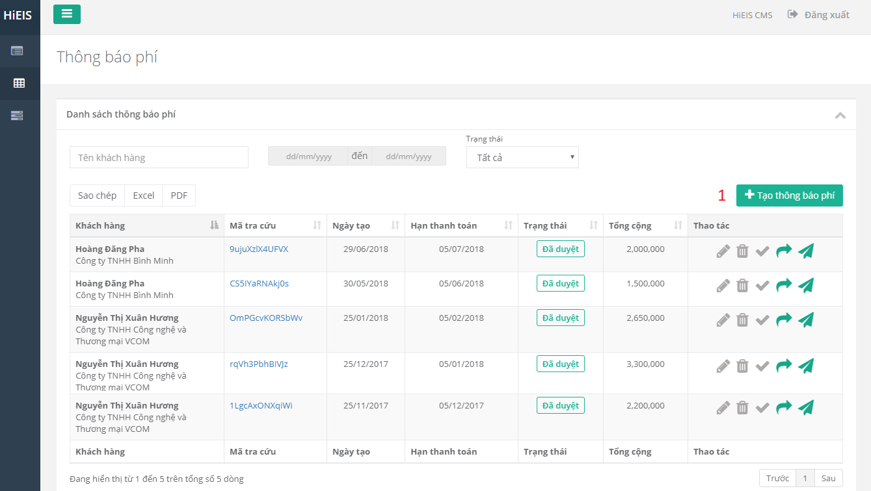

Figure 122. <User Manual> Create proforma invoice (1)

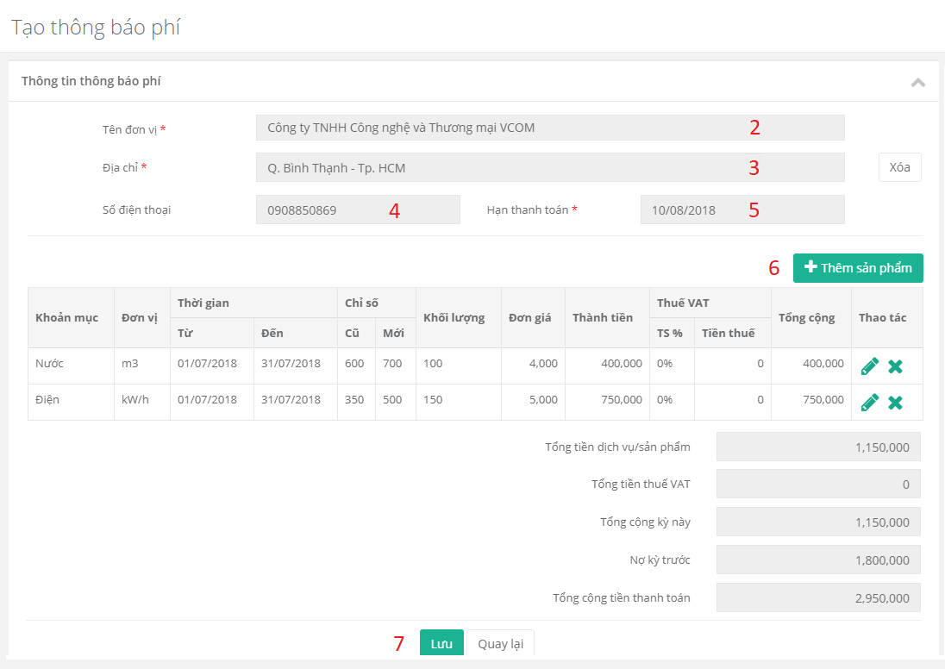

Figure 123. <User Manual> Create proforma invoice (2)

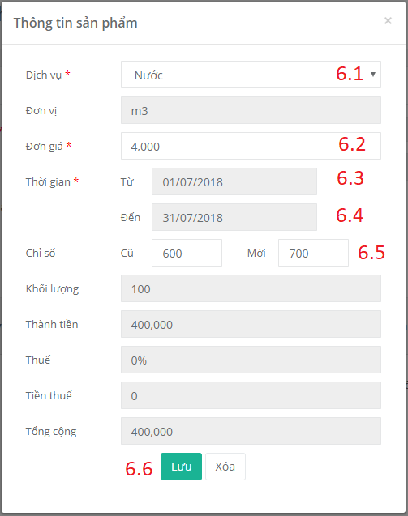

Figure 124. <User Manual> Create proforma invoice (3)

|  |  |
| --- | --- |
| **Step** | **Description** |
| 1 | Click on “Tạo thông báo phí” button |
| 2 | Fill in customer’s enterprise name |
| 3 | Fill in customer’s address |
| 4 | Fill in customer’s phone number |
| 5 | Select payment deadline from datepicker |
| 6 | Click on “Thêm sản phẩm” button |
| 6.1 | Select a product |
| 6.2 | Change unit price (optional) |
| 6.3 | Select start date |
| 6.4 | Select end date |
| 6.5 | Fill in new index number |
| 6.6 | Click on “Lưu” button of product popup |
| 7 | Click on “Lưu” button |

Table 184. <User Manual> Create proforma invoice

1. **Approve proforma invoice**

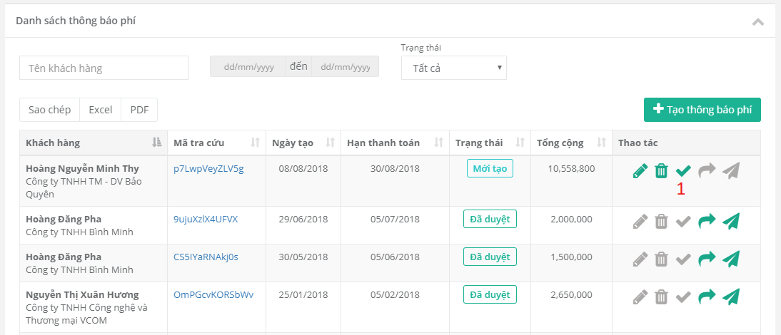

Figure 125. <User Manual> Approve proforma invoice (1)

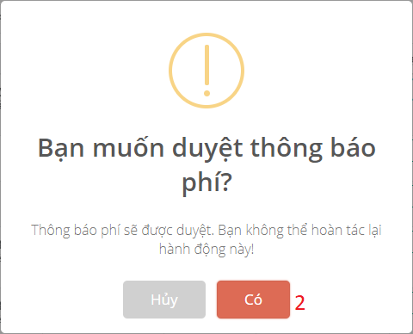

Figure 126. <User Manual> Approve proforma invoice (2)

|  |  |
| --- | --- |
| **Step** | **Description** |
| 1 | Click on  icon. (Tooltip: “Duyệt thông báo phí”) |
| 2 | Click on “Có” button. |

Table 185. <User Manual> Approve proforma invoice

1. **Convert proforma invoice**

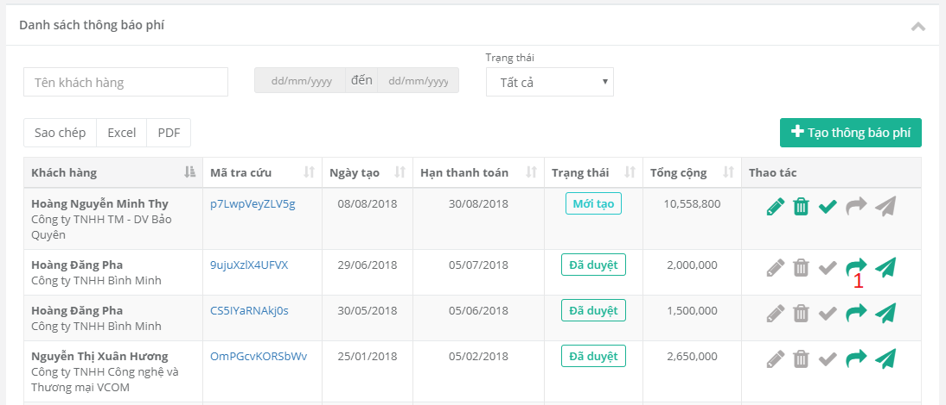

Figure 127. <User Manual> Convert proforma invoice (1)

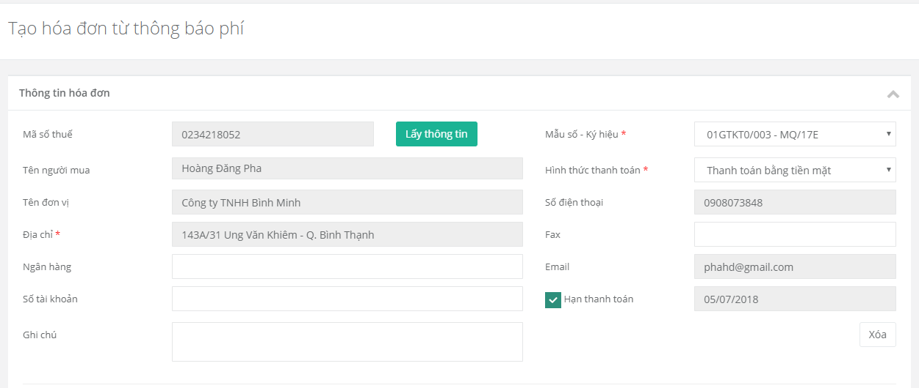

Figure 128. <User Manual> Convert proforma invoice (2)

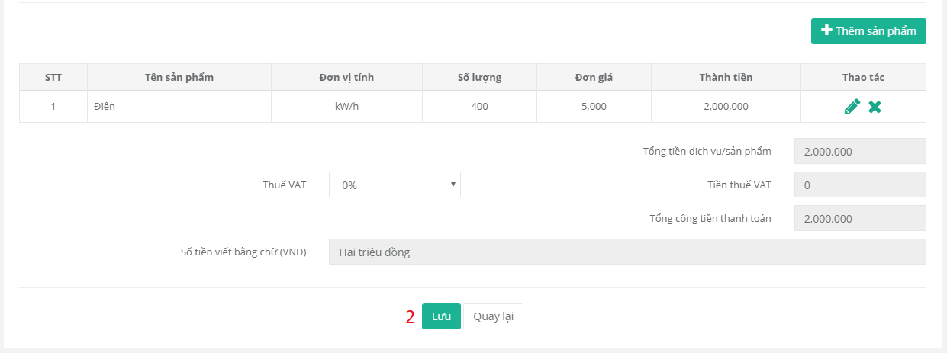

Figure 129. <User Manual> Convert proforma invoice (3)

|  |  |
| --- | --- |
| **Step** | **Description** |
| 1 | Click on  icon. (Tooltip: “Chuyển thành hóa đơn”) |
| 2 | Click on “Lưu” button. |

Table 186. <User Manual> Convert proforma invoice

1. **Add payment**

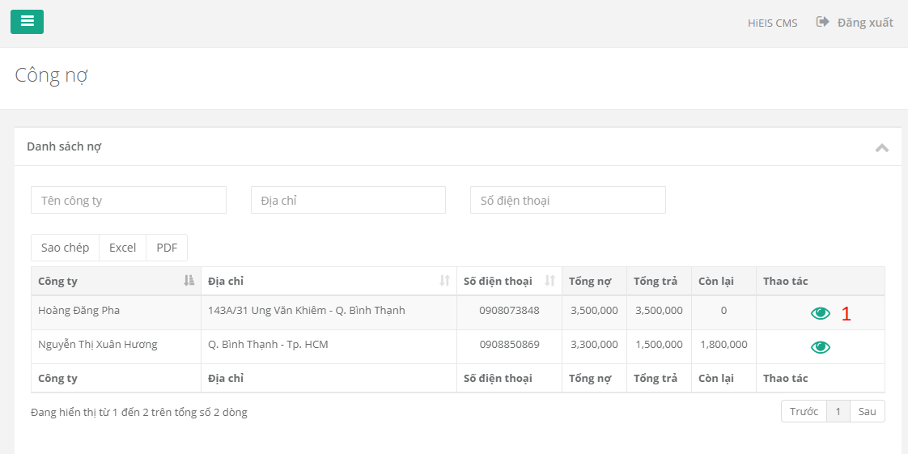

Figure 130. <User Manual> Add payment (1)

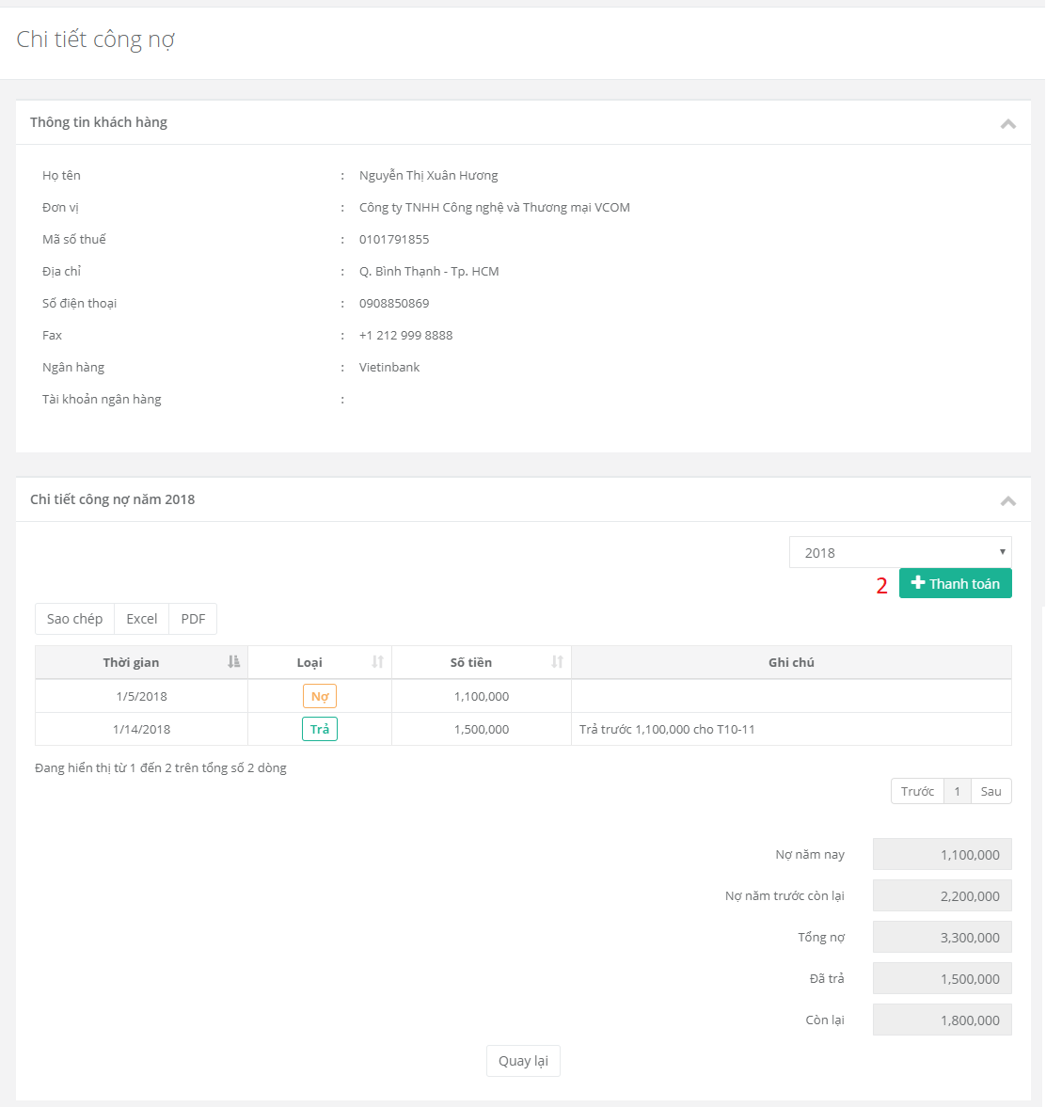

Figure 131. <User Manual> Add payment (2)

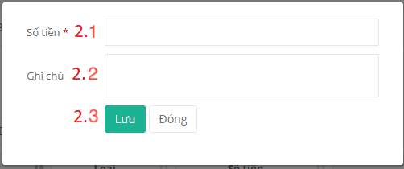

Figure 132. <User Manual> Add payment (3)

|  |  |
| --- | --- |
| **Step** | **Description** |
| 1 | Click on  icon |
| 2 | Click on “Thanh toán” button |
| 2.1 | Fill in amount of payment |
| 2.2 | Fill in note |
| 2.3 | Click on “Lưu” button |

Table 187. <User Manual> Add payment

### 2.2. Windows Application

1. **Login**

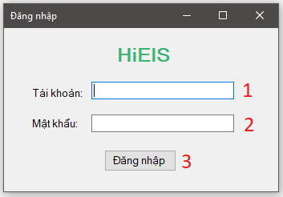

Figure 133. <User Manual> Window application - Login

|  |  |
| --- | --- |
| **Step** | **Description** |
| 1 | Enter username. |
| 2 | Enter password. |
| 53 | Click on “Đăng nhập” button |

Table 188. <User Manual> Window application - Login

1. **Sign invoice**

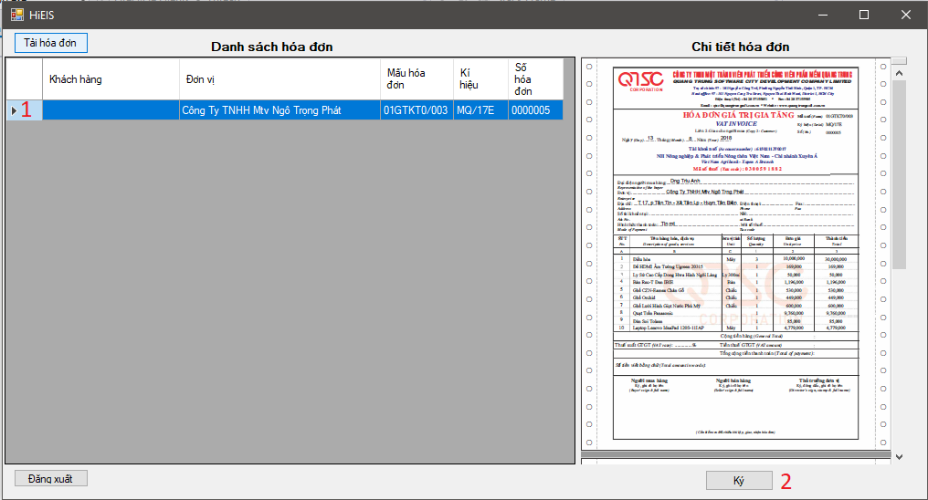

Figure 134. <User Manual> Window application - Sign (1)

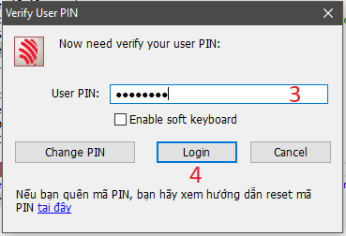

Figure 135. <User Manual> Window application - Sign (2)

|  |  |
| --- | --- |
| **Step** | **Description** |
| 1 | Choose the invoice |
| 2 | Click on “Ký” button |
| 3 | Enter pin number |
| 4 | Click on “Login” button |

Table 189. <User Manual> Window application - Sign

**F2. ソフトウェアユーザーマニュアル**

**1. インストレーションガイド**

仕様は、このドキュメントの前のセクションの依存性要件とパフォーマンステストの結果に基づいています。

### 1.1. ハードウェア要件

|  |  |
| --- | --- |
| クライテリア | 最小要件 |
| インターネット接続 | ケーブル(4 Mbps) |
| コンピュータプロセッサ | 2つのコアを備えた64ビットCPU 1.4GHz |
| コンピュータメモリ | 4 GB RAM |

Table 190. ハードウェア要件

### 1.2. ソフトウェア要件

|  |  |
| --- | --- |
| Name | Name/Version |
| オペレーティング·システム | Windows 8以上 |
| IDE | Visual Studio 2017 |
| DBMS | SQL Server 2014以上 |
| ウェブブラウザ | Firefox (v52以上), Chromes (v50以上) |

Table 191. ソフトウェア要件

**2. ユーザーマニュアル**

1. **ウェブアプリケーション**

#### ログイン

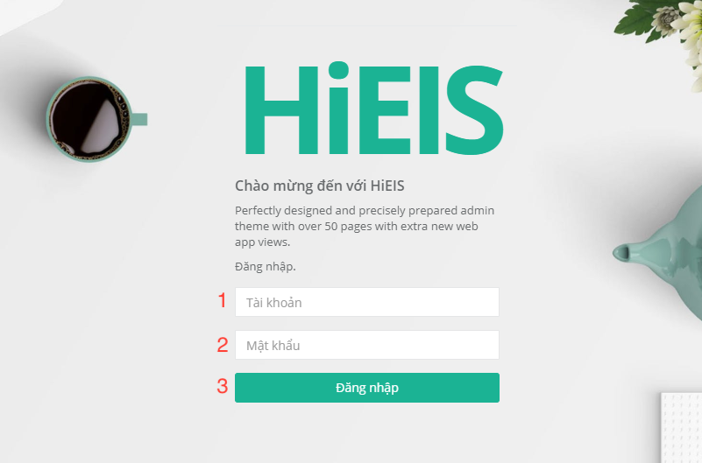

Figure 136. ログイン

|  |  |
| --- | --- |
| **ステップ** | **説明** |
| 1 | ユーザー名を入力します。 |
| 2 | パスワードを入力します。 |
| 3 | 「Đăng nhập 」というボタンをクリックします。 |

Table 192.ログイン

* + 1. **請求書を作成します**

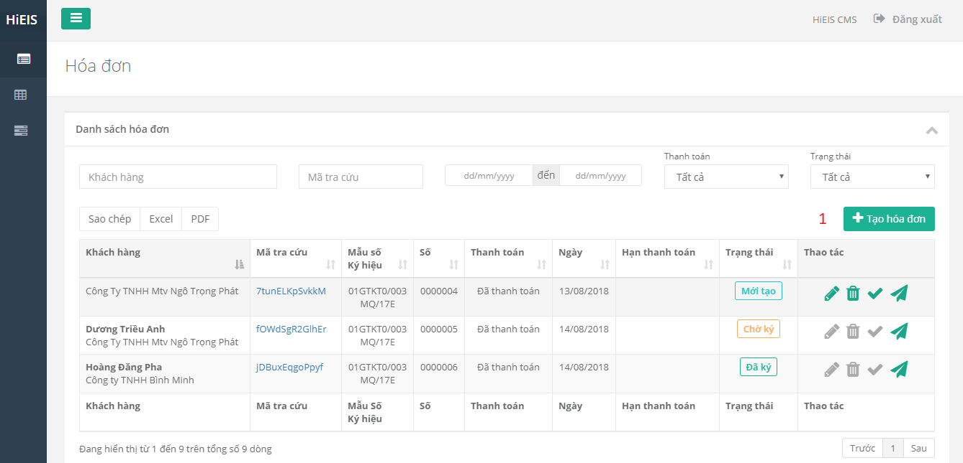

Figure 137. 請求書を作成します (1)

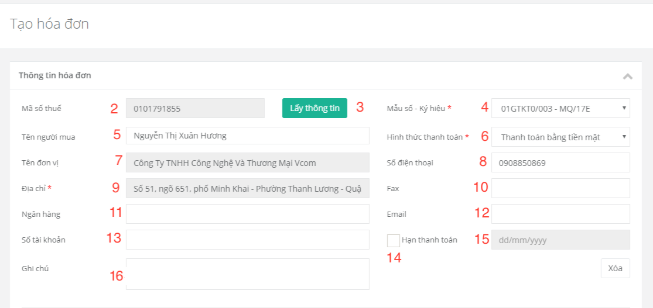

Figure 138. 請求書を作成します (2)

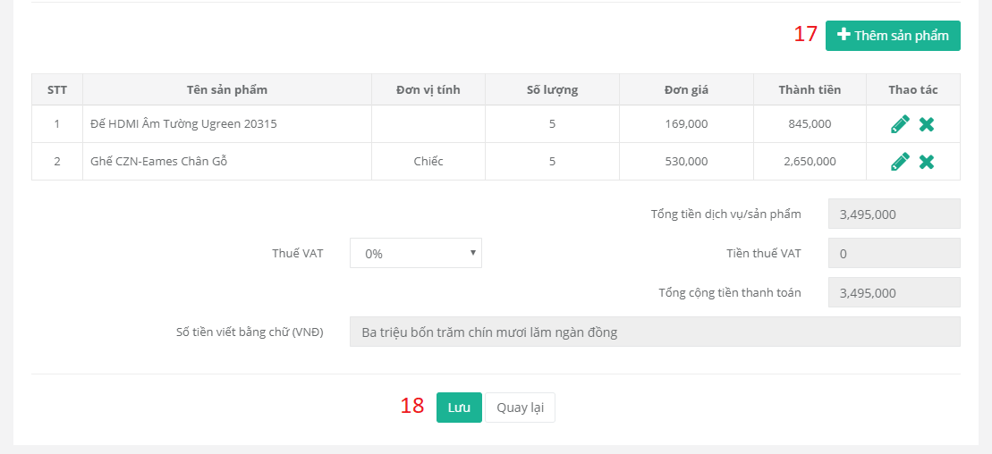

Figure 139. 請求書を作成します (3)



Figure 140. 請求書を作成します (4)

|  |  |
| --- | --- |
| **ステップ** | **説明** |
| 1 | 「Tạo hóa đơn 」というボタンをクリックします。 |
| 2 | 税番号を入力します。 |
| 3 | 「Lấy thông tin 」というボタンをクリックします。 |
| 4 | テンプレートの形式とシリアルを選択します。 |
| 5 | 顧客名を入力します。 |
| 6 | 支払方法を選択します。 |
| 7 | 企業を入力します。 |
| 8 | 電話番号を入力します。 |
| 9 | 住所を入力します。 |
| 10 | ファックスを入力します。 |
| 11 | 銀行の名前を入力します。 |
| 12 | メールを入力します。 |
| 13 | 銀行の口座番号を入力します。 |
| 14 | 支払期限チェックボックスをチェックします。 |
| 15 | 支払期限を選択します。 |
| 16 | ノートの内容を入力します。 |
| 17 | 「Thêm sản phẩm 」というボタンをクリックします。 |
| 17.1 | 商品を選択します。 |
| 17.2 | 単価を入力します。 |
| 17.3 | 数量を入力します。 |
| 17.4 | 「Lưu」というボタンをクリックします。 |
| 18 | 「Lưu」というボタンをクリックします。 |

Table 193. 請求書を作成します

* + 1. **支払いを確認します**



Figure 141. 支払いを確認します (1)

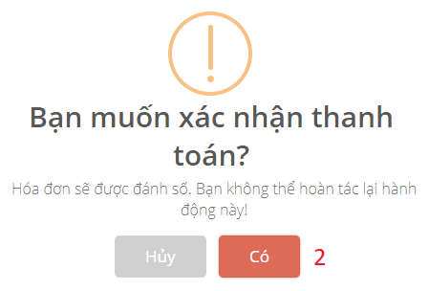

Figure 142. 支払いを確認します (2)

|  |  |
| --- | --- |
| **ステップ** | **説明** |
| 1 | アイコンをクリックします。「Xác nhận thanh toán」というツールチップです。 |
| 2 | 「Có」というボタンをクリックします。 |

Table 194. 支払いを確認します

* + 1. **プロフォーマインボイスを作成します**



Figure 143. プロフォーマインボイスを作成します (1)



Figure 144. プロフォーマインボイスを作成します (2)



Figure 145. プロフォーマインボイスを作成します (3)

|  |  |
| --- | --- |
| **ステップ** | **説明** |
| 1 | 「Tạo thông báo phí 」のボタンをクリックします。 |
| 2 | 企業を入力します。 |
| 3 | 住所を入力します。 |
| 4 | 電話番号を入力します。 |
| 5 | 支払期限を選択します。 |
| 6 | 「Thêm sản phẩm 」のボタンをクリックします。 |
| 6.1 | 商品名を選択します。 |
| 6.2 | 単価を入力します。 |
| 6.3 | 日付からの内容を入力します。 |
| 6.4 | 日付までの内容を入力します。 |
| 6.5 | 新しいインデックスを入力します。 |
| 6.6 | 「Lưu」というボタンをクリックします。 |
| 7 | 「Lưu」というボタンをクリックします。 |

Table 195. プロフォーマインボイスを作成します

* + 1. **プロフォーマインボイスを承認します**



Figure 146. プロフォーマインボイスを承認します (1)



Figure 147. プロフォーマインボイスを承認します (2)

|  |  |
| --- | --- |
| **ステップ** | **説明** |
| 1 | アイコンをクリックします。「Duyệt thông báo phí」というツールチップです。 |
| 2 | 「Có」というボタンをクリックします。 |

Table 196. プロフォーマインボイスを承認します

* + 1. **プロフォーマインボイスを請求書に変換します**



Figure 148. プロフォーマインボイスを請求書に変換します (1)



Figure 149. プロフォーマインボイスを請求書に変換します (2)



Figure 150. プロフォーマインボイスを請求書に変換します (3)

|  |  |
| --- | --- |
| **ステップ** | **説明** |
| 1 | アイコンをクリックします。「Chuyển thành hóa đơn」というツールチップです。 |
| 2 | 「Lưu」のボタンをクリックします。 |

Table 197. プロフォーマインボイスを請求書に変換します

* + 1. **支払いを追加します**



Figure 151. 支払いを追加します (1)



Figure 152. 支払いを追加します(2)



Figure 153. 支払いを更新します(3)

|  |  |
| --- | --- |
| **ステップ** | **説明** |
| 1 | アイコンをクリックします。 |
| 2 | 「Thanh toán」というボタンをクリックします。 |
| 2.1 | お金の数量を入力します。 |
| 2.2 | ノートの内容を入力します。 |
| 2.3 | 「Lưu」というボタンをクリックします。 |

Table 198. 支払いを更新します

1. **Windowsアプリケーション**
2. **ログイン**



Figure 154. ログイン

|  |  |
| --- | --- |
| **ステップ** | **説明** |
| 1 | ユーザー名を入力します。 |
| 2 | パスワードを入力します。 |
| 3 | 「Đăng nhập 」というボタンをクリックします。 |

Table 199. ログイン

1. **請求書に署名します**



Figure 155. 請求書に署名します (1)



Figure 156. 請求書に署名します(2)

|  |  |
| --- | --- |
| **ステップ** | **説明** |
| 1 | 請求書を選択します。 |
| 2 | 「Ký 」というボタンをクリックします。 |
| 3 | ユーザーのピンを入力します。 |
| 4 | 「Login」というボタンをクリックします。 |

Table 200. 請求書に署名します

**G.** **Appendix**

1. ***C# Coding Conventions***

<https://docs.microsoft.com/en-us/dotnet/csharp/programming-guide/inside-a-program/coding-conventions>

1. **“Capstone Project Guideline” by FPT University**